# 2021 Observing Notes

2021 Observing Notes 1

Highlights Year in Review 4

January 5

2021-Jan-06 (Jan-07 UT): M42 Wide Angle, Narrowband Blue Regime 5

2021-Jan-10 (Jan-11 UT): M42 Huygens Region Video – 730OIII 7

2021-Jan-11 (Jan-12 UT): M42 Huygens Region Video – 550GRN, 380NUV, 1000NIR 8

2021-Jan-19 (Jan-20 UT): M42 Wide Angle Spectrum 11

February 12

2021-Feb-24 (Feb-23 UT): M42 Video 12

March 15

2021-Mar-01 (Mar-02 UT): M42 Video 15

2021-Mar-02 (Mar-03 UT): M42 Video 19

2021-Mar-03 (Mar-04 UT): Flame and Horsehead Imaging 24

April 25

2021-Mar-31 (Apr -01 UT): M97 Imaging 25

2021- Apr -01 (Apr -02 UT): M108 Imaging – 467HeII, 550OPN, 658NII, 730OIII 26

2021- Apr -07 (Apr-08 UT): M108 Imaging – 467HeII 27

2021- Apr -08 (Apr-09 UT): M108 Imaging – 672SII 28

May 29

Summer 2021 Planning 29

June 30

2021-Jun-21 (Jun-22 UT): Moon and Flat Fields 30

2021-Jun-22 (Jun-22 UT): Jupiter with NH3 Video 31

July 34

2021-Jul-08 (Jul-08 UT): Jupiter with NH3 Video 34

2021-Jul-19 (Jul-19 UT): Jupiter with NH3 Video; CEM70 First Light! 36

2021-Jul-20 (Jul-20 UT): Jupiter with NH3 Video 38

2021-Jul-26 (Jul-27 UT): Vega Spectra for 632nm Filter Calibration 40

2021-Jul-27 (Jul-28 UT): Double Star Videos 41

2021-Jul-28 (Jul-29 UT): Double Star Videos 42

August 43

2021-Aug-11 (Aug-12 UT): Jupiter ST2000XM NH3 Imaging 43

2021-Aug-16 (Aug-17 UT): Jupiter ST2000XM NH3 Imaging 44

2021-Aug-29 (Aug-30 UT): Jupiter ST2000XM NH3 Imaging 45

September 46

Fall 2021 Planning 46

2021-Sep-04 (Sep-05 UT): Jupiter, Saturn, NGC7009, and NGC 6543 Imaging 48

2021-Sep-05 (Sep-06 UT): Jupiter, Saturn, NGC7009, and NGC 6543 Imaging 49

2021-Sep-09 (Sep-10 UT): Jupiter, Saturn, and NGC7009 Video 50

2021-Sep-12 (Sep-13 UT): Jupiter Video 54

2021-Sep-14 (Sep-15 UT): Jupiter Video 57

2021-Sep-18 (Sep-19 UT): Jupiter Video 60

2021-Sep-19 (Sep-20 UT): Jupiter and Saturn Video 61

2021-Sep-22 (Sep-23 UT): Jupiter Video 64

2021-Sep-25 (Sep-26 UT): Jupiter and Neptune Video and NGC7009 spectra 65

2021-Sep-26 (Sep-27 UT): Jupiter Video 66

October 67

2021-Oct-03 (Oct-04 UT): PNe Imaging (M57, M27, NGC6826) 67

2021-Oct-04 (Oct-05 UT): PNe Imaging (NGC6543, M27, NGC7009) 68

2021-Oct-05 (Oct-06 UT): PNe Imaging (NGC6543, M57, M27, NGC7009) 69

2021-Oct-09 (Oct-10 UT): PNe (M27) and Galaxy (NGC6946) Imaging 70

2021-Oct-10 (Oct-11 UT): PNe (M57, NGC6543) and Galaxy (NGC6946) Imaging 72

2021-Oct-11 (Oct-12 UT): PNe (M57, M27) and Galaxy (NGC6946) Imaging 73

2021-Oct-13 (Oct-14 UT): PNe (M57) and Galaxy (NGC6946) Imaging 74

2021-Oct-16 (Oct-17 UT): Saturn, Jupiter, Neptune, and 96 Aqr Video 75

2021-Oct-18 (Oct-19 UT): Jupiter, Neptune, and 96 Aqr Video 77

2021-Oct-21 (Oct-22 UT): Jupiter Video 78

2021-Oct-25 (Oct-26 UT): PNe and other Nebulae Narrow Band Imaging 78

2021-Oct-27 (Oct-28 UT): PNe and other Nebulae Narrow Band Imaging 79

2021-Oct-28 (Oct-29 UT): M27, NGC7331, and M33 (NGC604 region) Imaging 79

References 80

## Highlights Year in Review

Main efforts so far

* Emission line data gathering for nebulae and galaxy analysis with continuum subtraction
  + M33
  + M42
  + M109
  + M51
* Planetary observations

## January

### 2021-Jan-06 (Jan-07 UT): M42 Wide Angle, Narrowband Blue Regime

Last Updated 1/9/2021

Transparency was excellent (4/5) and seeing was good (3/5).

|  |  |
| --- | --- |
|  |  |
| M42-20210107UT-486HIB-sum29m45s-Flattened-Log.png | M42-20210107UT-501OIII-sum30m00s-Flattened-Log.png |
|  |  |
| M42-20210107UT-467HeII-sum29m45s-Flattened-Log.png | M42-20210107UT-540CNT-sum29m30s-Flattened-Log.png |
|  |  |
| M42-20210107UT-540CNT-sum5m30s-Saturated-Flattened-Log.png | M42-20210107UT-XXX-R(486)G(467)B(501).png |

**Data Disposition:**

* Raw data is zipped and archived on the 4TB drive.
* Processed data is in appropriate project directories on the Astronomy SD card.

### 2021-Jan-10 (Jan-11 UT): M42 Huygens Region Video – 730OIII

Last Updated 1/12/2021

Transparency was good (3/5) and seeing was very good (4/5).

~30% top images (300 per avi file)

Dark frame multiplied by 0.5 (50%) worked superbly to remove artifacts

|  |  |  |  |  |  |
| --- | --- | --- | --- | --- | --- |
| **Video File** | **Exposure** | **Gain** | **Gamma** | **Binning** | **Capture Area** |
| 2021-01-11-0241_9-M42_730OIII.avi | 0.999 | 100 | 50 | 1 | 1280x960 |
| 2021-01-11-0354_1-M42_730OIII.avi | 0.999 | 100 | 50 | 1 | 1280x960 |
| 2021-01-11-0430_4-M42_Dark.avi | 0.999 | 100 | 50 | 1 | 1280x960 |

|  |  |
| --- | --- |
|  |  |
| 2021-01-11-0XXX_X-M42-730OIII-Stack1800Dark50pct-Lin.png | 2021-01-11-0XXX_X-M42-730OIII-Stack1800Dark50pct-Log.png |

**Data Disposition:**

* Raw data is zipped and archived on the 4TB drive.
* Processed data is in appropriate project directories on the Astronomy SD card.

### 2021-Jan-11 (Jan-12 UT): M42 Huygens Region Video – 550GRN, 380NUV, 1000NIR

Last Updated 1/12/2021

Transparency was good (3/5) and seeing was very good (4/5).

|  |  |  |  |  |  |
| --- | --- | --- | --- | --- | --- |
| **Video File** | **Exposure** | **Gain** | **Gamma** | **Binning** | **Capture Area** |
| 2021-01-12-0249_0-M42_550GRN.avi | 0.2 | 100 | 50 | 1 | 1280x960 |
| 2021-01-12-0251_2-M42_550GRN.avi | 0.2 | 100 | 50 | 1 | 1280x960 |
| 2021-01-12-0253_3-M42_550GRN.avi | 0.2 | 100 | 50 | 1 | 1280x960 |
| 2021-01-12-0255_6-M42_550GRN.avi | 0.2 | 100 | 50 | 1 | 1280x960 |
| 2021-01-12-0301_8-M42_550GRN.avi | 0.2 | 100 | 50 | 1 | 1280x960 |
| 2021-01-12-0315_3-M42_380NUV.avi | 0.999 | 100 | 50 | 1 | 1280x960 |
| 2021-01-12-0336_1-M42_380NUV.avi | 0.999 | 100 | 50 | 1 | 1280x960 |
| 2021-01-12-0356_4-M42_380NUV.avi | 0.999 | 100 | 50 | 1 | 1280x960 |
| 2021-01-12-0421_0-M42_380NUV.avi | 0.999 | 100 | 50 | 1 | 1280x960 |
| 2021-01-12-0450_2-M42_1000NIR.avi | 0.999 | 100 | 50 | 1 | 1280x960 |
| 2021-01-12-0513_0-M42_1000NIR.avi | 0.999 | 100 | 50 | 1 | 1280x960 |
| 2021-01-12-0534_1-M42_1000NIR.avi | 0.999 | 100 | 50 | 1 | 1280x960 |
| 2021-01-12-0643_8-Dark_999ms.avi | 0.999 | 100 | 50 | 1 | 1280x960 |
| 2021-01-12-0646_2-Dark_200ms.avi | 0.2 | 100 | 50 | 1 | 1280x960 |

|  |  |
| --- | --- |
|  |  |
| 2021-01-12-0XXX_R(1000)G(550)B(380)-Lin.png | 2021-01-12-0XXX_R(1000)G(550)B(380)-Log-ClrBal.png |

|  |  |
| --- | --- |
|  |  |
| 2021-01-12-0XXX_0-M42_1000NIR-Stack900Dark50%-Lin.png | 2021-01-12-0XXX_0-M42_1000NIR-Stack900Dark999ms50%-Log.png |
|  |  |
| 2021-01-12-0XXX_X-M42_550GRN-Stack1000Dark999ms50%-Lin.png | 2021-01-12-0XXX_X-M42_550GRN-Stack1000Dark999ms50%-Log.png |
|  |  |
| 2021-01-12-0XXX_X-M42_380NUV-Stack1200Dark50%-Lin.png | 2021-01-12-0XXX_X-M42_380NUV-Stack1200Dark50%-Log.png |

**Data Disposition:**

* Raw data is zipped and archived on the 4TB drive.
* Processed data is in appropriate project directories on the Astronomy SD card.

### 2021-Jan-19 (Jan-20 UT): M42 Wide Angle Spectrum

Last Updated 1/12/2021

Transparency was good (3/5) and seeing was very good (4/5).

|  |
| --- |
|  |
|  |
| M42-Spectrum-20210120UT-685NIR-sum1h55m30s-Cropped-HalfSize.jpg |

## February

### 2021-Feb-24 (Feb-23 UT): M42 Video

Last Updated 3/3/2021

Transparency was excellent (4/5) and seeing was good (3/5).

|  |  |  |  |  |  |
| --- | --- | --- | --- | --- | --- |
| **Video File** | **Exposure** | **Gain** | **Gamma** | **Binning** | **Capture Area** |
| 2021-02-23-0255_4-M42-656HIA.avi | 0.2 | 100 | 50 | 1 | 1280x960 |
| 2021-02-23-0257_6-M42_656HIA.avi | 0.2 | 100 | 50 | 1 | 1280x960 |
| 2021-02-23-0304_3-M42_658NII.avi | 0.2 | 100 | 50 | 1 | 1280x960 |
| 2021-02-23-0306_7-M42_658NII.avi | 0.2 | 100 | 50 | 1 | 1280x960 |
| 2021-02-23-0309_1-M42_658NII.avi | 0.2 | 100 | 50 | 1 | 1280x960 |
| 2021-02-23-0312_2-M42_658NII.avi | 0.2 | 100 | 50 | 1 | 1280x960 |
| 2021-02-23-0318_3-M42_672SII.avi | 0.2 | 100 | 50 | 1 | 1280x960 |
| 2021-02-23-0322_4-M42_672SII.avi | 0.2 | 100 | 50 | 1 | 1280x960 |
| 2021-02-23-0325_3-M42_672SII.avi | 0.2 | 100 | 50 | 1 | 1280x960 |
| 2021-02-23-0327_6-M42_672SII.avi | 0.2 | 100 | 50 | 1 | 1280x960 |
| 2021-02-23-0329_8-M42_672SII.avi | 0.2 | 100 | 50 | 1 | 1280x960 |
| 2021-02-23-0343_3-M42_647CNT.avi | 0.2 | 100 | 50 | 1 | 1280x960 |
| 2021-02-23-0345_5-M42_647CNT.avi | 0.2 | 100 | 50 | 1 | 1280x960 |
| 2021-02-23-0351_3-M42_647CNT.avi | 0.2 | 100 | 50 | 1 | 1280x960 |
| 2021-02-23-0354_0-M42_647CNT.avi | 0.2 | 100 | 50 | 1 | 1280x960 |
| 2021-02-23-0356_1-M42_647CNT.avi | 0.2 | 100 | 50 | 1 | 1280x960 |
| 2021-02-23-0404_1-M42_656HIA.avi | 0.2 | 100 | 50 | 1 | 1280x960 |
| 2021-02-23-0406_8-M42_656HIA.avi | 0.2 | 100 | 50 | 1 | 1280x960 |
| 2021-02-23-0413_2-M42_656HIA.avi | 0.2 | 100 | 50 | 1 | 1280x960 |
| 2021-02-23-0415_8-M42_656HIA.avi | 0.2 | 100 | 50 | 1 | 1280x960 |
| 2021-02-23-0418_0-M42_656HIA.avi | 0.2 | 100 | 50 | 1 | 1280x960 |
| 2021-02-23-0429_1-Dark_200ms.avi | 0.2 | 100 | 50 | 1 | 1280x960 |
| 2021-02-23-0430_2-Dark_999ms.avi | 0.999 | 100 | 50 | 1 | 1280x960 |
| 2021-02-23-0437_4-Flat_656HIA.avi | 0.999 | 100 | 50 | 1 | 1280x960 |
| 2021-02-23-0438_7-Flat_647CNT.avi | 0.999 | 100 | 50 | 1 | 1280x960 |
| 2021-02-23-0441_4-Flat_672SII.avi | 0.999 | 100 | 50 | 1 | 1280x960 |
| 2021-02-23-0442_8-Flat_658NII.avi | 0.999 | 100 | 50 | 1 | 1280x960 |

|  |  |
| --- | --- |
|  |  |
| 2021-02-23-0324_7-M42_672SII-200msDark50pctStack1000-Lin.jpg | 2021-02-23-0324_7-M42_672SII-200msDark50pctStack1000-Log.jpg |
|  |  |
| 2021-02-23-0308_1-M42_658NII-200msDark50pctStack800-Lin.jpg | 2021-02-23-0308_1-M42_658NII-200msDark50pctStack800-Log.jpg |
|  |  |
| 2021-02-23-0350_1-M42_656HIA-200msDark50pctStack1400-Lin.jpg | 2021-02-23-0350_1-M42_656HIA-200msDark50pctStack1400-Log.jpg |

|  |  |
| --- | --- |
|  |  |
| 2021-02-23-0350_0-M42_647CNT-200msDark50pctStack1000-Lin.jpg | 2021-02-23-0350_0-M42_647CNT-200msDark50pctStack1000-Log.jpg |

**Data Disposition:**

* Raw data is zipped and archived on the 4TB drive.
* Processed data is in appropriate project directories on the Astronomy SD card.

## March

### 2021-Mar-01 (Mar-02 UT): M42 Video

Last Updated 3/3/2021

Transparency was excellent (4/5) and seeing was excellent (4.5/5).

|  |  |  |  |  |  |
| --- | --- | --- | --- | --- | --- |
| **Video File** | **Exposure** | **Gain** | **Gamma** | **Binning** | **Capture Area** |
| 2021-03-02-0223_7-M42_650RED.avi | 0.2 | 100 | 50 | 1 | 1280x960 |
| 2021-03-02-0225_8-M42_650RED.avi | 0.2 | 100 | 50 | 1 | 1280x960 |
| 2021-03-02-0227_8-M42_650RED.avi | 0.2 | 100 | 50 | 1 | 1280x960 |
| 2021-03-02-0230_4-M42_650RED.avi | 0.2 | 100 | 50 | 1 | 1280x960 |
| 2021-03-02-0232_6-M42_650RED.avi | 0.2 | 100 | 50 | 1 | 1280x960 |
| 2021-03-02-0240_0-M42_450BLU.avi | 0.2 | 100 | 50 | 1 | 1280x960 |
| 2021-03-02-0242_9-M42_450BLU.avi | 0.2 | 100 | 50 | 1 | 1280x960 |
| 2021-03-02-0245_1-M42_450BLU.avi | 0.2 | 100 | 50 | 1 | 1280x960 |
| 2021-03-02-0247_2-M42_450BLU.avi | 0.2 | 100 | 50 | 1 | 1280x960 |
| 2021-03-02-0254_9-M42_380NUV.avi | 0.999 | 100 | 50 | 1 | 1280x960 |
| 2021-03-02-0257_1-M42_380NUV.avi | 0.999 | 100 | 50 | 1 | 1280x960 |
| 2021-03-02-0259_2-M42_380NUV.avi | 0.999 | 100 | 50 | 1 | 1280x960 |
| 2021-03-02-0301_6-M42_380NUV.avi | 0.999 | 100 | 50 | 1 | 1280x960 |
| 2021-03-02-0303_8-M42_380NUV.avi | 0.999 | 100 | 50 | 1 | 1280x960 |
| 2021-03-02-0306_3-M42_380NUV.avi | 0.999 | 100 | 50 | 1 | 1280x960 |
| 2021-03-02-0309_0-M42_380NUV.avi | 0.999 | 100 | 50 | 1 | 1280x960 |
| 2021-03-02-0311_2-M42_380NUV.avi | 0.999 | 100 | 50 | 1 | 1280x960 |
| 2021-03-02-0313_4-M42_380NUV.avi | 0.999 | 100 | 50 | 1 | 1280x960 |
| 2021-03-02-0315_6-M42_380NUV.avi | 0.999 | 100 | 50 | 1 | 1280x960 |
| 2021-03-02-0317_8-M42_380NUV.avi | 0.999 | 100 | 50 | 1 | 1280x960 |
| 2021-03-02-0320_0-M42_380NUV.avi | 0.999 | 100 | 50 | 1 | 1280x960 |
| 2021-03-02-0324_3-M42_672SII.avi | 0.2 | 100 | 50 | 1 | 1280x960 |
| 2021-03-02-0326_6-M42_672SII.avi | 0.2 | 100 | 50 | 1 | 1280x960 |
| 2021-03-02-0328_9-M42_672SII.avi | 0.2 | 100 | 50 | 1 | 1280x960 |
| 2021-03-02-0331_1-M42_672SII.avi | 0.2 | 100 | 50 | 1 | 1280x960 |
| 2021-03-02-0333_4-M42_672SII.avi | 0.2 | 100 | 50 | 1 | 1280x960 |
| 2021-03-02-0335_7-M42_672SII.avi | 0.2 | 100 | 50 | 1 | 1280x960 |
| 2021-03-02-0338_0-M42_672SII.avi | 0.2 | 100 | 50 | 1 | 1280x960 |
| 2021-03-02-0340_1-M42_672SII.avi | 0.2 | 100 | 50 | 1 | 1280x960 |
| 2021-03-02-0344_7-M42_672SII.avi | 0.2 | 100 | 50 | 1 | 1280x960 |
| 2021-03-02-0347_2-M42_672SII.avi | 0.2 | 100 | 50 | 1 | 1280x960 |
| 2021-03-02-0349_4-M42_672SII.avi | 0.2 | 100 | 50 | 1 | 1280x960 |
| 2021-03-02-0352_0-M42_672SII.avi | 0.999 | 100 | 50 | 1 | 1280x960 |
| 2021-03-02-0354_2-M42_672SII.avi | 0.999 | 100 | 50 | 1 | 1280x960 |
| 2021-03-02-0400_2-M42_658NII.avi | 0.2 | 100 | 50 | 1 | 1280x960 |
| 2021-03-02-0402_5-M42_658NII.avi | 0.2 | 100 | 50 | 1 | 1280x960 |
| 2021-03-02-0404_7-M42_658NII.avi | 0.2 | 100 | 50 | 1 | 1280x960 |
| 2021-03-02-0407_5-M42_658NII.avi | 0.2 | 100 | 50 | 1 | 1280x960 |
| 2021-03-02-0409_7-M42_658NII.avi | 0.2 | 100 | 50 | 1 | 1280x960 |
| 2021-03-02-0411_9-M42_658NII.avi | 0.2 | 100 | 50 | 1 | 1280x960 |
| 2021-03-02-0415_0-M42_658NII.avi | 0.2 | 100 | 50 | 1 | 1280x960 |
| 2021-03-02-0417_2-M42_658NII.avi | 0.2 | 100 | 50 | 1 | 1280x960 |
| 2021-03-02-0419_6-M42_658NII.avi | 0.2 | 100 | 50 | 1 | 1280x960 |
| 2021-03-02-0422_2-M42_658NII.avi | 0.2 | 100 | 50 | 1 | 1280x960 |
| 2021-03-02-0424_4-M42_658NII.avi | 0.2 | 100 | 50 | 1 | 1280x960 |
| 2021-03-02-0436_0-M42_Dark_200ms.avi | 0.2 | 100 | 50 | 1 | 1280x960 |
| 2021-03-02-0437_6-M42_Dark_999ms.avi | 0.999 | 100 | 50 | 1 | 1280x960 |

|  |  |
| --- | --- |
|  |  |
| 2021-03-02-0353_1-M42_672SII-999msDark50pctStack80-Lin.jpg | 2021-03-02-0353_1-M42_672SII-999msDark50pctStack80-Log.jpg |
|  |  |
| 2021-03-02-0336_3-M42_672SII-200msDark50pctStack2200-Log.jpg | 2021-03-02-0336_3-M42_672SII-200msDark50pctStack2200-Log.jpg |

|  |  |
| --- | --- |
|  |  |
| 2021-03-02-0412_3-M42_658NII-200msDark50pctStack2200-Lin.jpg | 2021-03-02-0412_3-M42_658NII-200msDark50pctStack2200-Log.jpg |
|  |  |
| 2021-03-02-0228_0-M42_650RED-200msDark50pctStack1000-Lin.jpg | 2021-03-02-0228_0-M42_650RED-200msDark50pctStack1000-Log.jpg |

|  |  |
| --- | --- |
|  |  |
| 2021-03-02-0243_8-M42_450BLU-200msDark50pctStack800-Lin.jpg | 2021-03-02-0243_8-M42_450BLU-200msDark50pctStack800-Log.jpg |
|  |  |
| 2021-03-02-0307_5-M42_380NUV-999msDark50pctStack480-Lin.jpg | 2021-03-02-0307_5-M42_380NUV-999msDark50pctStack480-Log.jpg |

**Data Disposition:**

* Raw data is zipped and archived on the 4TB drive.
* Processed data is in appropriate project directories on the Astronomy SD card.

### 2021-Mar-02 (Mar-03 UT): M42 Video

Last Updated 3/3/2021

Transparency was excellent (4/5) and seeing was excellent (4/5).

|  |  |  |  |  |  |
| --- | --- | --- | --- | --- | --- |
| **Video File** | **Exposure** | **Gain** | **Gamma** | **Binning** | **Capture Area** |
| 2021-03-03-0212_2-M42_501OIII.avi | 0.2 | 50 | 100 | 1 | 1280x960 |
| 2021-03-03-0214_6-M42_501OIII.avi | 0.2 | 50 | 100 | 1 | 1280x960 |
| 2021-03-03-0216_9-M42_501OIII.avi | 0.2 | 50 | 100 | 1 | 1280x960 |
| 2021-03-03-0219_1-M42_501OIII.avi | 0.2 | 50 | 100 | 1 | 1280x960 |
| 2021-03-03-0221_3-M42_501OIII.avi | 0.2 | 50 | 100 | 1 | 1280x960 |
| 2021-03-03-0223_4-M42_501OIII.avi | 0.2 | 50 | 100 | 1 | 1280x960 |
| 2021-03-03-0225_5-M42_501OIII.avi | 0.2 | 50 | 100 | 1 | 1280x960 |
| 2021-03-03-0227_7-M42_501OIII.avi | 0.2 | 50 | 100 | 1 | 1280x960 |
| 2021-03-03-0229_8-M42_501OIII.avi | 0.2 | 50 | 100 | 1 | 1280x960 |
| 2021-03-03-0237_4-M42_486HIB.avi | 0.2 | 50 | 100 | 1 | 1280x960 |
| 2021-03-03-0239_6-M42_486HIB.avi | 0.2 | 50 | 100 | 1 | 1280x960 |
| 2021-03-03-0241_7-M42_486HIB.avi | 0.2 | 50 | 100 | 1 | 1280x960 |
| 2021-03-03-0243_9-M42_486HIB.avi | 0.2 | 50 | 100 | 1 | 1280x960 |
| 2021-03-03-0246_1-M42_486HIB.avi | 0.2 | 50 | 100 | 1 | 1280x960 |
| 2021-03-03-0248_7-M42_486HIB.avi | 0.2 | 50 | 100 | 1 | 1280x960 |
| 2021-03-03-0251_2-M42_486HIB.avi | 0.2 | 50 | 100 | 1 | 1280x960 |
| 2021-03-03-0253_4-M42_486HIB.avi | 0.2 | 50 | 100 | 1 | 1280x960 |
| 2021-03-03-0257_1-M42_486HIA.avi | 0.2 | 50 | 100 | 1 | 1280x960 |
| 2021-03-03-0259_5-M42_486HIA.avi | 0.2 | 50 | 100 | 1 | 1280x960 |
| 2021-03-03-0301_7-M42_486HIA.avi | 0.2 | 50 | 100 | 1 | 1280x960 |
| 2021-03-03-0303_9-M42_486HIA.avi | 0.2 | 50 | 100 | 1 | 1280x960 |
| 2021-03-03-0306_2-M42_486HIA.avi | 0.2 | 50 | 100 | 1 | 1280x960 |
| 2021-03-03-0311_5-M42_658NII.avi | 0.2 | 50 | 100 | 1 | 1280x960 |
| 2021-03-03-0315_4-M42_658NII.avi | 0.2 | 50 | 100 | 1 | 1280x960 |
| 2021-03-03-0322_3-M42_658NII.avi | 0.999 | 50 | 100 | 1 | 1280x960 |
| 2021-03-03-0324_4-M42_658NII.avi | 0.999 | 50 | 100 | 1 | 1280x960 |
| 2021-03-03-0326_5-M42_658NII.avi | 0.999 | 50 | 100 | 1 | 1280x960 |
| 2021-03-03-0329_7-M42_672SII.avi | 0.999 | 50 | 100 | 1 | 1280x960 |
| 2021-03-03-0331_8-M42_672SII.avi | 0.999 | 50 | 100 | 1 | 1280x960 |
| 2021-03-03-0334_6-M42_672SII.avi | 0.999 | 50 | 100 | 1 | 1280x960 |
| 2021-03-03-0336_8-M42_672SII.avi | 0.999 | 50 | 100 | 1 | 1280x960 |
| 2021-03-03-0339_1-M42_672SII.avi | 0.999 | 50 | 100 | 1 | 1280x960 |
| 2021-03-03-0341_6-M42_672SII.avi | 0.999 | 50 | 100 | 1 | 1280x960 |
| 2021-03-03-0343_8-M42_672SII.avi | 0.999 | 50 | 100 | 1 | 1280x960 |
| 2021-03-03-0346_5-M42_672SII.avi | 0.999 | 50 | 100 | 1 | 1280x960 |
| 2021-03-03-0349_1-M42_672SII.avi | 0.999 | 50 | 100 | 1 | 1280x960 |
| 2021-03-03-0355_2-M42_685NIR.avi | 0.2 | 50 | 100 | 1 | 1280x960 |
| 2021-03-03-0357_8-M42_685NIR.avi | 0.2 | 50 | 100 | 1 | 1280x960 |
| 2021-03-03-0359_9-M42_685NIR.avi | 0.2 | 50 | 100 | 1 | 1280x960 |
| 2021-03-03-0402_0-M42_685NIR.avi | 0.2 | 50 | 100 | 1 | 1280x960 |
| 2021-03-03-0404_1-M42_685NIR.avi | 0.2 | 50 | 100 | 1 | 1280x960 |
| 2021-03-03-0406_3-M42_685NIR.avi | 0.2 | 50 | 100 | 1 | 1280x960 |
| 2021-03-03-0408_8-M42_685NIR.avi | 0.2 | 50 | 100 | 1 | 1280x960 |
| 2021-03-03-0412_2-M42_200msDark.avi | 0.2 | 50 | 100 | 1 | 1280x960 |
| 2021-03-03-0413_8-M42_999msDark.avi | 0.999 | 50 | 100 | 1 | 1280x960 |

|  |  |
| --- | --- |
|  |  |
| 2021-03-03-0221_2-M42_501OIII-200msDark50pctStack1400-Lin.jpg | 2021-03-03-0221_2-M42_501OIII-200msDark50pctStack1400-Log.jpg |
|  |  |
| 2021-03-03-0245_3-M42_486HIB-200msDark50pctStack1600-Lin.jpg | 2021-03-03-0245_3-M42_486HIB-200msDark50pctStack1600-Log.jpg |

|  |  |
| --- | --- |
|  |  |
| 2021-03-03-0301_7-M42_656HIA-200msDark50pctStack1000-Lin.jpg | 2021-03-03-0301_7-M42_656HIA-200msDark50pctStack1000-Log.jpg |
|  |  |
| 2021-03-03-0313_5-M42_658NII-200msDark50pctStack400-Lin.jpg | 2021-03-03-0313_5-M42_658NII-200msDark50pctStack400-Log.jpg |

|  |  |
| --- | --- |
|  |  |
| 2021-03-03-0324_4-M42_658NII-999msDark50pctStack120-Lin.jpg | 2021-03-03-0324_4-M42_658NII-999msDark50pctStack120-Log.jpg |
|  |  |
| 2021-03-03-0339_2-M42_672SII-999msDark50pctStack360-Lin.jpg | 2021-03-03-0339_2-M42_672SII-999msDark50pctStack360-Log.jpg |
|  |  |
| 2021-03-03-0402_0-M42_685NIR-200msDark50pctStack1400-Lin.jpg | 2021-03-03-0402_0-M42_685NIR-200msDark50pctStack1400-Log.jpg |

|  |  |
| --- | --- |
|  |  |
| 2021-0X-XX-0XXX_X-M42-R(RED)G(GRN)B(BLU)-16bit-Gam50pct.png | 2021-03-0X-0XXX_X-M42_XXX-R(672)G(656)B(501)-16bit-Gam50pct.png |
|  |  |
| 2021-0X-XX-0XXX_X-M42_XXX-R(730)G(486)B(501)-Gam50pct.png | 2021-0X-XX-0XXX_X-M42_XXX-R(672)G(486)B(1000)-Gam50pct.png |

### 2021-Mar-03 (Mar-04 UT): Flame and Horsehead Imaging

Last Updated 4/8/2021

Transparency was excellent (4/5) and seeing was excellent (4/5).

|  |  |
| --- | --- |
|  |  |
| Flame-20210304UT-550OPN-sum04m12s.jpg | HH-20210304UT-550OPN-sum00m50s.jpg |
|  |  |
| NGC2023-20210304UT-550OPN-sum02m30s.jpg | HH-20210304UT-658NII-sum04m50s-Flattened.jpg |

## April

### 2021-Mar-31 (Apr -01 UT): M97 Imaging

Last Updated 3/3/2021

Transparency was excellent (4/5) and seeing was excellent (4.5/5).

|  |  |
| --- | --- |
|  |  |
| M97--20210401UT-sum17m20s-550OPN-Flattened.jpg | M97--20210401UT-sum01h14m00s-658NII-Flattened.jpg |

### 2021- Apr -01 (Apr -02 UT): M108 Imaging – 467HeII, 550OPN, 658NII, 730OIII

Last Updated 3/3/2021

Transparency was excellent (4/5) and seeing was excellent (4.5/5).

|  |  |
| --- | --- |
|  |  |
| M108--20210402UT-2x2-550OPN-sum0h27m00s-Flattened.jpg | M108--20210402UT-2x2-658NII-sum1h07m30s-Flattened.jpg |
|  |  |
| M108--20210402UT-2x2-467HeII-sum10m40s-Flattened.jpg | M108--20210402UT-2x2-730OII-sum09m10s-Flattened.jpg |

### 2021- Apr -07 (Apr-08 UT): M108 Imaging – 467HeII

Last Updated 3/3/2021

Transparency was fair (4/5) and seeing was good (3.5/5). High cirrus to the south, but the north seemed fully at least for most of the integration time.

|  |  |
| --- | --- |
|  |  |
| M108--20210408UT-2x2-467HeII-sum51m50s-Flattened.jpg | M108--2021040XUT-2x2-467HeII-sum01h02m30s-Flattened.jpg |

### 2021- Apr -08 (Apr-09 UT): M108 Imaging – 672SII

Last Updated 3/3/2021

Transparency was fair (4/5) and seeing was good (3.5/5). Accidentally took 1x1 binned image rather than 2x2 so signal-to-noise is very low.

|  |
| --- |
|  |
| M108--20210409UT-1x1-672SII-sum30m00s-HalfSize-Flattened.jpg |

## May

### Summer 2021 Planning

Last Updated 5/26/2021

* Observations
  + Pre-CEM70
    - Targets of opportunity
    - Moon/minerology
    - Early morning Jupiter?
    - M108 or M97 follow up?
    - Additional M57 multispectral imaging with ST2000XM
      * New 1000nm and 730nm (maybe purchase and add 587 HeI and 630 OI)
      * More integration time on 467HeII, 486HIB, 658NII, 656HIA, 672SII
  + Post-CEM
    - Jupiter August evening observations (rising) – high res. ASI120MM RGB, NH3 and CH4 imaging
    - Multiple planetary nebulae with ST2000XM color and emission line imaging
* Equipment
  + Set up, test, and start using CEM70 mount – expected to arrive at the end of June
* Analysis

## June

### 2021-Jun-21 (Jun-22 UT): Moon and Flat Fields

Last Updated 6/23/2021

Transparency was good (4/5) and seeing was good (3.5/5).

|  |  |  |  |  |  |
| --- | --- | --- | --- | --- | --- |
| **Video File** | **Exposure** | **Gain** | **Gamma** | **Binning** | **Capture Area** |
| 2021-06-22-0433_2-Plato_685NUV.avi | 0.015 | 50 | 50 | 1 | 640x480 |
| 2021-06-22-0433_9-Plato_685NUV.avi | 0.015 | 50 | 50 | 1 | 640x480 |
| 2021-06-22-0435_2-Plato_685NUV.avi | 0.015 | 50 | 50 | 1 | 1280x960 |
| 2021-06-22-0439_4-FLAT_Full_685NIR.avi | 0.015 | 50 | 50 | 1 | 1280x960 |
| 2021-06-22-0439_8-FLAT_Half_685NIR.avi | 0.015 | 50 | 50 | 1 | 640x480 |
| 2021-06-22-0441_0-FLAT_Half_889CH4.avi | 0.999 | 50 | 50 | 1 | 640x480 |
| 2021-06-22-0442_8-FLAT_Full_889CH4.avi | 0.999 | 50 | 50 | 1 | 1280x960 |
| 2021-06-22-0444_5-FLAT_Full_380NUV.avi | 0.999 | 70 | 50 | 1 | 1280x960 |
| 2021-06-22-0445_7-FLAT_Half_380NUV.avi | 0.999 | 70 | 50 | 1 | 640x480 |
| 2021-06-22-0446_9-FLAT_Half_450BLU.avi | 0.02 | 50 | 50 | 1 | 640x480 |
| 2021-06-22-0447_5-FLAT_Full_450BLU.avi | 0.02 | 50 | 50 | 1 | 1280x960 |
| 2021-06-22-0448_1-FLAT_Full_550GRN.avi | 0.01 | 50 | 50 | 1 | 1280x960 |
| 2021-06-22-0448_5-FLAT_Half_550GRN.avi | 0.01 | 50 | 50 | 1 | 640x480 |
| 2021-06-22-0449_3-FLAT_Half_647CNT.avi | 0.05 | 50 | 50 | 1 | 640x480 |
| 2021-06-22-0449_9-FLAT_Full_647CNT.avi | 0.05 | 50 | 50 | 1 | 1280x960 |
| 2021-06-22-0451_6-FLAT_Full_656HIA.avi | 0.1 | 50 | 50 | 1 | 1280x960 |
| 2021-06-22-0452_0-FLAT_Full_656HIA.avi | 0.1 | 50 | 50 | 1 | 1280x960 |
| 2021-06-22-0452_8-FLAT_Half_656HIA.avi | 0.1 | 50 | 50 | 1 | 640x480 |

|  |  |
| --- | --- |
|  |  |
| 2021-03-02-0353_1-M42_672SII-999msDark50pctStack80-Lin.jpg | 2021-03-02-0353_1-M42_672SII-999msDark50pctStack80-Log.jpg |

### 2021-Jun-22 (Jun-22 UT): Moon and Jupiter NH3 Video

Last Updated 6/23/2021

Transparency was good (4/5) and seeing was good (3.5/5).

|  |  |  |  |  |  |
| --- | --- | --- | --- | --- | --- |
| **Video File** | **Exposure** | **Gain** | **Gamma** | **Binning** | **Capture Area** |
| 2021-06-22-0433_2-Plato_685NUV.avi | 0.015 | 50 | 50 | 1 | 640x480 |
| 2021-06-22-0433_9-Plato_685NUV.avi | 0.015 | 50 | 50 | 1 | 640x480 |
| 2021-06-22-0435_2-Plato_685NUV.avi | 0.015 | 50 | 50 | 1 | 1280x960 |

|  |  |  |  |  |  |
| --- | --- | --- | --- | --- | --- |
| **Video File** | **Exposure** | **Gain** | **Gamma** | **Binning** | **Capture Area** |
| 2021-06-22-0439_4-FLAT_Full_685NIR.avi | 0.015 | 50 | 50 | 1 | 1280x960 |
| 2021-06-22-0439_8-FLAT_Half_685NIR.avi | 0.015 | 50 | 50 | 1 | 640x480 |
| 2021-06-22-0441_0-FLAT_Half_889CH4.avi | 0.999 | 50 | 50 | 1 | 640x480 |
| 2021-06-22-0442_8-FLAT_Full_889CH4.avi | 0.999 | 50 | 50 | 1 | 1280x960 |
| 2021-06-22-0444_5-FLAT_Full_380NUV.avi | 0.999 | 70 | 50 | 1 | 1280x960 |
| 2021-06-22-0445_7-FLAT_Half_380NUV.avi | 0.999 | 70 | 50 | 1 | 640x480 |
| 2021-06-22-0446_9-FLAT_Half_450BLU.avi | 0.02 | 50 | 50 | 1 | 640x480 |
| 2021-06-22-0447_5-FLAT_Full_450BLU.avi | 0.02 | 50 | 50 | 1 | 1280x960 |
| 2021-06-22-0448_1-FLAT_Full_550GRN.avi | 0.01 | 50 | 50 | 1 | 1280x960 |
| 2021-06-22-0448_5-FLAT_Half_550GRN.avi | 0.01 | 50 | 50 | 1 | 640x480 |
| 2021-06-22-0449_3-FLAT_Half_647CNT.avi | 0.05 | 50 | 50 | 1 | 640x480 |
| 2021-06-22-0449_9-FLAT_Full_647CNT.avi | 0.05 | 50 | 50 | 1 | 1280x960 |
| 2021-06-22-0451_6-FLAT_Full_656HIA.avi | 0.1 | 50 | 50 | 1 | 1280x960 |
| 2021-06-22-0452_0-FLAT_Full_656HIA.avi | 0.1 | 50 | 50 | 1 | 1280x960 |
| 2021-06-22-0452_8-FLAT_Half_656HIA.avi | 0.1 | 50 | 50 | 1 | 640x480 |

|  |  |
| --- | --- |
|  |  |
| 2021-06-22-0433_6-Plato_685NUV-FlatStack800-Wavelets3x30-Wavelets.png | 2021-06-22-0435_2-Plato_685NUV-FlatStack100-Wavelets3x30.png |

|  |  |  |  |  |  |
| --- | --- | --- | --- | --- | --- |
| **Video File** | **Exposure** | **Gain** | **Gamma** | **Binning** | **Capture Area** |
| 2021-06-22-1013_6-Jupiter_685NIR.avi | 0.05 | 50 | 50 | 1 | 640x480 |
| 2021-06-22-1016_1-Jupiter_450BLU.avi | 0.05 | 50 | 50 | 1 | 640x480 |
| 2021-06-22-1019_1-Jupiter_550GRN.avi | 0.05 | 50 | 50 | 1 | 640x480 |
| 2021-06-22-1022_7-Jupiter_647CNT.avi | 0.2 | 70 | 50 | 1 | 640x480 |
| 2021-06-22-1025_0-Jupiter_656HIA.avi | 0.2 | 70 | 50 | 1 | 640x480 |
| 2021-06-22-1027_0-Jupiter_656HIA.avi | 0.2 | 70 | 50 | 1 | 640x480 |
| 2021-06-22-1029_4-Jupiter_647CNT.avi | 0.2 | 70 | 50 | 1 | 640x480 |
| 2021-06-22-1034_2-Jupiter_380NUV.avi | 0.5 | 100 | 50 | 2 | 640x480 |
| 2021-06-22-1036_3-Jupiter_380NUV.avi | 0.5 | 100 | 50 | 2 | 640x480 |
| 2021-06-22-1040_4-Jupiter_450BLU.avi | 0.05 | 50 | 50 | 1 | 640x480 |
| 2021-06-22-1043_5-Jupiter_550GRN.avi | 0.05 | 50 | 50 | 1 | 640x480 |
| 2021-06-22-1045_8-Jupiter_685NIR.avi | 0.05 | 50 | 50 | 1 | 640x480 |
| 2021-06-22-1048_6-Jupiter_647CNT.avi | 0.05 | 70 | 50 | 2 | 640x480 |
| 2021-06-22-1050_9-Jupiter_656HIA_HalfSize.avi | 0.05 | 70 | 50 | 2 | 640x480 |
| 2021-06-22-1055_2-Jupiter_889CH4_HalfSize.avi | 0.999 | 100 | 50 | 2 | 640x480 |
| 2021-06-22-1057_3-Jupiter_889CH4_HalfSize.avi | 0.999 | 100 | 50 | 2 | 640x480 |
| 2021-06-22-1059_3-Jupiter_889CH4_HalfSize.avi | 0.999 | 100 | 50 | 2 | 640x480 |
| 2021-06-22-1101_5-Jupiter_889CH4_HalfSize.avi | 0.999 | 100 | 50 | 2 | 640x480 |
| 2021-06-22-1103_9-Jupiter_999msDark_100Gain_HalfSize.avi | 0.999 | 100 | 50 | 2 | 640x480 |
| 2021-06-22-1105_2-Jupiter_500msDark_100Gain_HalfSize.avi | 0.5 | 100 | 50 | 2 | 640x480 |
| 2021-06-22-1106_3-Jupiter_200msDark_070Gain_HalfSize.avi | 0.2 | 70 | 50 | 2 | 640x480 |
| 2021-06-22-1107_3-Jupiter_200msDark_070Gain_FullSize.avi | 0.2 | 70 | 50 | 1 | 640x480 |

**Navigated Image Products**

2021-06-22-1058_3-Jupiter_889CH4_HalfSize-Derot-Stack-Wavelets.png

2021-06-22-1026_0-Jupiter_647CNT-Wavelets-Derot-Stack.png

2021-06-22-1026_0-Jupiter_656HIA-Wavelets-Derot-Stack.png

2021-06-22-1029_8-Jupiter-(685)GB-RGB-WhtBal-Wavelets-Stack-Derot.png

2021-06-22-1029_8-Jupiter-(685)GB-RGB-WhtBal-Wavelets-Stack-Derot-Wavelets.png

**Data Disposition:**

* Raw data is zipped and archived on the 4TB drive.
* Processed data is in appropriate project directories on the Astronomy SD card.

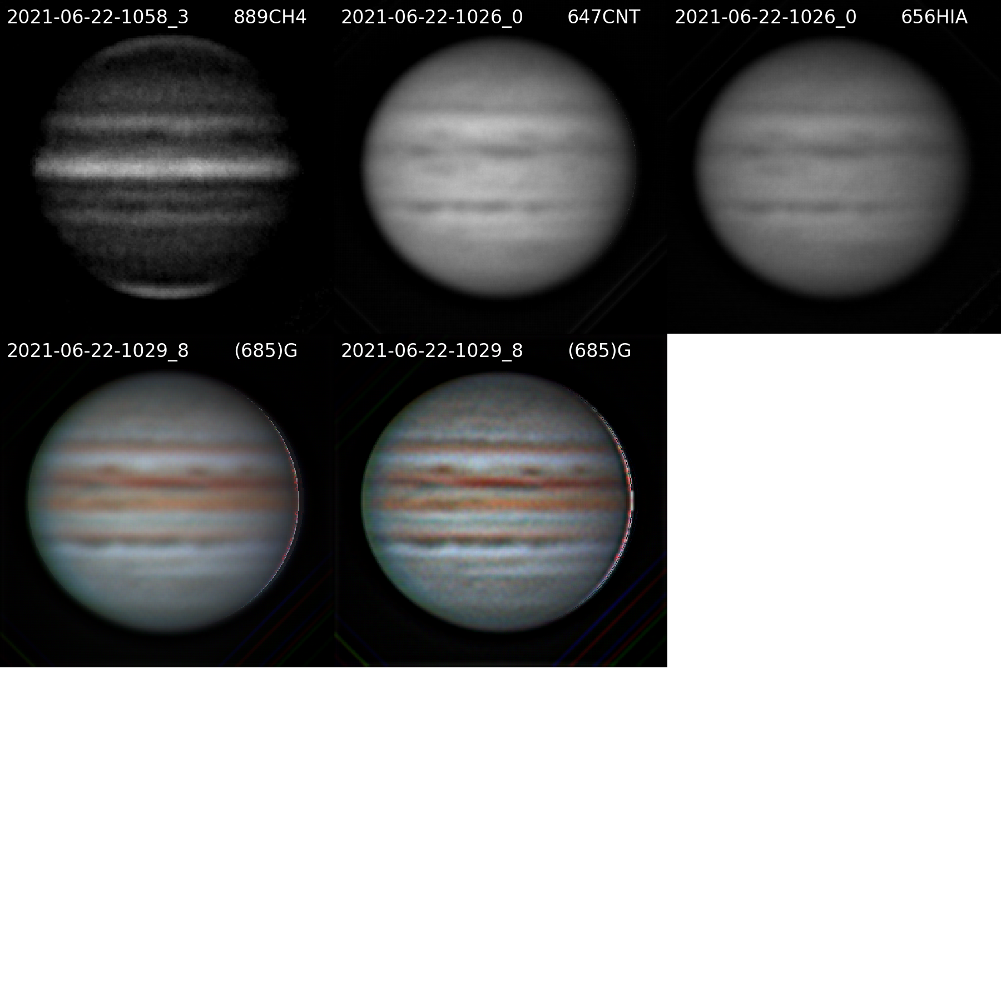

20210622UTJupiter-NavigatedArray.png

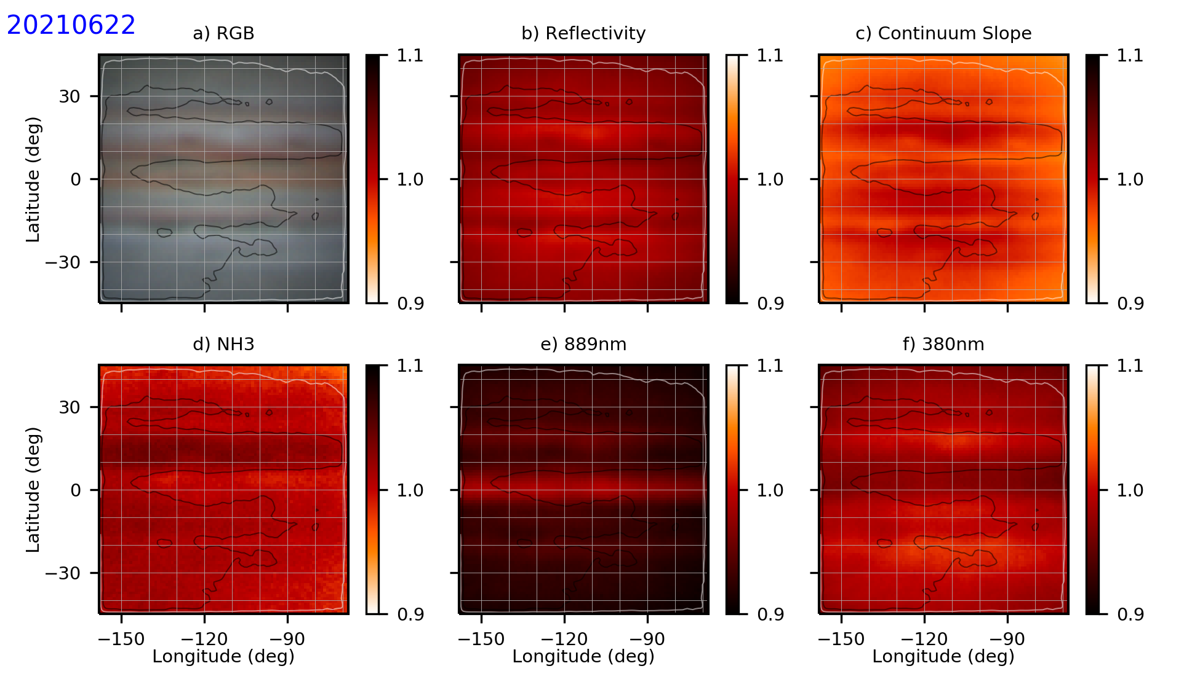

20210622UTJupiter-NH3.png

## July

### 2021-Jul-08 (Jul-08 UT): Jupiter with NH3 Video

Last Updated 6/23/2021

Transparency was good (4/5), but had some early and high cirrus. Seeing was very good (4/5).

I observed Jupiter on the morning of 7/8 with 632nm filter for the first time. (I need to be careful to call it 632, not 630.) I took a set of 630/647/656 images followed by NUV, GRN, BLU, and CH4 images, finally bracketed by a second set of 630/647/656 images.

|  |  |  |  |  |  |
| --- | --- | --- | --- | --- | --- |
| **Video File** | **Exposure** | **Gain** | **Gamma** | **Binning** | **Capture Area** |
| 2021-07-08-1023_9-Jupiter_630OI_Half-2x2.avi | 0.05 | 60 | 50 | 2 | 640x480 |
| 2021-07-08-1026_3-Jupiter_647CNT_Half-2x2.avi | 0.05 | 60 | 50 | 2 | 640x480 |
| 2021-07-08-1029_5-Jupiter_656HIA_Half-2x2.avi | 0.05 | 60 | 50 | 2 | 640x480 |
| 2021-07-08-1032_4-Jupiter_550GRN_Half-2x2.avi | 0.005 | 60 | 50 | 2 | 640x480 |
| 2021-07-08-1035_7-Jupiter_450BLU_Half-2x2.avi | 0.01 | 60 | 50 | 2 | 640x480 |
| 2021-07-08-1040_4-Jupiter_380NUV_Half-2x2.avi | 0.2 | 100 | 50 | 2 | 640x480 |
| 2021-07-08-1042_5-Jupiter_380NUV_Half-2x2.avi | 0.2 | 100 | 50 | 2 | 640x480 |
| 2021-07-08-1050_0-Jupiter_889CH4_Full-2x2.avi | 0.999 | 100 | 50 | 2 | 1280x960 |
| 2021-07-08-1052_1-Jupiter_889CH4_Full-2x2.avi | 0.999 | 100 | 50 | 2 | 1280x960 |
| 2021-07-08-1054_2-Jupiter_889CH4_Full-2x2.avi | 0.999 | 100 | 50 | 2 | 1280x960 |
| 2021-07-08-1056_3-Jupiter_889CH4_Full-2x2.avi | 0.999 | 100 | 50 | 2 | 1280x960 |
| 2021-07-08-1059_9-Jupiter_647CNT_Half-2x2.avi | 0.05 | 60 | 50 | 2 | 640x480 |
| 2021-07-08-1102_2-Jupiter_656HIA_Half-2x2.avi | 0.05 | 60 | 50 | 2 | 640x480 |
| 2021-07-08-1104_4-Jupiter_630OI_Half-2x2.avi | 0.05 | 60 | 50 | 2 | 640x480 |

|  |  |  |  |  |  |
| --- | --- | --- | --- | --- | --- |
| Video File | Exposure | Gain | Gamma | Binning | Capture Area |
| 2021-07-08-1109_2-Jupiter_450BLU-Flat-Half-2x2.avi | 0.999 | 60 | 50 | 2 | 640x480 |
| 2021-07-08-1111_5-Jupiter_550GRN_Flat_Half-2x2.avi | 0.999 | 60 | 50 | 2 | 640x480 |
| 2021-07-08-1121_8-Jupiter_889CH4_Dark_Full_2x2.avi | 0.999 | 100 | 50 | 2 | 1280x960 |
| 2021-07-08-1124_8-Jupiter_380NUV_Dark_Half_2x2.avi | 0.2 | 100 | 50 | 2 | 640x480 |
| 2021-07-08-1129_5-Jupiter_380NUV_Flat_Half_2x2.avi | 0.999 | 100 | 50 | 2 | 640x480 |
| 2021-07-08-1132_8-Jupiter_889CH4_Flat_Full_2x2.avi | 0.999 | 100 | 50 | 2 | 1280x960 |
| 2021-07-08-1136_7-Jupiter_656HIA_Flat_Half_2x2.avi | 0.2 | 60 | 50 | 2 | 640x480 |
| 2021-07-08-1138_2-Jupiter_647CNT_Flat_Half_2x2.avi | 0.2 | 60 | 50 | 2 | 640x480 |
| 2021-07-08-1141_2-Jupiter_630OI_Flat_Half_2x2.avi | 0.2 | 60 | 50 | 2 | 640x480 |

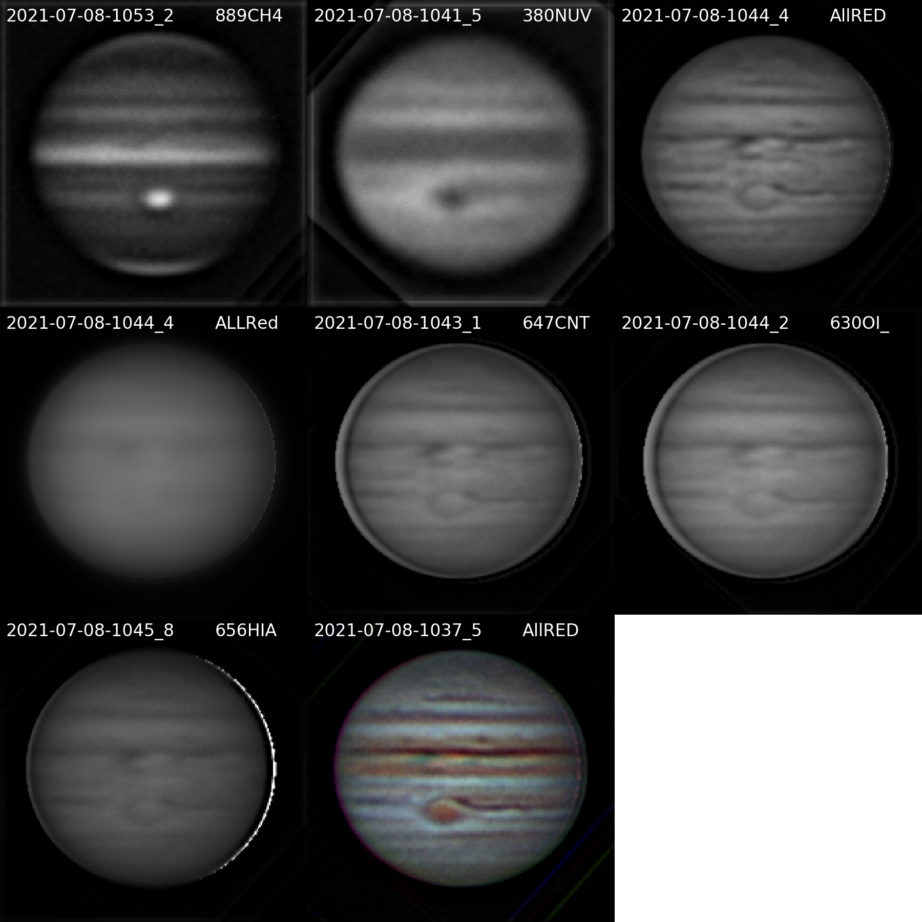

20210708UTJupiter-NavigatedArray.png

**Navigated Image Products**

2021-07-08-1053_2-Jupiter_889CH4_-Stack-Derot-Wavelets3x10+4x20.png

2021-07-08-1041_5-Jupiter_380NUV_-Derot-Stack-Wavelets4x10+5x20.png

2021-07-08-1044_4-Jupiter_AllREDs-Derot-Stack-Wavelets.png

2021-07-08-1044_4-Jupiter_ALLReds-NoWavelets-Derot-Stack.png

2021-07-08-1043_1-Jupiter_647CNT_Half-Derot_Stack-Wavelets2x20+3x20.png

2021-07-08-1044_2-Jupiter_630OI_Half-Derot-Stack-Wavelets2x20+3x20.png

2021-07-08-1045_8-Jupiter_656HIA_Half-Derot_Stack-Wavelets2x20+3x20.png

2021-07-08-1037_5-Jupiter-AllREDGB-RGB-WhtBal-ClrSmth-Smth-Wavelets.png

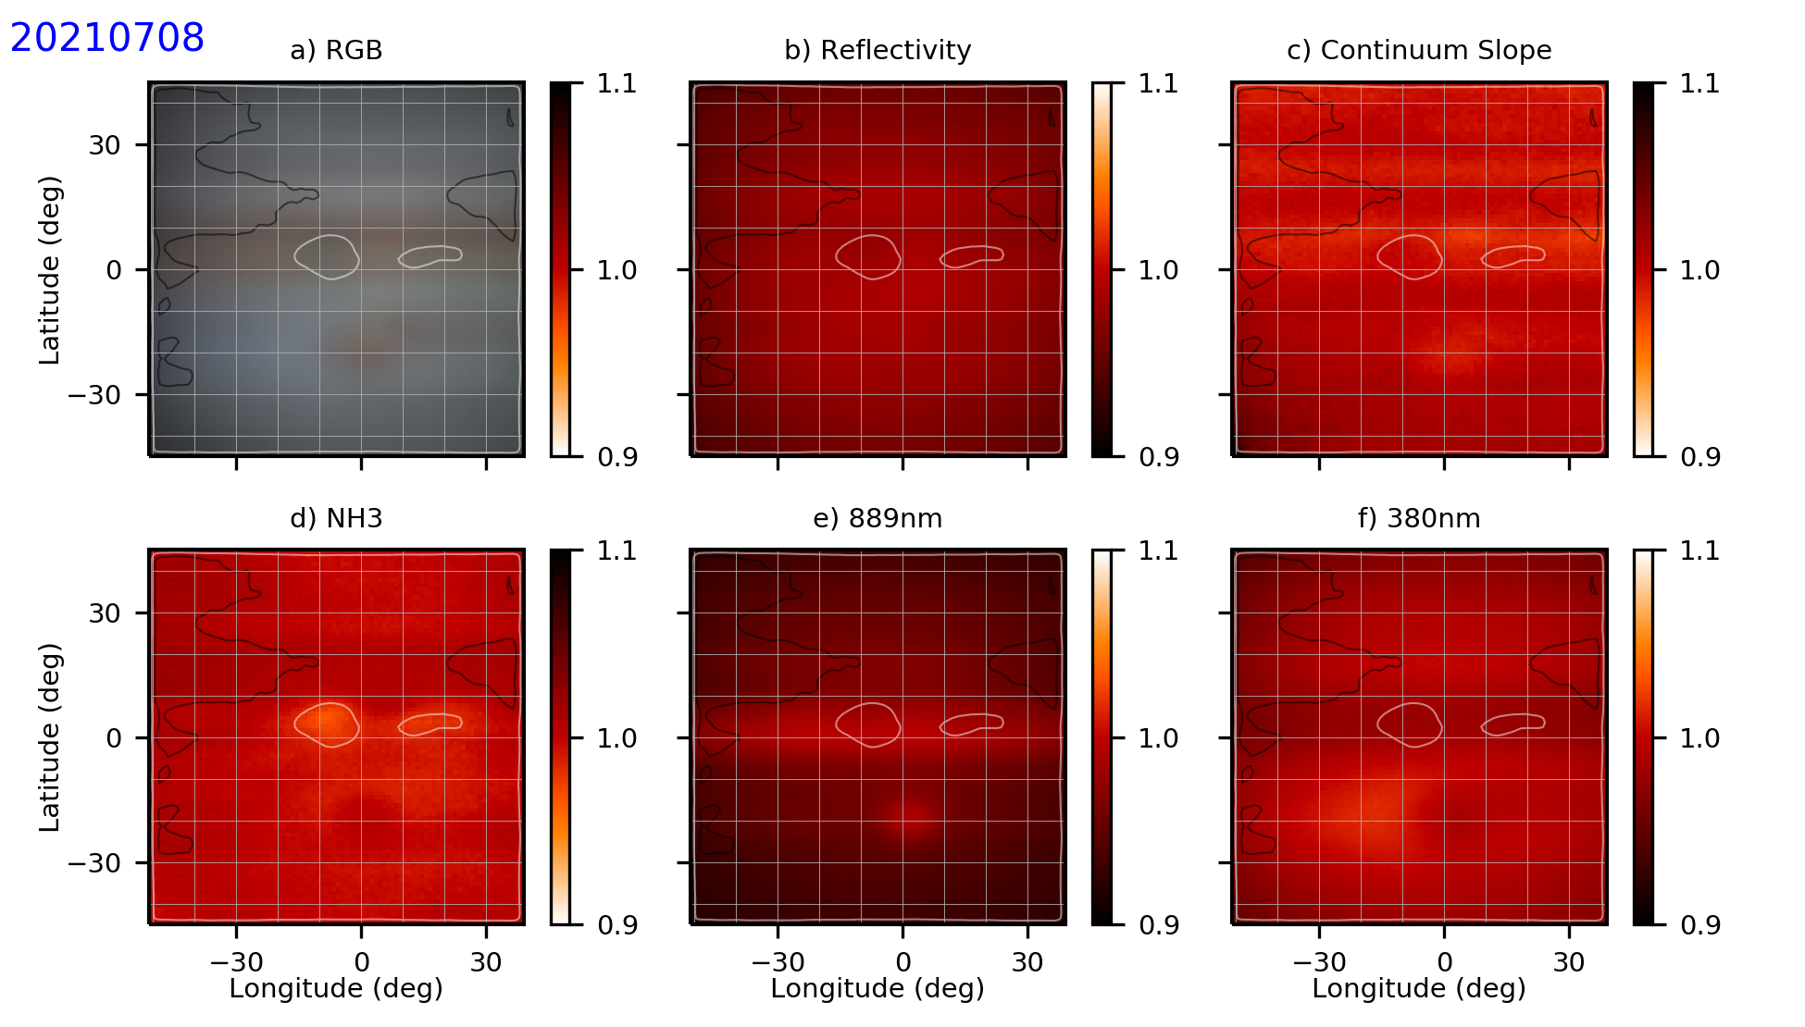

20210708UTJupiter-NH3.png

**Data Disposition:**

* Raw data is zipped and archived on the 4TB drive.
* Processed data is in appropriate project directories on the Astronomy SD card.

### 2021-Jul-19 (Jul-19 UT): Jupiter with NH3 Video; CEM70 First Light!

Last Updated 6/23/2021

Transparency was bad (2.5/5) due to smoke. Up to about 20-30 degrees above the horizon it was visibly smokey in daylight. In the early morning Jupiter was visibly reddened. I would probably call this moderate smoke by the standards of last summer and fall. Seeing was very good (4/5 maybe even 4.5/5) .

I need to give some description of initial performance of the CEM70 mount here, including the prior evening’s pointing experiments.

|  |  |  |  |  |  |
| --- | --- | --- | --- | --- | --- |
| **Video File** | **Exposure** | **Gain** | **Gamma** | **Binning** | **Capture Area** |
| 2021-07-19-1028_7-Jupiter_647NH3.avi | 0.1 | 60 | 50 | 2 | 640x480 |
| 2021-07-19-1031_1-Jupiter_630OI.avi | 0.1 | 60 | 50 | 2 | 640x480 |
| 2021-07-19-1033_4-Jupiter_656HIA.avi | 0.1 | 60 | 50 | 2 | 640x480 |
| 2021-07-19-1036_3-Jupiter_550GRN.avi | 0.01 | 60 | 50 | 2 | 640x480 |
| 2021-07-19-1037_8-Jupiter_450BLU.avi | 0.02 | 60 | 50 | 2 | 640x480 |
| 2021-07-19-1042_6-Jupiter_380NUV.avi | 0.999 | 100 | 50 | 2 | 640x480 |
| 2021-07-19-1044_7-Jupiter_380NUV.avi | 0.999 | 100 | 50 | 2 | 640x480 |
| 2021-07-19-1054_9-Jupiter_889CH4.avi | 0.999 | 100 | 50 | 2 | 640x480 |
| 2021-07-19-1057_0-Jupiter_889CH4.avi | 0.999 | 100 | 50 | 2 | 640x480 |
| 2021-07-19-1059_6-Jupiter_889CH4.avi | 0.999 | 100 | 50 | 2 | 1280x960 |
| 2021-07-19-1105_8-Jupiter_647NH3.avi | 0.1 | 60 | 50 | 2 | 640x480 |
| 2021-07-19-1107_8-Jupiter_647NH3.avi | 0.1 | 60 | 50 | 2 | 640x480 |
| 2021-07-19-1111_4-Jupiter_630OI.avi | 0.1 | 60 | 50 | 2 | 640x480 |
| 2021-07-19-1113_8-Jupiter_656HIA.avi | 0.1 | 60 | 50 | 2 | 640x480 |
| 2021-07-19-1119_4-Jupiter_550GRN.avi | 0.01 | 60 | 50 | 2 | 640x480 |
| 2021-07-19-1120_8-Jupiter_450BLU.avi | 0.02 | 60 | 50 | 2 | 640x480 |
| 2021-07-19-1123_2-Jupiter_Dark_Full_2x2.avi | 0.999 | 100 | 50 | 2 | 1280x960 |

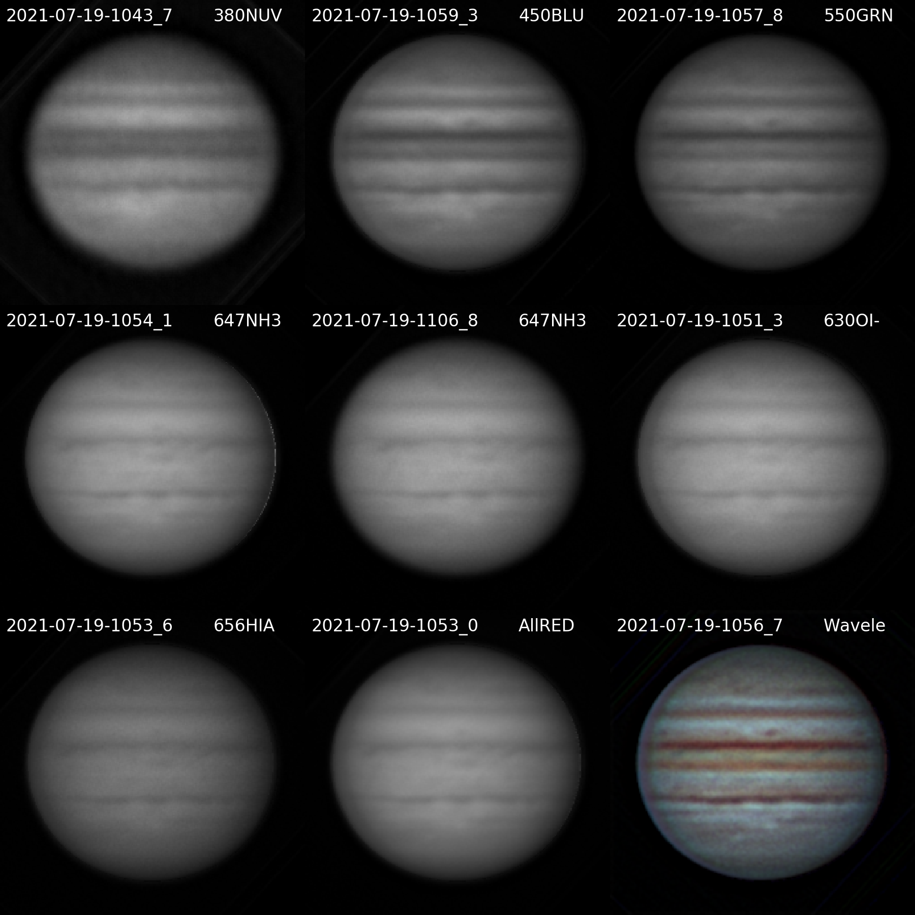

20210719UTJupiter-NavigatedArray.png

**Navigated Image Products**

2021-07-19-1043_7-Jupiter_380NUV-Wavelets4x20-Derot-Stack.png

2021-07-19-1059_3-Jupiter_450BLU-Wavelets2x30-Derot-Stack.png

2021-07-19-1057_8-Jupiter_550GRN-Wavelets2x30-Derot-Stack.png

2021-07-19-1054_1-Jupiter_647NH3-Wavelets2x20-Derot-Stack3.png

2021-07-19-1106_8-Jupiter_647NH3-Wavelets2x20-Derot-Stack2.png

2021-07-19-1051_3-Jupiter_630OI-Wavelets2x20-Derot-Stack.png

2021-07-19-1053_6-Jupiter_656HIA-Wavelets2x20-Derot-Stack.png

2021-07-19-1053_0-Jupiter_AllRED-Wavelets2x20-Derot-Stack.png

2021-07-19-1056_7-Jupiter-Wavelets-RGB-WhtBal-ClrSmth-Smth-Wavelets.png

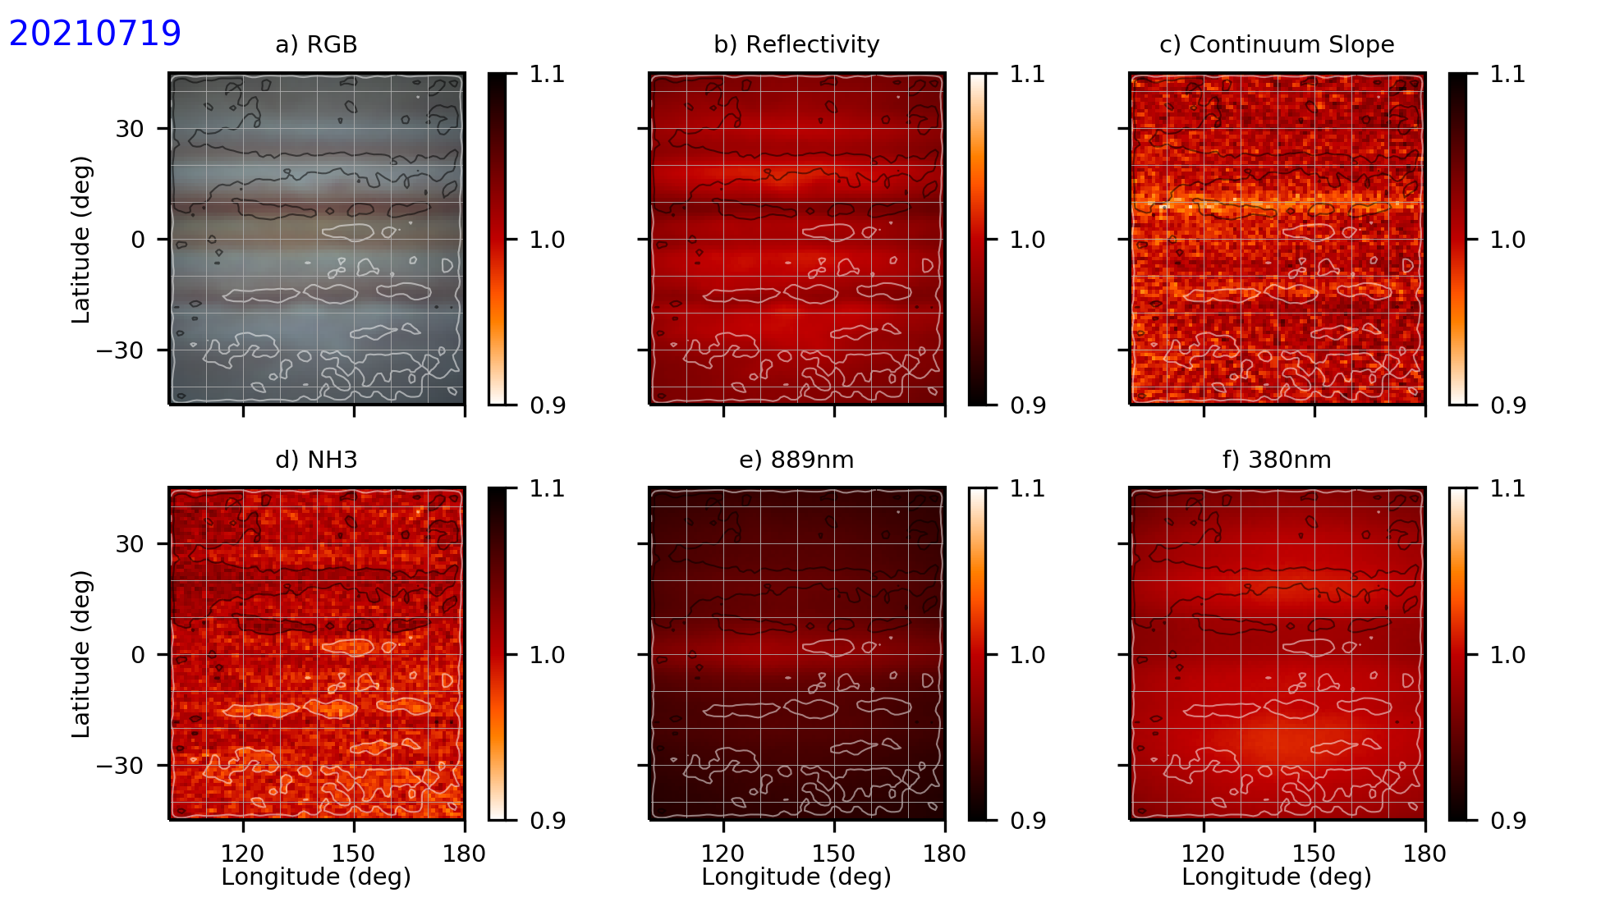

20210719UTJupiter-NH3.png

**Data Disposition:**

* Raw data is zipped and archived on the 4TB drive.
* Processed data is in appropriate project directories on the Astronomy SD card.

### 2021-Jul-20 (Jul-20 UT): Jupiter with NH3 Video

Last Updated 8/13/2021

|  |  |  |  |  |  |
| --- | --- | --- | --- | --- | --- |
| **Video File** | **Exposure** | **Gain** | **Gamma** | **Binning** | **Capture Area** |
| 2021-07-20-1035_6-Jupiter_647NH3.avi | 0.1 | 60 | 50 | 2 | 640x480 |
| 2021-07-20-1037_7-Jupiter_647NH3.avi | 0.1 | 60 | 50 | 2 | 640x480 |
| 2021-07-20-1040_0-Jupiter_656HIA.avi | 0.1 | 60 | 50 | 2 | 640x480 |
| 2021-07-20-1042_3-Jupiter_630OI.avi | 0.1 | 60 | 50 | 2 | 640x480 |
| 2021-07-20-1044_3-Jupiter_550GRN.avi | 0.01 | 60 | 50 | 2 | 640x480 |
| 2021-07-20-1045_5-Jupiter_550GRN.avi | 0.01 | 60 | 50 | 2 | 640x480 |
| 2021-07-20-1047_0-Jupiter_450BLU.avi | 0.02 | 60 | 50 | 2 | 640x480 |
| 2021-07-20-1048_1-Jupiter_450BLU.avi | 0.02 | 60 | 50 | 2 | 640x480 |
| 2021-07-20-1054_6-Jupiter_380NUV.avi | 0.999 | 100 | 50 | 2 | 640x480 |
| 2021-07-20-1056_7-Jupiter_380NUV.avi | 0.999 | 100 | 50 | 2 | 640x480 |
| 2021-07-20-1058_8-Jupiter_380NUV.avi | 0.999 | 100 | 50 | 2 | 640x480 |
| 2021-07-20-1103_3-Jupiter_CH4.avi | 0.999 | 100 | 50 | 2 | 1280x960 |
| 2021-07-20-1105_6-Jupiter_CH4.avi | 0.999 | 100 | 50 | 2 | 640x480 |
| 2021-07-20-1107_7-Jupiter_CH4.avi | 0.999 | 100 | 50 | 2 | 640x480 |
| 2021-07-20-1109_8-Jupiter_CH4.avi | 0.999 | 100 | 50 | 2 | 640x480 |
| 2021-07-20-1114_9-Jupiter_647NH3.avi | 0.1 | 60 | 50 | 2 | 640x480 |
| 2021-07-20-1117_0-Jupiter_647NH3.avi | 0.1 | 60 | 50 | 2 | 640x480 |
| 2021-07-20-1119_2-Jupiter_656HIA.avi | 0.1 | 60 | 50 | 2 | 640x480 |
| 2021-07-20-1121_6-Jupiter_656HIA.avi | 0.1 | 60 | 50 | 2 | 640x480 |
| 2021-07-20-1123_9-Jupiter_630OI.avi | 0.1 | 60 | 50 | 2 | 640x480 |
| 2021-07-20-1126_1-Jupiter_630OI.avi | 0.1 | 60 | 50 | 2 | 640x480 |
| 2021-07-20-1128_2-Jupiter_630OI.avi | 0.1 | 60 | 50 | 2 | 640x480 |
| 2021-07-20-1130_4-Jupiter_656HIA.avi | 0.1 | 60 | 50 | 2 | 640x480 |
| 2021-07-20-1132_8-Jupiter_DARK_Half_2x2.avi | 0.999 | 60 | 50 | 2 | 640x480 |
| 2021-07-20-1134_3-Jupiter_DARK_Half_2x2.avi | 0.999 | 60 | 50 | 2 | 1280x960 |

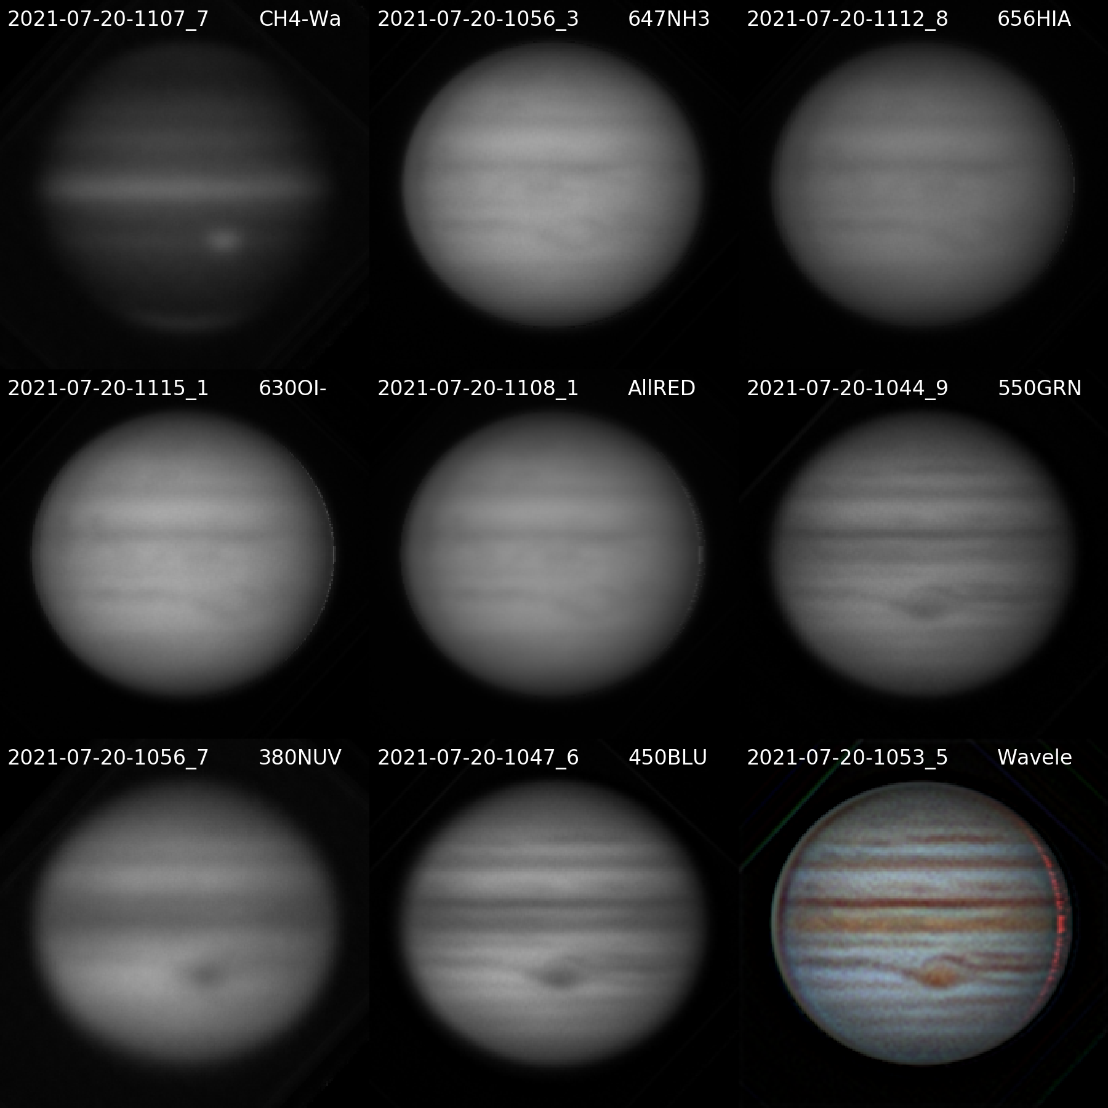

20210720UTJupiter-NavigatedArray.png

**Navigated Image Products**

2021-07-20-1107_7-Jupiter_CH4-Wavelets4x10-Derot-Stack.png

2021-07-20-1056_3-Jupiter_647NH3-Wavelets2x20-Derot-Stack.png

2021-07-20-1112_8-Jupiter_656HIA-Wavelets2x20-Derot-Stack.png

2021-07-20-1115_1-Jupiter_630OI-Wavelets2x20-Derot-Stack.png

2021-07-20-1108_1-Jupiter_AllRED-Wavelets2x20-Derot-Stack.png

2021-07-20-1044_9-Jupiter_550GRN-Wavelets2x30-Derot-Stack.png

2021-07-20-1056_7-Jupiter_380NUV-Wavelets4x10-Derot-Stack.png

2021-07-20-1047_6-Jupiter_450BLU-Wavelets2x30-Derot-Stack.png

2021-07-20-1053_5-Jupiter-Wavelets-RGB-WhtBal-ClrSmth-Smth-Wavelets.png

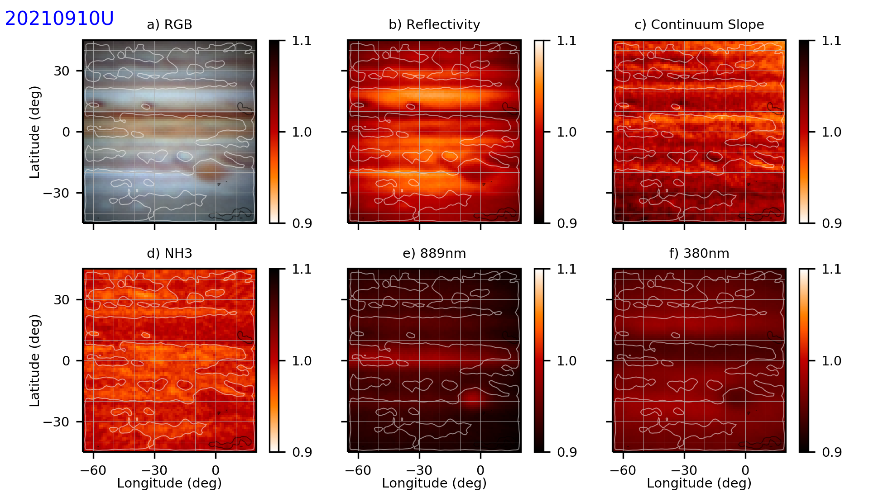

20210720UTJupiter-NH3.png

**Data Disposition:**

* Raw data is zipped and archived on the 4TB drive.
* Processed data is in appropriate project directories on the Astronomy SD card.

### 2021-Jul-26 (Jul-27 UT): Vega Spectra for 632nm Filter Calibration

Last Updated 7/27/2021

Seeing was very good 4/5 and transparency was very good 4/5. Possibly a bit of smoke, but no noticeable reddening.

This was first time I’ve taken spectra in a while, and I encountered a few problems. The most significant were:

* I forgot to take bias images!
* There was frosting on the detector at -10C that may have contaminated the edges of the 550OPN spectra. So I retook them at +1C. The location of the early 632nm spectra appears to be well within the frost-free zone, but I also took +1C spectra for 632nm.

### 2021-Jul-27 (Jul-28 UT): Double Star Videos

Last Updated 7/28/2021

Seeing was very good 4/5 and transparency was very good 4/5.

|  |  |  |  |  |  |
| --- | --- | --- | --- | --- | --- |
| **Video File** | **Exposure** | **Gain** | **Gamma** | **Binning** | **Capture Area** |
| 2021-07-28-0332_6-XiBoo_685NIR.avi | 0.02 | 100 | 50 | 1 | 320x240 |
| 2021-07-28-0335_2-XiBoo_685NIR.avi | 0.1 | 100 | 50 | 1 | 1280x960 |
| 2021-07-28-0335_9-XiBoo_685NIR.avi | 0.1 | 100 | 50 | 1 | 1280x960 |
| 2021-07-28-0348_8-SigCrB_685NIR.avi | 0.03 | 100 | 50 | 1 | 320x240 |
| 2021-07-28-0354_7-ZetHer_685NIR.avi | 0.01 | 100 | 50 | 1 | 320x240 |
| 2021-07-28-0355_4-ZetHer_685NIR.avi | 0.01 | 100 | 50 | 1 | 320x240 |
| 2021-07-28-0357_0-ZetHer_685NIR.avi | 0.03 | 100 | 50 | 1 | 1280x960 |
| 2021-07-28-0416_4-EpsLyrA_685NIR.avi | 0.03 | 100 | 50 | 1 | 320x240 |
| 2021-07-28-0420_9-EpsLyrB_685NIR.avi | 0.03 | 100 | 50 | 1 | 320x240 |
| 2021-07-28-0423_3-EpsLyrB_685NIR.avi | 0.1 | 100 | 50 | 1 | 1280x960 |
| 2021-07-28-0441_0-BU648-685NIR.avi | 0.03 | 100 | 50 | 1 | 320x240 |
| 2021-07-28-0443_1-BU648-685NIR.avi | 0.05 | 100 | 50 | 1 | 320x240 |

|  |  |  |  |
| --- | --- | --- | --- |
| **Xi Boo** | | **Sig CrB** | |
|  | 2021-07-28-0332_6-XiBoo_685NIR-Stack600-RotCrop.jpg |  | 2021-07-28-0348_8-SigCrB_685NIR-Stack600-RotCrop.jpg |
| **Zet Her** | | **Zet Her** | |
|  | 2021-07-28-0354_7-ZetHer_685NIR-Stack600-RotCrop.jpg |  | 2021-07-28-0355_4-ZetHer_685NIR-Stack600-RotCrop.jpg |
| **Eps Lyr 1** | | **Eps Lyr 2** | |
|  | 2021-07-28-0416_4-EpsLyrA_685NIR-Stack600-RotCrop.jpg |  | 2021-07-28-0420_9-EpsLyrB_685NIR-Stack600-RotCrop.jpg |
| **BU 648** | | **BU 648** | |
|  | 2021-07-28-0441_0-BU648-685NIR-Stack600-RotCrop.jpg |  | 2021-07-28-0443_1-BU648-685NIR-Stack400-RotCrop.jpg |

### 2021-Jul-28 (Jul-29 UT): Double Star Videos

Last Updated 8/4/2021

Seeing was very good 4/5 and transparency was very good 4/5.

|  |  |  |  |  |  |
| --- | --- | --- | --- | --- | --- |
| **Video File** | **Exposure** | **Gain** | **Gamma** | **Binning** | **Capture Area** |
| 2021-07-29-0418_8-LamOph_685NIR.avi | 0.02 | 100 | 50 | 1 | 320x240 |
| 2021-07-29-0429_2-STF2173_685NIR.avi | 0.03 | 100 | 50 | 1 | 320x240 |
| 2021-07-29-0504_4-70Oph_685NIR.avi | 0.01 | 100 | 50 | 1 | 320x240 |
| 2021-07-29-0505_0-70Oph_685NIR.avi | 0.01 | 100 | 50 | 1 | 320x240 |
| 2021-07-29-0507_1-70Oph_685NIR.avi | 0.1 | 100 | 50 | 1 | 1280x960 |
| 2021-07-29-0512_6-TauOph_685NIR.avi | 0.05 | 100 | 50 | 1 | 320x240 |
| 2021-07-29-0519_5-99Her_685NIR.avi | 0.05 | 100 | 50 | 1 | 320x240 |
| 2021-07-29-0526_8-MuDra_685NIR.avi | 0.02 | 100 | 50 | 1 | 320x240 |

## August

### 2021-Aug-11 (Aug-12 UT): Jupiter ST2000XM NH3 Imaging

Last Updated 8/12/2021

Transparency was poor (2/5) but had some early low clouds. “Moderate” smoke (for these ‘times.”). Seeing was good (3/5), but hard to determine since so few stars were visible.

Side notes:

* Tried to take **flats** but then discovered the filter wheel was freezing. Took the camera apart and found it was probably the height of the 632OI filter cell. I screwed it in tighter and worked afterward.
* Since I missed the opportunity for sky flats on 8/12, I took them the following evening (8/12 local, 8/13 UT)
* I tried to image **Saturn**, but it was in the top limbs of a neighbor’s tree. Experimentation showed that 2x2 binning worked much better to show Titan in the 889CH4 and 940NIR channels.
* I also slewed to nu Acq and after updating the mount to that location, slewed to NGC 7009 (**Saturn Nebula**) and it was on the camera detector! I did some quick exposures (30 sec) and found *I~*190000 counts for 656HIA, *I~*5200 counts 647CNT, and *I~*7200 counts for 630OI. It’s not clear if the difference between the 647 and 630 channels is due to throughputs of the filters or due to actual 630 nm OI emission.

Two sequences of images of Jupiter were made. The first was a series of 30 1-sec images in each of the red channels (630, 647, and 656). The images were interleaved in the sequence so that the exposure midpoint times are very close to one another. However, that spreads out the exposure for each channel. Given download time and filter moving time, there’s about 49 seconds between exposures in a selected channel. Given plate scale (~0.5 arcsec-pix-1), seeing (~1-2 arcsec at best?), and the canonical rule from the WinJUPOS site that images separated by more than 2 minutes should be derotated. **So, I would suggest that images should be stacked in sets of 3 and then those ten stacks would be derotated.** Each set of 3 would span 147 seconds.

The second sequence consisted of pairs of 940NIR and 889CH4 images. These images were separated by about 32 seconds. **I would suggest that images should be stacked in sets of 5 and then those six stacks derotated.** Each set of 5 would span 160 seconds.

For the disk-integrated photometry, all the images can be stacked without derotation.

### 2021-Aug-16 (Aug-17 UT): Jupiter ST2000XM NH3 Imaging

Last Updated 9/2/2021

Transparency was poor (2/5) with “moderate” smoke (for these ‘times.”). Seeing was good (3/5).

### 2021-Aug-29 (Aug-30 UT): Jupiter ST2000XM NH3 Imaging

Last Updated 9/2/2021

Transparency was fair (2.5/5) but had some adjacent low clouds that didn’t pass in front of Jupiter. “Light” smoke (for these ‘times.”) and or haze. Seeing was good (3.5/5).

## September

### Fall 2021 Planning

* Planetary Observations
  + Jupiter
    - Lucky imaging: multiple full longitude coverage, including ammonia imaging, tracking ammonia features over several rotations, synoptic changes over the observing season
    - Photometric imaging: mainly targeted at ammonia and methane, periodic to cover changes over the observing season
  + Saturn
    - Lucky imaging for coverage of this observing season
  + Titan
    - Photometric imaging in 940NIR and 889NIR for detection of surface albedo
* Planetary Nebula Observations
  + NGC6543 - Draco
  + NGC6720 M57 – in Lyra
    - Photometric imaging:
      * Blues (486HIB & 540CNT references; 656HIA for reddening)
        + More Signal: 467HeII, 486HIB, 540CNT, 540CNT
        + New Bands: N/A
      * Reds (656HIA & 647CNT references)
        + More Signal: 672SII, 658NII, 647CNT, 656HIA
        + New Bands: 630OI
      * NIR: No HI reference, 647CNT continuum reference?
        + More Signal: N/A
        + New Bands: 730OII, >1000NIR (SIII)
      * Broadband
        + More Signal: 380NUV, 685NIR
        + New Bands: 742NIR, 807NIR
  + NGC6826 Blinking Planetary - Cygnus
  + NGC6853 M27 Dumbbell – Vulpecula
    - Photometric imaging: 632OI, 730OII, and >1000NIR (SIII) needed. Additional signal for 672SII and 467HeII needed also
  + NGC7009 – Aquarius
    - Photometric imaging:
      * Blues (486HIB & 540CNT references; 656HIA for reddening)
        + More Signal: 501OIII
        + New Bands: 467HeII, 486HIB, 540CNT
      * Reds (656HIA & 647CNT references)
        + More Signal: 658NII, 647CNT, 656HIA
        + New Bands: 630OI, 672SII
      * NIR: No HI reference, 647CNT continuum reference?
        + More Signal: N/A
        + New Bands: 730OII, >1000NIR (SIII)
      * Broadband
        + More Signal: (450BLU, 550GRN, 650RED maybe?)
        + New Bands: 380NUV, 685NIR, 742NIR, 807NIR
  + NGC7293 Helix - Aquarius
  + NGC7662 Blue Snowball – Andromeda

### 2021-Sep-04 (Sep-05 UT): Jupiter, Saturn, NGC7009, and NGC 6543 Imaging

Last Updated 9/2/2021

Transparency was excellent (4.5/5) and was clear of smoke as far as I could tell. Seeing was very good (4/5).

### 2021-Sep-05 (Sep-06 UT): Jupiter, Saturn, NGC7009, and NGC 6543 Imaging

Last Updated 9/2/2021

Transparency was good (3.5/5) with maybe a hint of smoke/haze near the horizon. Seeing was very good (4/5).

### 2021-Sep-09 (Sep-10 UT): Jupiter, Saturn, and NGC7009 Video

Last Updated 9/20/2021

Transparency was good (3.5/5, but there may have been light smoke. Seeing was very good (4/5).

|  |  |  |  |  |  |
| --- | --- | --- | --- | --- | --- |
| **Video File** | **Exposure** | **Gain** | **Gamma** | **Binning** | **Capture Area** |
| 2021-09-10-0409_2-Jupiter_632OI.avi | 0.05 | 60 | 50 | 2 | 640x480 |
| 2021-09-10-0411_2-Jupiter_632OI.avi | 0.05 | 60 | 50 | 2 | 640x480 |
| 2021-09-10-0413_6-Jupiter_647CNT.avi | 0.05 | 60 | 50 | 2 | 640x480 |
| 2021-09-10-0415_6-Jupiter_647CNT.avi | 0.05 | 60 | 50 | 2 | 640x480 |
| 2021-09-10-0418_1-Jupiter_656HIA.avi | 0.05 | 60 | 50 | 2 | 640x480 |
| 2021-09-10-0420_3-Jupiter_656HIA.avi | 0.05 | 60 | 50 | 2 | 640x480 |
| 2021-09-10-0422_3-Jupiter_550GRN.avi | 0.01 | 60 | 50 | 2 | 640x480 |
| 2021-09-10-0423_4-Jupiter_550GRN.avi | 0.01 | 60 | 50 | 2 | 640x480 |
| 2021-09-10-0424_9-Jupiter_450BLU.avi | 0.01 | 60 | 50 | 2 | 640x480 |
| 2021-09-10-0426_0-Jupiter_450BLU.avi | 0.01 | 60 | 50 | 2 | 640x480 |
| 2021-09-10-0429_6-Jupiter_380NUV.avi | 0.5 | 100 | 50 | 2 | 640x480 |
| 2021-09-10-0431_6-Jupiter_380NUV.avi | 0.5 | 100 | 50 | 2 | 640x480 |
| 2021-09-10-0436_0-Jupiter_889CH4.avi | 1 | 100 | 50 | 2 | 1280x960 |
| 2021-09-10-0438_5-Jupiter_889CH4.avi | 1 | 100 | 50 | 2 | 1280x960 |
| 2021-09-10-0440_7-Jupiter_889CH4.avi | 1 | 100 | 50 | 2 | 1280x960 |
| 2021-09-10-0443_0-Jupiter_889CH4.avi | 1 | 100 | 50 | 2 | 1280x960 |
| 2021-09-10-0445_1-Jupiter_889CH4_Dark.avi | 1 | 100 | 50 | 2 | 1280x960 |
| 2021-09-10-0446_5-Jupiter_380NUV_Dark.avi | 0.5 | 100 | 50 | 2 | 640x480 |
| 2021-09-10-0452_4-Jupiter_550GRN_Flat.avi | 0.2 | 60 | 50 | 2 | 640x480 |
| 2021-09-10-0453_3-Jupiter_450BLU_Flat.avi | 0.4 | 60 | 50 | 2 | 640x480 |
| 2021-09-10-0454_8-Jupiter_632OI_Flat.avi | 2 | 60 | 50 | 2 | 640x480 |
| 2021-09-10-0456_3-Jupiter_656HIA_Flat.avi | 4 | 60 | 50 | 2 | 640x480 |
| 2021-09-10-0457_6-Jupiter_647CNT_Flat.avi | 2 | 60 | 50 | 2 | 640x480 |

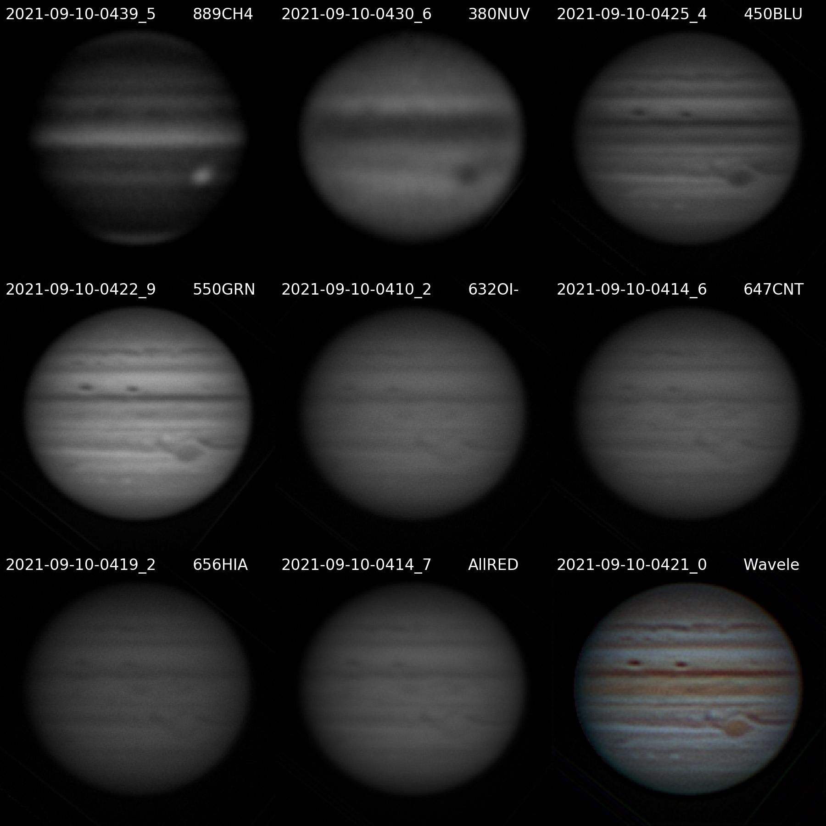

20210910UTJupiter-NavigatedArray.png

**Navigated Image Products**

2021-09-10-0439_5-Jupiter_889CH4-Wavelets-Derot-Stack.png

2021-09-10-0430_6-Jupiter_380NUV-Wavelets-Derot-Stack.png

2021-09-10-0425_4-Jupiter_450BLU-Wavelets-Derot-Stack.png

2021-09-10-0422_9-Jupiter_550GRN-Wavelets-Derot-Stack.png

2021-09-10-0410_2-Jupiter_632OI-Wavelets-Derot-Stack.png

2021-09-10-0414_6-Jupiter_647CNT-Wavelets-Derot-Stack.png

2021-09-10-0419_2-Jupiter_656HIA-Wavelets-Derot-Stack.png

2021-09-10-0414_7-Jupiter_AllRED-Wavelets-Derot-Stack.png

2021-09-10-0421_0-Jupiter-Wavelets-R(AllRED)GB-RGB-WhtBal-ClrSmth-Smth-Wavelets.png



20210910UTwJupiter-NH3.png

|  |  |  |  |  |  |
| --- | --- | --- | --- | --- | --- |
| **Video File** | **Exposure** | **Gain** | **Gamma** | **Binning** | **Capture Area** |
| 2021-09-10-0334_5-Saturn_550GRN.avi | 0.05 | 50 | 50 | 2 | 640x480 |
| 2021-09-10-0336_6-Saturn_550GRN.avi | 0.05 | 50 | 50 | 2 | 640x480 |
| 2021-09-10-0339_1-Saturn_450BLU.avi | 0.1 | 50 | 50 | 2 | 640x480 |
| 2021-09-10-0341_1-Saturn_450BLU.avi | 0.1 | 50 | 50 | 2 | 640x480 |
| 2021-09-10-0343_9-Saturn_632OI.avi | 0.1 | 75 | 50 | 2 | 640x480 |
| 2021-09-10-0346_0-Saturn_632OI.avi | 0.1 | 75 | 50 | 2 | 640x480 |
| 2021-09-10-0348_6-Saturn_632OI.avi | 0.1 | 75 | 50 | 2 | 640x480 |

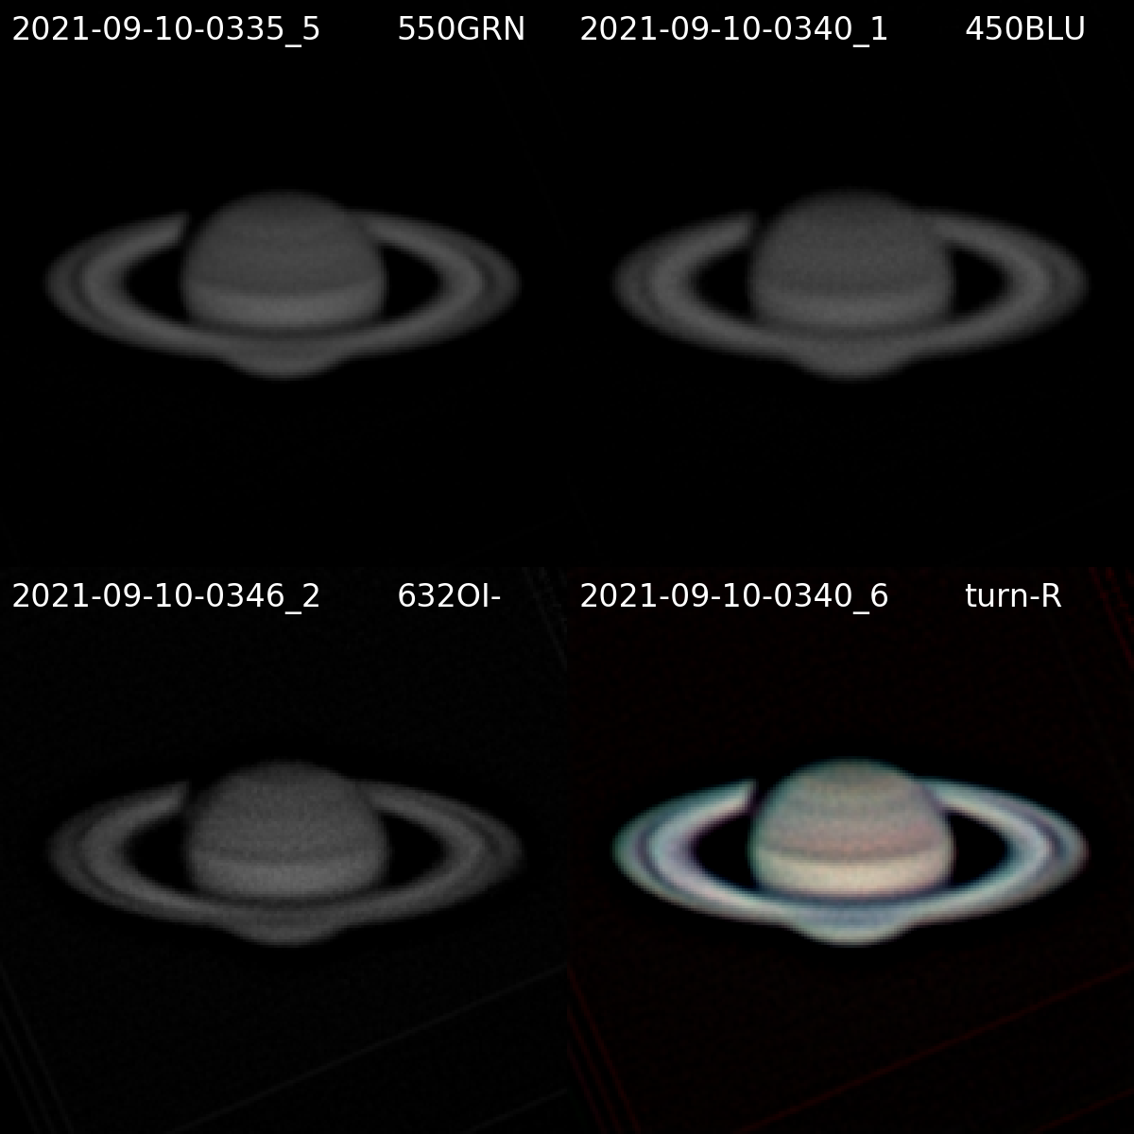

20210910UTSaturn-NavigatedArray.png

**Navigated Image Products**

2021-09-10-0335_5-Saturn_550GRN-Wavelets-Derot-Stack.png

2021-09-10-0340_1-Saturn_450BLU-Wavelets-Derot-Stack.png

2021-09-10-0346_2-Saturn_632OI-Wavelets-Derot-Stack.png

2021-09-10-0340_6-Hill-Saturn-R(632)GB-RGB-WhtBal-ClrSmth-Smth-Wavelets.png

|  |  |  |  |  |  |
| --- | --- | --- | --- | --- | --- |
| **Video File** | **Exposure** | **Gain** | **Gamma** | **Binning** | **Capture Area** |
| 2021-09-10-0359_3-NGC7009_656HIA.avi | 10 | 100 | 50 | 2 | 1280x960 |
| 2021-09-10-0403_6-NGC7009_656HIA_Dark.avi | 10 | 100 | 50 | 2 | 1280x960 |

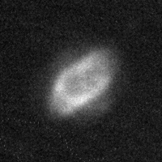

NGC7009-20210910UT-656HIA-sum310sec-Lucky-Crop.jpg

### 2021-Sep-12 (Sep-13 UT): Jupiter Video

Last Updated 9/20/2021

I believe this night had both very good transparency and seeing, but this is from a recollection several days later.

|  |  |  |  |  |  |
| --- | --- | --- | --- | --- | --- |
| **Video File** | **Exposure** | **Gain** | **Gamma** | **Binning** | **Capture Area** |
| 2021-09-13-0437_6-Jupiter_630OI.avi | 0.05 | 60 | 50 | 2 | 640x480 |
| 2021-09-13-0439_8-Jupiter_630OI.avi | 0.05 | 60 | 50 | 2 | 640x480 |
| 2021-09-13-0442_2-Jupiter_656HIA.avi | 0.05 | 60 | 50 | 2 | 640x480 |
| 2021-09-13-0444_4-Jupiter_656HIA.avi | 0.05 | 60 | 50 | 2 | 640x480 |
| 2021-09-13-0446_8-Jupiter_647CNT.avi | 0.05 | 60 | 50 | 2 | 640x480 |
| 2021-09-13-0448_9-Jupiter_647CNT.avi | 0.05 | 60 | 50 | 2 | 640x480 |
| 2021-09-13-0452_0-Jupiter_450BLU.avi | 0.01 | 60 | 50 | 2 | 640x480 |
| 2021-09-13-0453_1-Jupiter_450BLU.avi | 0.01 | 60 | 50 | 2 | 640x480 |
| 2021-09-13-0454_8-Jupiter_550GRN.avi | 0.005 | 60 | 50 | 2 | 640x480 |
| 2021-09-13-0455_8-Jupiter_550GRN.avi | 0.005 | 60 | 50 | 2 | 640x480 |
| 2021-09-13-0502_3-Jupiter_380NUV.avi | 0.25 | 100 | 50 | 2 | 640x480 |
| 2021-09-13-0504_4-Jupiter_380NUV.avi | 0.25 | 100 | 50 | 2 | 640x480 |
| 2021-09-13-0507_1-Jupiter_380NUV.avi | 0.25 | 100 | 50 | 2 | 640x480 |
| 2021-09-13-0510_2-Jupiter_889CH4.avi | 0.5 | 100 | 50 | 2 | 1280x960 |
| 2021-09-13-0512_3-Jupiter_889CH4.avi | 0.5 | 100 | 50 | 2 | 1280x960 |
| 2021-09-13-0514_3-Jupiter_889CH4.avi | 0.5 | 100 | 50 | 2 | 1280x960 |
| 2021-09-13-0516_6-Jupiter_889CH4.avi | 0.5 | 100 | 50 | 2 | 1280x960 |
| 2021-09-13-0518_4-Jupiter_889CH4_DARK.avi | 0.5 | 100 | 50 | 2 | 1280x960 |
| 2021-09-13-0519_3-Jupiter_380NUV_DARK.avi | 0.25 | 100 | 50 | 2 | 640x480 |

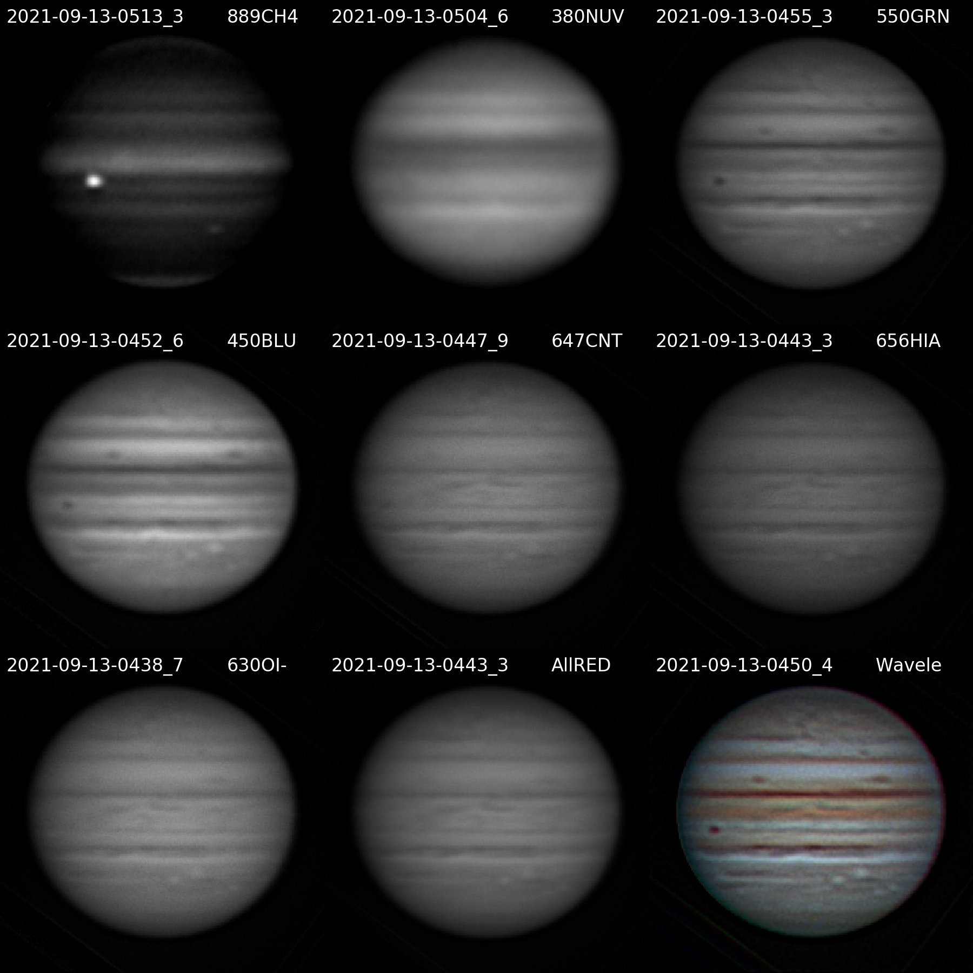

20210913UTJupiter-NavigatedArray.png

**Navigated Image Products**

2021-09-13-0513_3-Jupiter_889CH4-Wavelets-Derot-Stack.png

2021-09-13-0504_6-Jupiter_380NUV-Wavelets-Derot-Stack.png

2021-09-13-0455_3-Jupiter_550GRN-Wavelets-Derot-Stack.png

2021-09-13-0452_6-Jupiter_450BLU-Wavelets-Derot-Stack.png

2021-09-13-0447_9-Jupiter_647CNT-Wavelets-Derot-Stack.png

2021-09-13-0443_3-Jupiter_656HIA-Wavelets-Derot-Stack.png

2021-09-13-0438_7-Jupiter_630OI-Wavelets-Derot-Stack.png

2021-09-13-0443_3-Jupiter_AllRED-Wavelets-Derot-Stack.png

2021-09-13-0450_4-Jupiter-Wavelets-R(AllRED)GB-RGB-WhtBal-ClrSmth-Smth-Wavelets.png

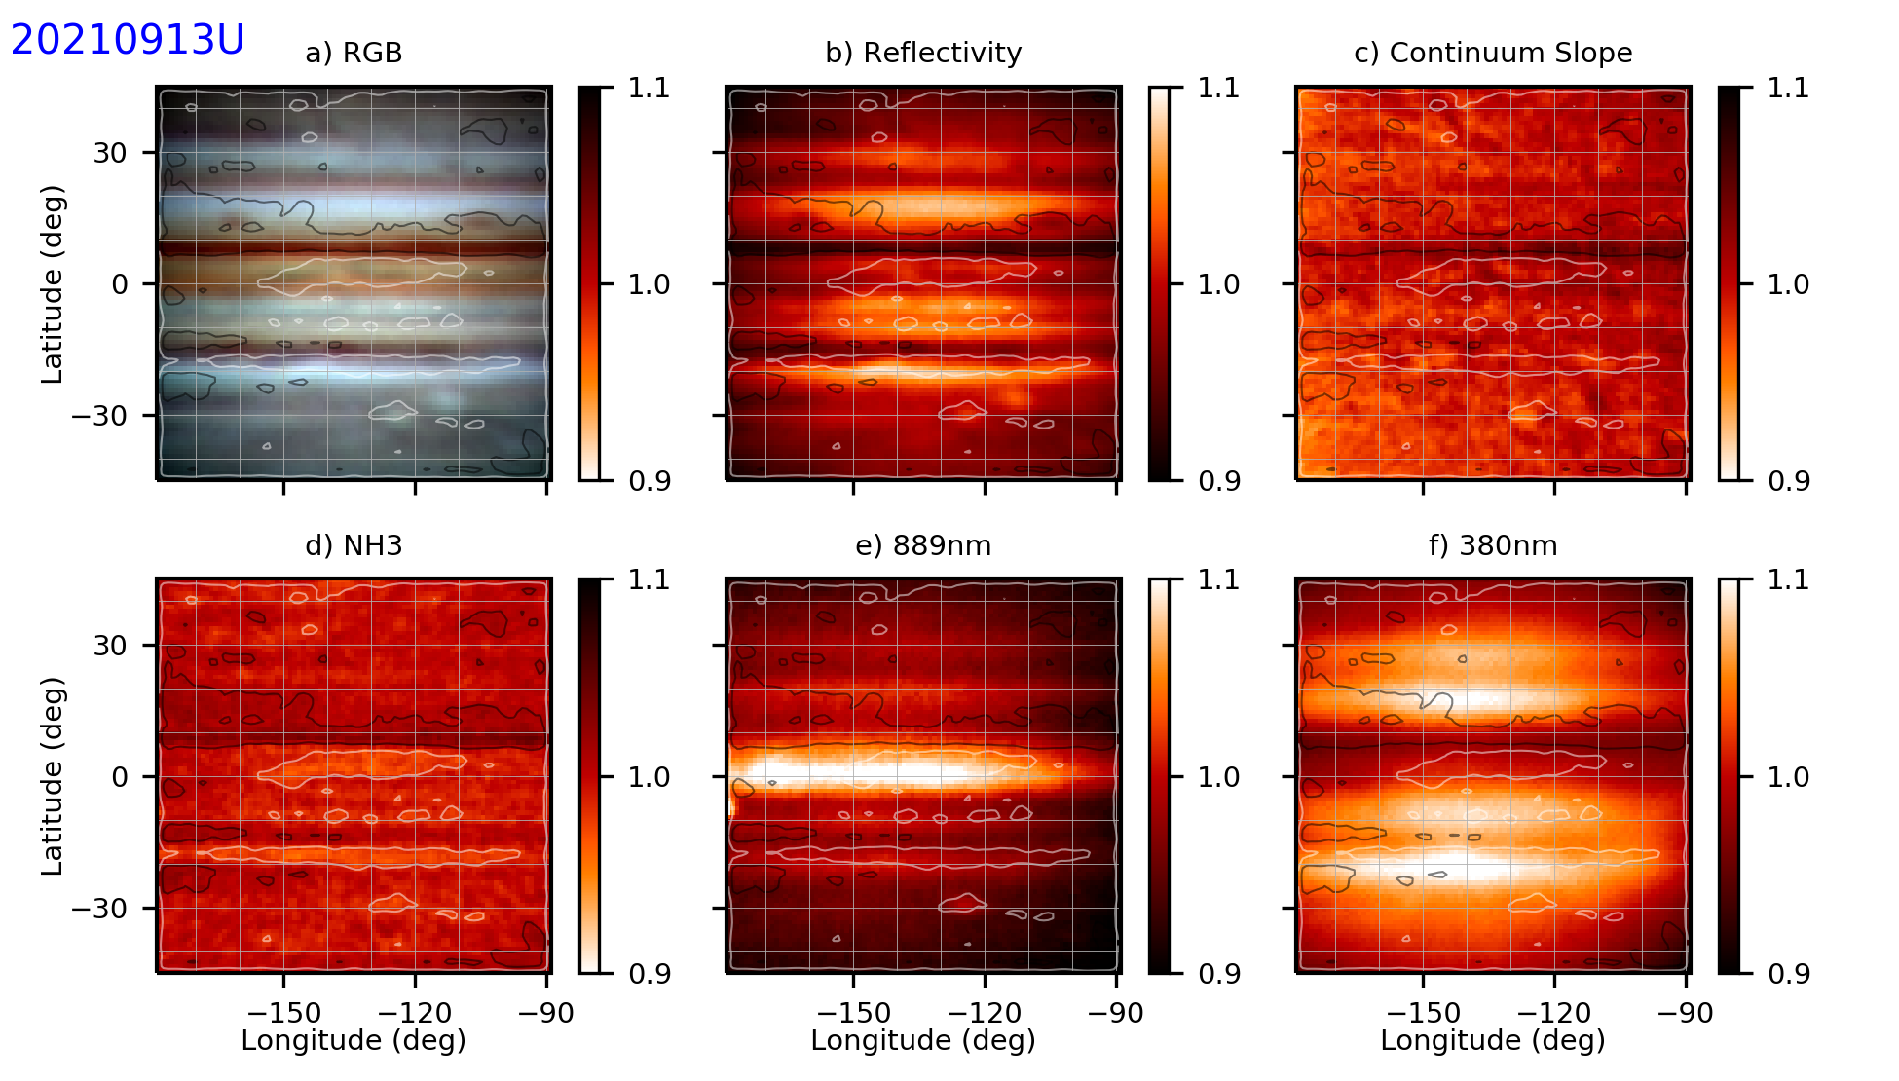

20210913UTwJupiter-NH3.png

**Data Disposition:**

* Raw data is zipped and archived on the 4TB drive.
* Processed data is in appropriate project directories on the Astronomy SD card.

### 2021-Sep-14 (Sep-15 UT): Jupiter Video

Last Updated 9/20/2021

I believe this night had both very good transparency and seeing, but this is from a recollection several days later.

|  |  |  |  |  |  |  |
| --- | --- | --- | --- | --- | --- | --- |
| **Video File** | **Exposure** | **Gain** | **Gamma** | **Binning** | **Capture Area** | |
| 2021-09-15-0343_5-Jupiter_632OI.avi | 0.05 | 60 | 50 | 2 | | 640x480 |
| 2021-09-15-0345_6-Jupiter_632OI.avi | 0.05 | 60 | 50 | 2 | | 640x480 |
| 2021-09-15-0347_9-Jupiter_656HIA.avi | 0.05 | 60 | 50 | 2 | | 640x480 |
| 2021-09-15-0350_0-Jupiter_656HIA.avi | 0.05 | 60 | 50 | 2 | | 640x480 |
| 2021-09-15-0352_4-Jupiter_647CNT.avi | 0.05 | 60 | 50 | 2 | | 640x480 |
| 2021-09-15-0354_5-Jupiter_647CNT.avi | 0.05 | 60 | 50 | 2 | | 640x480 |
| 2021-09-15-0357_3-Jupiter_550GRN.avi | 0.01 | 60 | 50 | 2 | | 640x480 |
| 2021-09-15-0358_5-Jupiter_550GRN.avi | 0.01 | 60 | 50 | 2 | | 640x480 |
| 2021-09-15-0359_9-Jupiter_450BLU.avi | 0.01 | 60 | 50 | 2 | | 640x480 |
| 2021-09-15-0401_0-Jupiter_450BLU.avi | 0.01 | 60 | 50 | 2 | | 640x480 |
| 2021-09-15-0403_8-Jupiter_380NUV.avi | 0.25 | 100 | 50 | 2 | | 640x480 |
| 2021-09-15-0406_1-Jupiter_380NUV.avi | 0.25 | 100 | 50 | 2 | | 640x480 |
| 2021-09-15-0410_4-Jupiter_889CH4.avi | 0.5 | 100 | 50 | 2 | | 1280x960 |
| 2021-09-15-0412_9-Jupiter_889CH4.avi | 0.5 | 100 | 50 | 2 | | 1280x960 |
| 2021-09-15-0415_0-Jupiter_889CH4.avi | 0.5 | 100 | 50 | 2 | | 1280x960 |
| 2021-09-15-0417_1-Jupiter_889CH4.avi | 0.5 | 100 | 50 | 2 | | 1280x960 |
| 2021-09-15-0419_1-Jupiter_889CH4_Dark.avi | 0.5 | 100 | 50 | 2 | | 1280x960 |
| 2021-09-15-0420_0-Jupiter_380NUV_Dark.avi | 0.25 | 100 | 50 | 2 | | 640x480 |

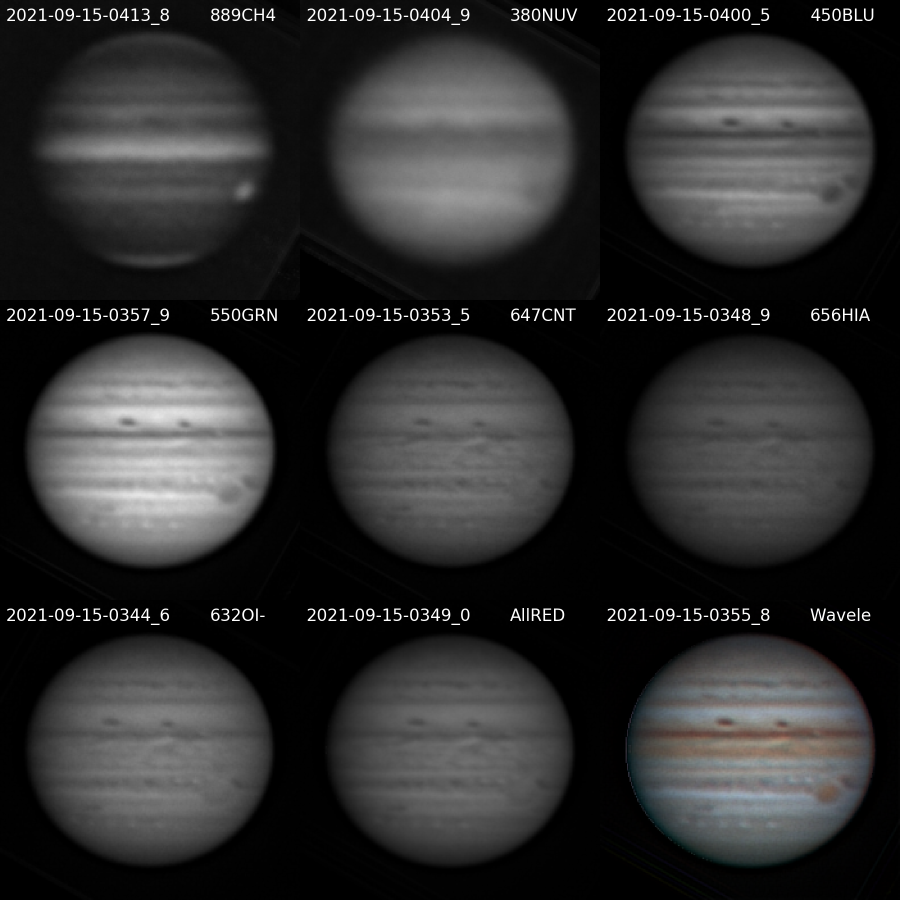

20210915UTJupiter-NavigatedArray.png

**Navigated Image Products**

2021-09-15-0413_8-Jupiter_889CH4-Wavelets-Derot-Stack.png

2021-09-15-0404_9-Jupiter_380NUV-Wavelets-Derot-Stack.png

2021-09-15-0400_5-Jupiter_450BLU-Wavelets-Derot-Stack.png

2021-09-15-0357_9-Jupiter_550GRN-Wavelets-Derot-Stack.png

2021-09-15-0353_5-Jupiter_647CNT-Wavelets-Derot-Stack.png

2021-09-15-0348_9-Jupiter_656HIA-Wavelets-Derot-Stack.png

2021-09-15-0344_6-Jupiter_632OI-Wavelets-Derot-Stack.png

2021-09-15-0349_0-Jupiter_AllRED-Wavelets-Derot-Stack.png

2021-09-15-0355_8-Jupiter-Wavelets-R(AllRED)GB-RGB-WhtBal-ClrSmth-Smth-Wavelets.png

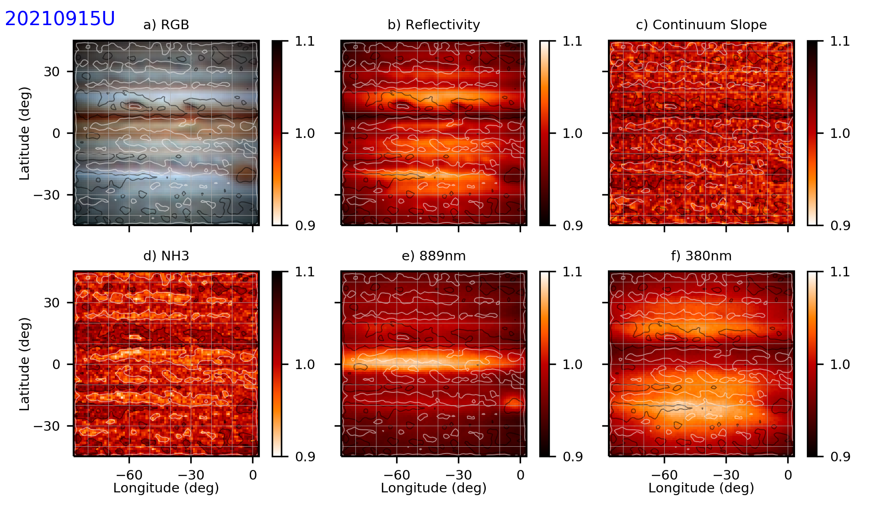

20210915UTwJupiter-NH3.png

**Data Disposition:**

* Raw data is zipped and archived on the 4TB drive.
* Processed data is in appropriate project directories on the Astronomy SD card.

### 2021-Sep-18 (Sep-19 UT): Jupiter Video

Last Updated 9/20/2021

Transparency was very poor (1/5), I was imaging through cirrus of various thicknesses. Attenuation was so bad I skipped 889CH4 and 380NUV images. Seeing was poor (2/5). The next morning I took new flats because the ones from 9/10 didn’t seem to be doing well anymore.

|  |  |  |  |  |  |
| --- | --- | --- | --- | --- | --- |
| **Video File** | **Exposure** | **Gain** | **Gamma** | **Binning** | **Capture Area** |
| 2021-09-19-0441_8-Jupiter_632OI.avi | 0.05 | 60 | 50 | 2 | 640x480 |
| 2021-09-19-0443_9-Jupiter_632OI.avi | 0.05 | 60 | 50 | 2 | 640x480 |
| 2021-09-19-0449_9-Jupiter_647CNT.avi | 0.1 | 60 | 50 | 2 | 640x480 |
| 2021-09-19-0452_0-Jupiter_647CNT.avi | 0.1 | 60 | 50 | 2 | 640x480 |
| 2021-09-19-0455_1-Jupiter_550GRN.avi | 0.05 | 60 | 50 | 2 | 640x480 |
| 2021-09-19-0457_2-Jupiter_550GRN.avi | 0.05 | 60 | 50 | 2 | 640x480 |
| 2021-09-19-0459_7-Jupiter_656HIA.avi | 0.1 | 60 | 50 | 2 | 640x480 |
| 2021-09-19-0501_8-Jupiter_656HIA.avi | 0.1 | 60 | 50 | 2 | 640x480 |
| 2021-09-19-0503_5-Jupiter_450BLU.avi | 0.05 | 60 | 50 | 2 | 640x480 |
| 2021-09-19-0504_4-Jupiter_450BLU.avi | 0.02 | 60 | 50 | 2 | 640x480 |
| 2021-09-19-0505_6-Jupiter_450BLU.avi | 0.02 | 60 | 50 | 2 | 640x480 |
| 2021-09-19-0507_9-Jupiter_656HIA.avi | 0.05 | 60 | 50 | 2 | 640x480 |
| 2021-09-19-0510_3-Jupiter_647CNT.avi | 0.05 | 60 | 50 | 2 | 640x480 |
| 2021-09-19-0512_5-Jupiter_632OI.avi | 0.05 | 60 | 50 | 2 | 640x480 |
| 2021-09-19-0514_5-Jupiter_550GRN.avi | 0.02 | 60 | 50 | 2 | 640x480 |
| 2021-09-19-1352_1-Jupiter_550GRN_Flat.avi | 0.005 | 60 | 50 | 2 | 640x480 |
| 2021-09-19-1352_7-Jupiter_450BLU_Flat.avi | 0.003 | 60 | 50 | 2 | 640x480 |
| 2021-09-19-1353_8-Jupiter_632OI_Flat.avi | 0.05 | 60 | 50 | 2 | 640x480 |
| 2021-09-19-1355_0-Jupiter_656HIA_Flat.avi | 0.1 | 60 | 50 | 2 | 640x480 |
| 2021-09-19-1355_9-Jupiter_647CNT_Flat.avi | 0.1 | 60 | 50 | 2 | 640x480 |
| 2021-09-19-1357_2-Jupiter_380NUV_Flat.avi | 0.2 | 60 | 50 | 2 | 640x480 |
| 2021-09-19-1400_3-Jupiter_889CH4_Flat.avi | 1 | 60 | 50 | 2 | 1280x960 |

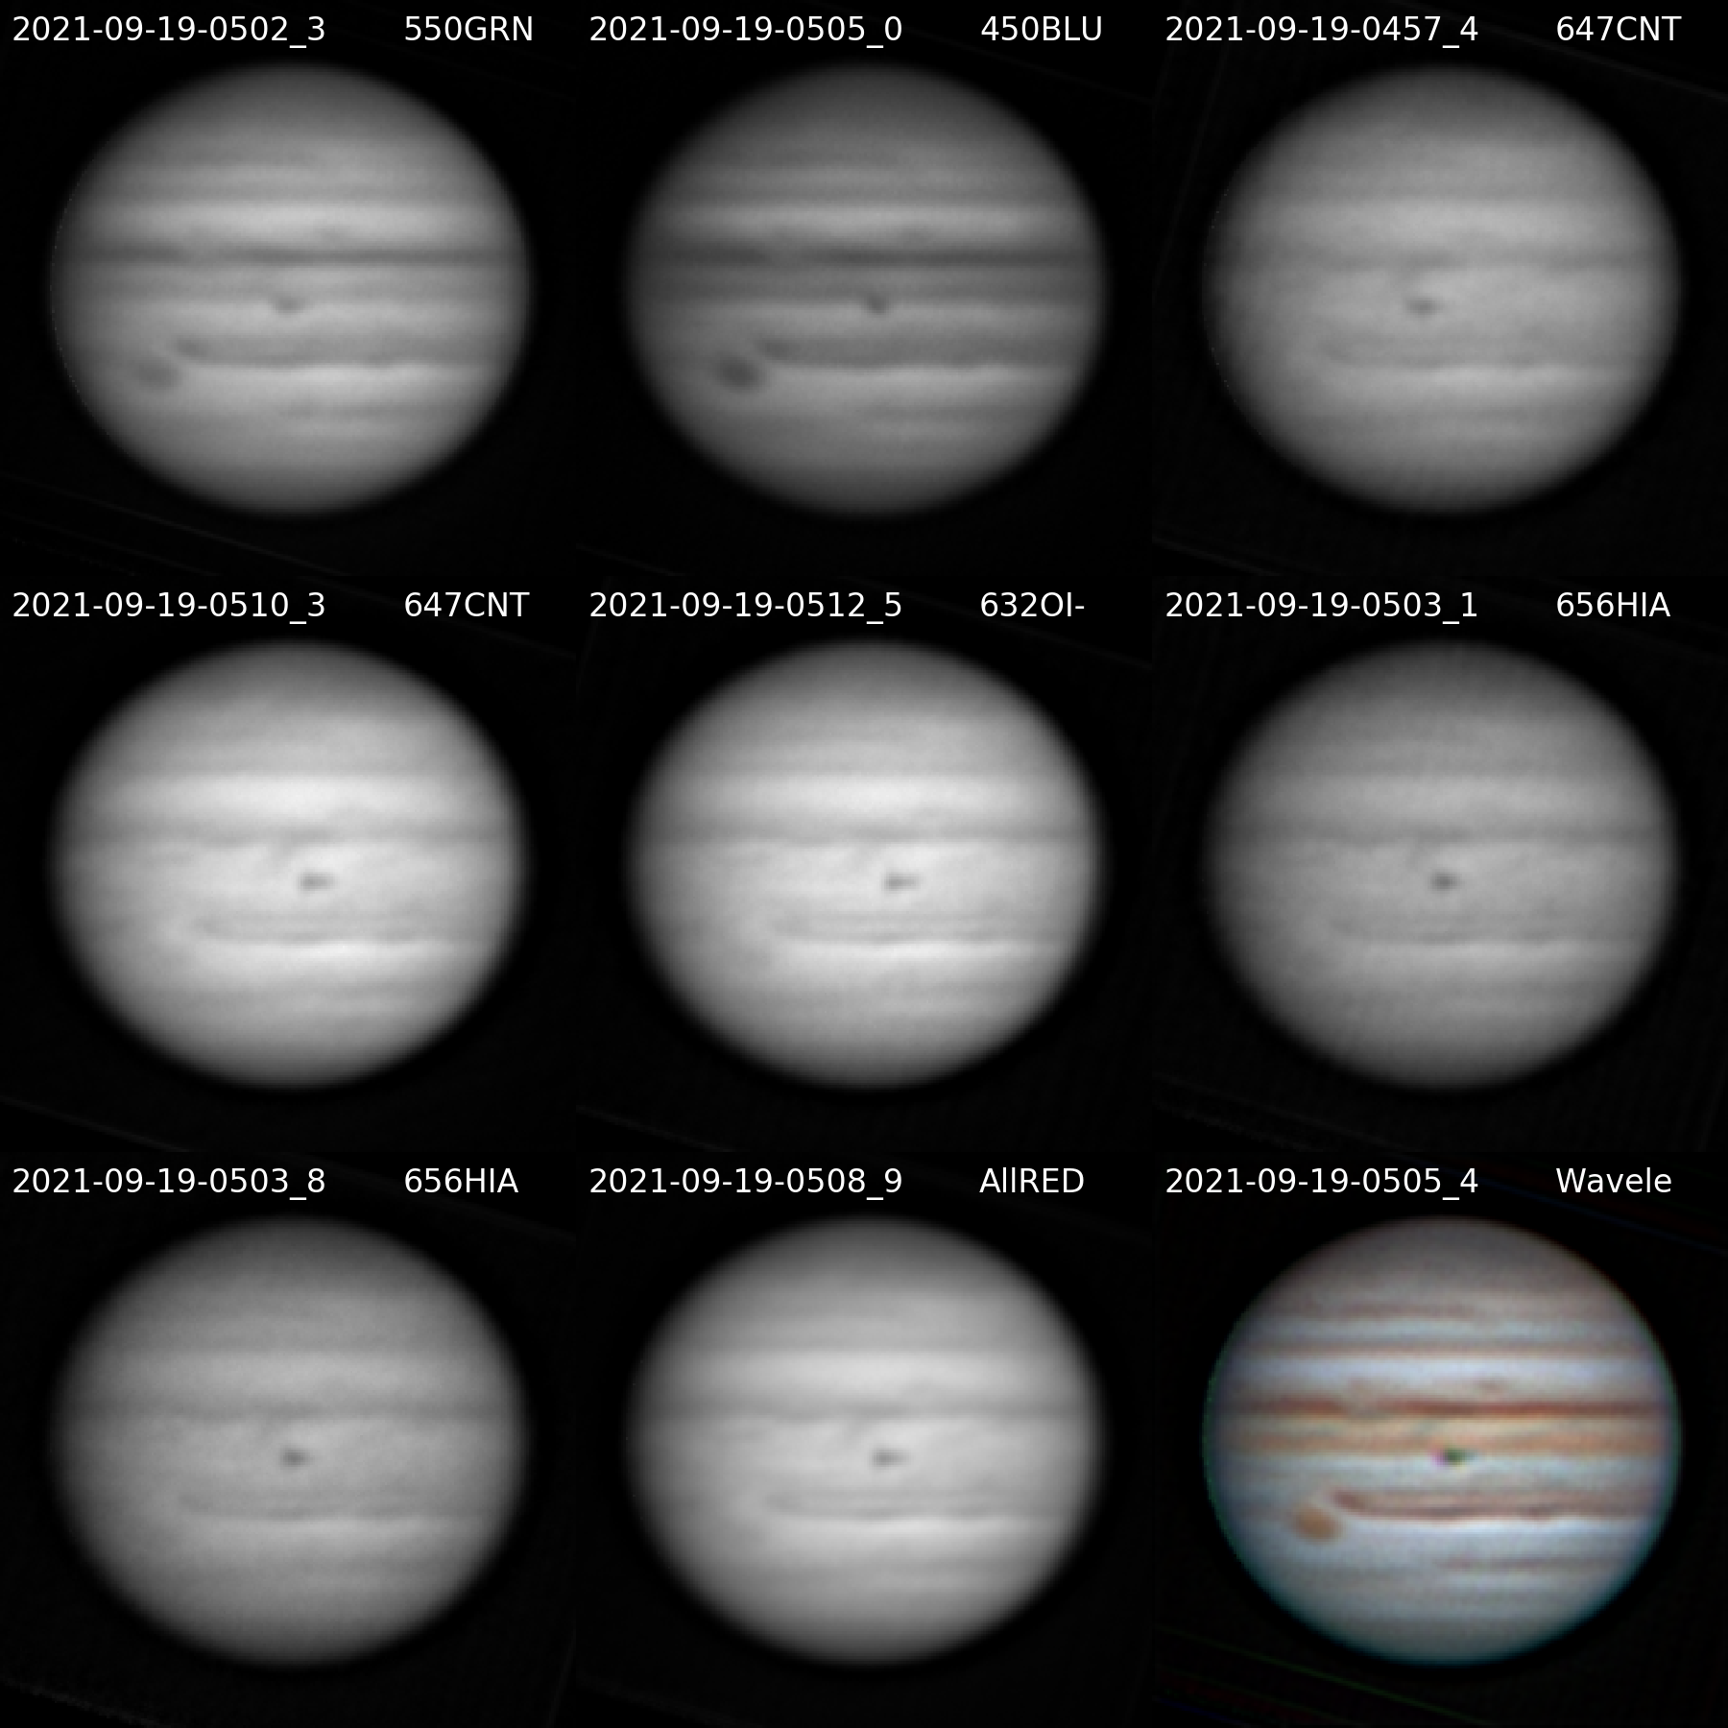

20210919UTJupiter-NavigatedArray.png

**Navigated Image Products**

2021-09-19-0502_3-Jupiter_550GRN-Wavelets-Derot-Stack.png

2021-09-19-0505_0-Jupiter_450BLU-Wavelets-Derot-Stack.png

2021-09-19-0457_4-Jupiter_647CNT-Wavelets-Derot-Stack.png

2021-09-19-0510_3-Jupiter_647CNT-Wavelets-Derot.png

2021-09-19-0512_5-Jupiter_632OI-Wavelets-Derot.png

2021-09-19-0503_1-Jupiter_656HIA-Wavelets-Derot-Stack.png

2021-09-19-0503_8-Jupiter_656HIA-Wavelets-Derot-Stack.png

2021-09-19-0508_9-Jupiter_AllRED-Wavelets-Derot-Stack.png

2021-09-19-0505_4-Jupiter-Wavelets-R(AllRed)GB-RGB-WhtBal-ClrSmth-Smth-Wavelets.png

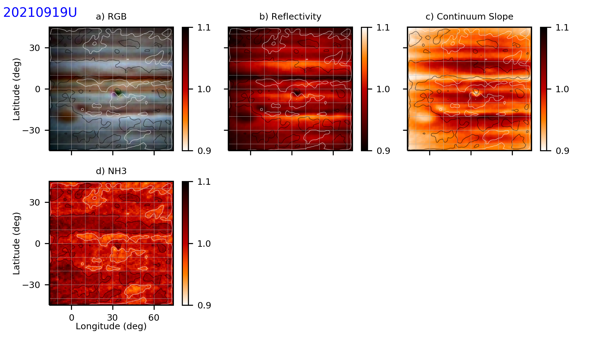

20210919UTwJupiter-NH3.png

**Data Disposition:**

* Raw data is zipped and archived on the 4TB drive.
* Processed data is in appropriate project directories on the Astronomy SD card.

### 2021-Sep-19 (Sep-20 UT): Jupiter and Saturn Video

Last Updated 9/20/2021

Transparency was good (3.5/5), with just a couple tiny cumulus. Seeing was fair to poor (2.5-3.0/5).

|  |  |  |  |  |  |
| --- | --- | --- | --- | --- | --- |
| **Video File** | **Exposure** | **Gain** | **Gamma** | **Binning** | **Capture Area** |
| 2021-09-20-0356_4-Jupiter_632OI.avi | 0.05 | 60 | 50 | 2 | 640x480 |
| 2021-09-20-0358_5-Jupiter_632OI.avi | 0.05 | 60 | 50 | 2 | 640x480 |
| 2021-09-20-0401_1-Jupiter_647CNT.avi | 0.05 | 60 | 50 | 2 | 640x480 |
| 2021-09-20-0403_3-Jupiter_647CNT.avi | 0.05 | 60 | 50 | 2 | 640x480 |
| 2021-09-20-0405_3-Jupiter_647CNT.avi | 0.05 | 60 | 50 | 2 | 640x480 |
| 2021-09-20-0407_6-Jupiter_656HIA.avi | 0.05 | 60 | 50 | 2 | 640x480 |
| 2021-09-20-0409_8-Jupiter_656HIA.avi | 0.05 | 60 | 50 | 2 | 640x480 |
| 2021-09-20-0411_8-Jupiter_656HIA.avi | 0.05 | 60 | 50 | 2 | 640x480 |
| 2021-09-20-0414_1-Jupiter_550GRN.avi | 0.005 | 60 | 50 | 2 | 640x480 |
| 2021-09-20-0415_4-Jupiter_550GRN.avi | 0.005 | 60 | 50 | 2 | 640x480 |
| 2021-09-20-0416_9-Jupiter_450BLU.avi | 0.01 | 60 | 50 | 2 | 640x480 |
| 2021-09-20-0418_1-Jupiter_450BLU.avi | 0.01 | 60 | 50 | 2 | 640x480 |
| 2021-09-20-0420_3-Jupiter_380NUV.avi | 0.25 | 100 | 50 | 2 | 640x480 |
| 2021-09-20-0422_1-Jupiter_380NUV.avi | 0.25 | 100 | 50 | 2 | 640x480 |
| 2021-09-20-0425_4-Jupiter_380NUV.avi | 0.25 | 100 | 50 | 2 | 640x480 |
| 2021-09-20-0428_4-Jupiter_889CH4.avi | 1 | 100 | 50 | 2 | 1280x960 |
| 2021-09-20-0430_4-Jupiter_889CH4.avi | 1 | 100 | 50 | 2 | 1280x960 |
| 2021-09-20-0432_5-Jupiter_889CH4.avi | 1 | 100 | 50 | 2 | 1280x960 |
| 2021-09-20-0434_6-Jupiter_889CH4.avi | 1 | 100 | 50 | 2 | 1280x960 |
| 2021-09-20-0436_7-Jupiter_889CH4_Dark.avi | 1 | 100 | 50 | 2 | 1280x960 |
| 2021-09-20-0437_7-Jupiter_380NUV_Dark.avi | 0.25 | 100 | 50 | 2 | 640x480 |

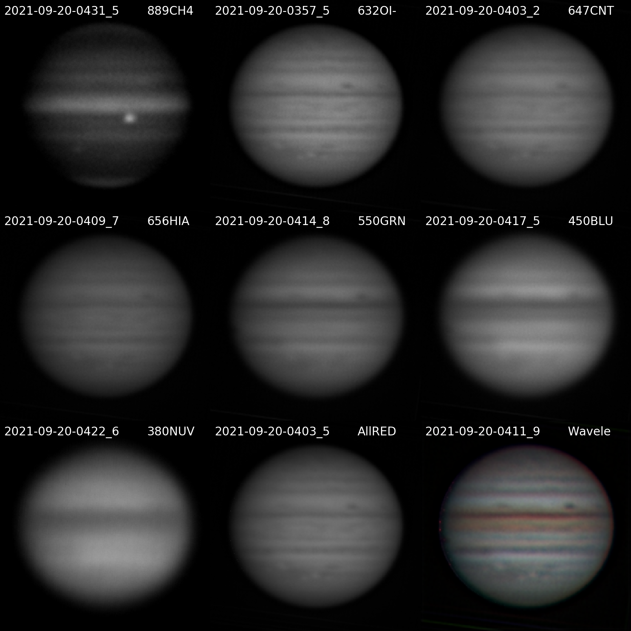

20210920UTJupiter-NavigatedArray.png

**Navigated Image Products**

2021-09-20-0431_5-Jupiter_889CH4-Wavelets-Derot-Stack.png

2021-09-20-0357_5-Jupiter_632OI-Wavelets-Derot-Stack.png

2021-09-20-0403_2-Jupiter_647CNT-Wavelets-Derot-Stack.png

2021-09-20-0409_7-Jupiter_656HIA-Wavelets-Derot-Stack.png

2021-09-20-0414_8-Jupiter_550GRN-Wavelets-Derot-Stack.png

2021-09-20-0417_5-Jupiter_450BLU-Wavelets-Derot-Stack.png

2021-09-20-0422_6-Jupiter_380NUV-Wavelets-Derot-Stack.png

2021-09-20-0403_5-Jupiter_AllRED-Wavelets-Derot-Stack.png

2021-09-20-0411_9-Jupiter-Wavelets-R(AllRED)GB-RGB-WhtBal-ClrSmth-Smth-Wavelets.png

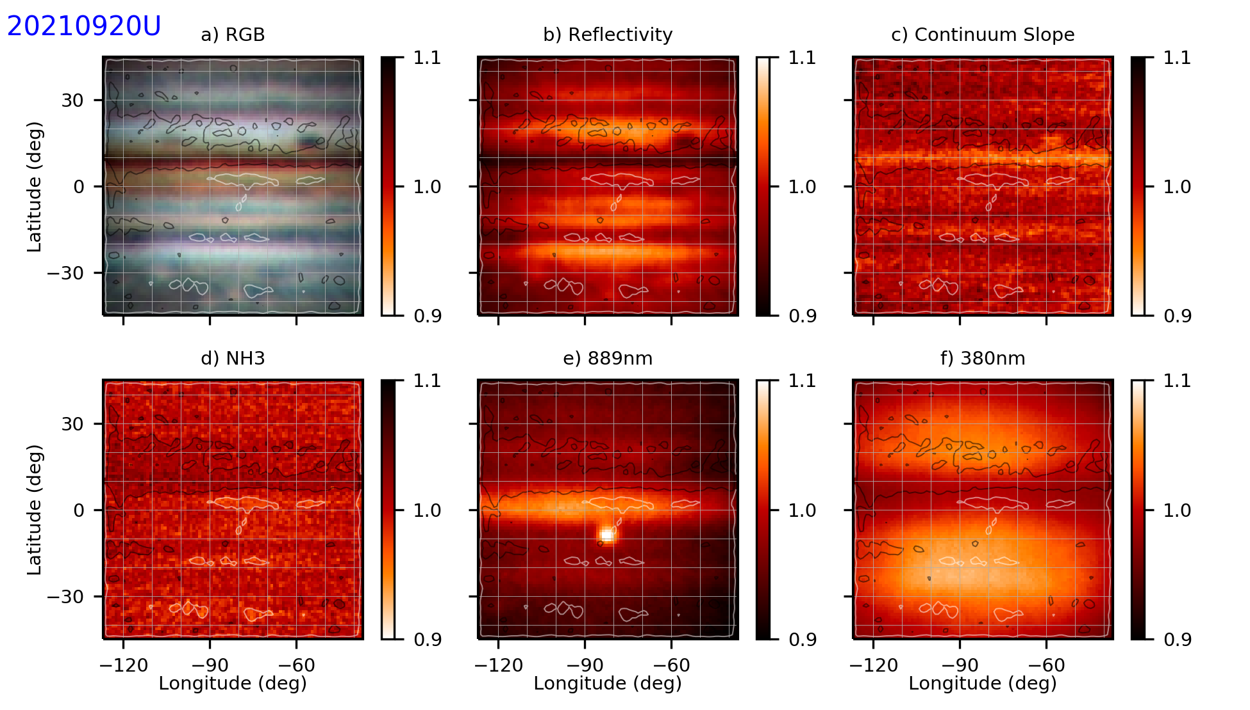

20210920UTwJupiter-NH3.png

|  |  |  |  |  |  |
| --- | --- | --- | --- | --- | --- |
| **Video File** | **Exposure** | **Gain** | **Gamma** | **Binning** | **Capture Area** |
| 2021-09-20-0340_1-Saturn_550GRN.avi | 0.02 | 60 | 50 | 2 | 640x480 |
| 2021-09-20-0341_3-Saturn_550GRN.avi | 0.02 | 60 | 50 | 2 | 640x480 |
| 2021-09-20-0343_3-Saturn_450BLU.avi | 0.05 | 60 | 50 | 2 | 640x480 |
| 2021-09-20-0345_4-Saturn_450BLU.avi | 0.05 | 60 | 50 | 2 | 640x480 |
| 2021-09-20-0348_2-Saturn_632OI.avi | 0.1 | 60 | 50 | 2 | 640x480 |
| 2021-09-20-0350_3-Saturn_632OI.avi | 0.1 | 60 | 50 | 2 | 640x480 |

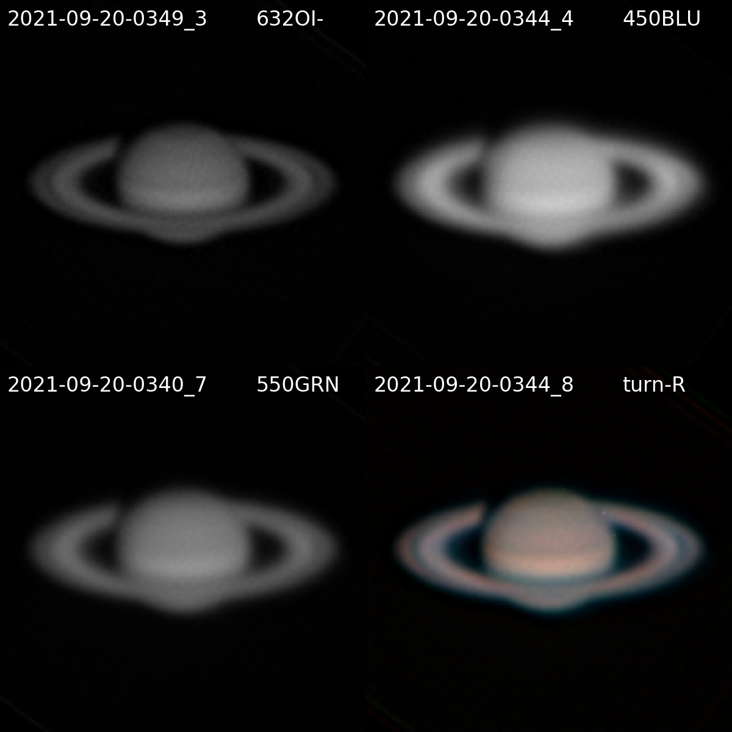

20210920UTSaturn-NavigatedArray.png

**Navigated Image Products**

2021-09-20-0349_3-Saturn_632OI-FlatStack600-Str0to128-Wavelets2x20-Derot.png

2021-09-20-0344_4-Saturn_450BLU-FlatStack1200-Str0to128-Wavelets2x20-Derot.png

2021-09-20-0340_7-Saturn_550GRN-FlatStack1500-Str0to128-Wavelets2x20-Derot.png

2021-09-20-0344_8-Hill-Saturn-R(632)GB-RGB-WhtBal-ClrSmth-Smth-Wavelets.png

**Data Disposition:**

* Raw data is zipped and archived on the 4TB drive.
* Processed data is in appropriate project directories on the Astronomy SD card.

### 2021-Sep-22 (Sep-23 UT): Jupiter Video

Last Updated 9/23/2021

Transparency was very good (4.0/5). Seeing was good (3.0/5).

|  |  |  |  |  |  |
| --- | --- | --- | --- | --- | --- |
| **Video File** | **Exposure** | **Gain** | **Gamma** | **Binning** | **Capture Area** |
| 2021-09-23-0428_8-Jupiter_632OI.avi | 0.05 | 60 | 50 | 2 | 640x480 |
| 2021-09-23-0431_1-Jupiter_632OI.avi | 0.05 | 60 | 50 | 2 | 640x480 |
| 2021-09-23-0433_4-Jupiter_647CNT.avi | 0.05 | 60 | 50 | 2 | 640x480 |
| 2021-09-23-0435_5-Jupiter_647CNT.avi | 0.05 | 60 | 50 | 2 | 640x480 |
| 2021-09-23-0438_0-Jupiter_656HIA.avi | 0.05 | 60 | 50 | 2 | 640x480 |
| 2021-09-23-0440_1-Jupiter_656HIA.avi | 0.05 | 60 | 50 | 2 | 640x480 |
| 2021-09-23-0444_5-Jupiter_550GRN.avi | 0.005 | 60 | 50 | 2 | 640x480 |
| 2021-09-23-0445_6-Jupiter_550GRN.avi | 0.005 | 60 | 50 | 2 | 640x480 |
| 2021-09-23-0447_2-Jupiter_450BLU.avi | 0.01 | 60 | 50 | 2 | 640x480 |
| 2021-09-23-0448_3-Jupiter_450BLU.avi | 0.01 | 60 | 50 | 2 | 640x480 |
| 2021-09-23-0449_5-Jupiter_450BLU.avi | 0.01 | 60 | 50 | 2 | 640x480 |
| 2021-09-23-0452_6-Jupiter_380NUV.avi | 0.25 | 100 | 50 | 2 | 640x480 |
| 2021-09-23-0454_7-Jupiter_380NUV.avi | 0.25 | 100 | 50 | 2 | 640x480 |
| 2021-09-23-0459_5-Jupiter_889CH4.avi | 0.5 | 100 | 50 | 2 | 1280x960 |
| 2021-09-23-0502_1-Jupiter_889CH4.avi | 0.5 | 100 | 50 | 2 | 1280x960 |
| 2021-09-23-0504_2-Jupiter_889CH4.avi | 0.5 | 100 | 50 | 2 | 1280x960 |
| 2021-09-23-0506_3-Jupiter_889CH4.avi | 0.5 | 100 | 50 | 2 | 1280x960 |
| 2021-09-23-0508_4-Jupiter_889CH4.avi | 0.5 | 100 | 50 | 2 | 1280x960 |
| 2021-09-23-0510_6-Jupiter_889CH4_Dark.avi | 0.5 | 100 | 50 | 2 | 1280x960 |
| 2021-09-23-0511_8-Jupiter_380NUV_Dark.avi | 0.25 | 100 | 50 | 2 | 640x480 |

**Navigated Image Products**

2021-09-23-0429_9-Jupiter_632OI-Wavelets-Derot-Stack.png

2021-09-23-0434_4-Jupiter_647CNT-Wavelets-Derot-Stack.png

2021-09-23-0439_0-Jupiter_656HIA-Wavelets-Derot-Stack.png

2021-09-23-0445_0-Jupiter_550GRN-Wavelets-Derot-Stack.png

2021-09-23-0447_7-Jupiter_450BLU-Wavelets-Derot-Stack.png

2021-09-23-0453_6-Jupiter_380NUV-Wavelets-Derot-Stack.png

2021-09-23-0505_3-Jupiter_889CH4-Wavelets-Derot-Stack.png

2021-09-23-0434_5-Jupiter_ALLRed-Wavelets-Derot-Stack.png

2021-09-23-0442_4-Jupiter-Wavelets-RGB-RAllGB-WhtBal-ClrSmth-Smth-Wavelets.png

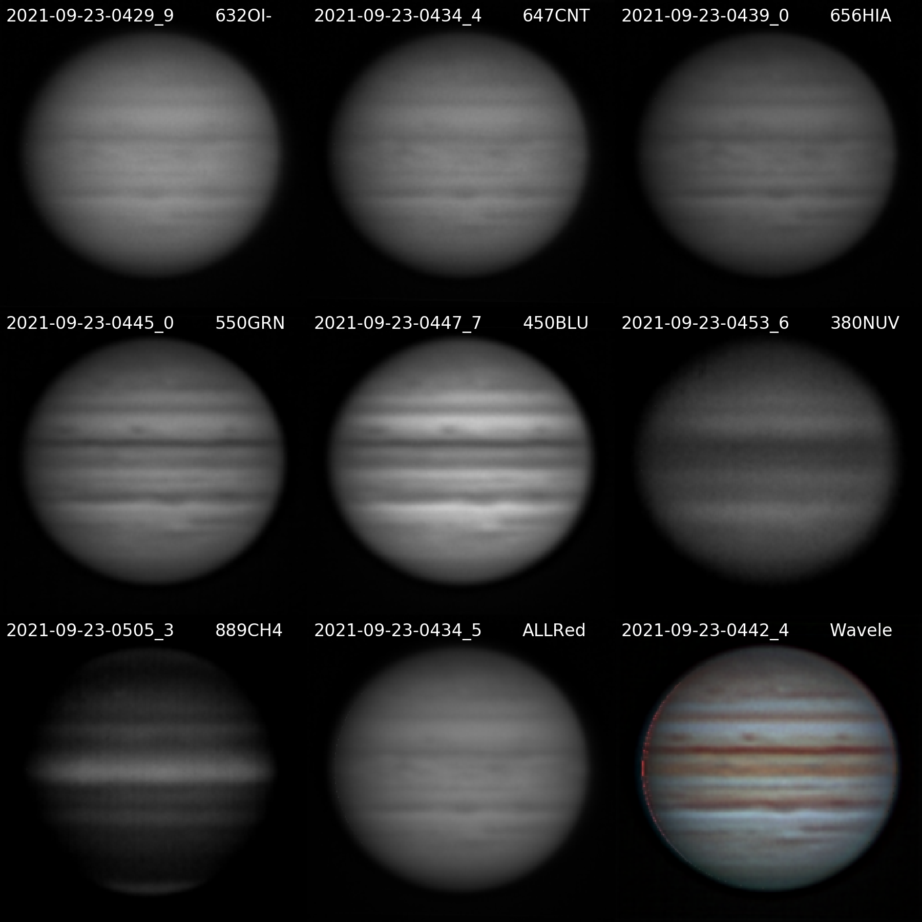

20210923UTJupiter-NavigatedArray.png

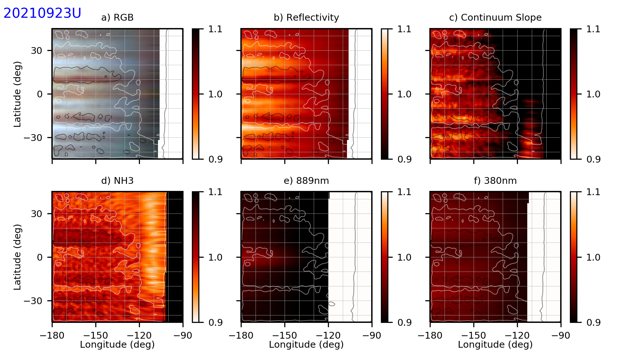

20210923UTaJupiter-NH3.png

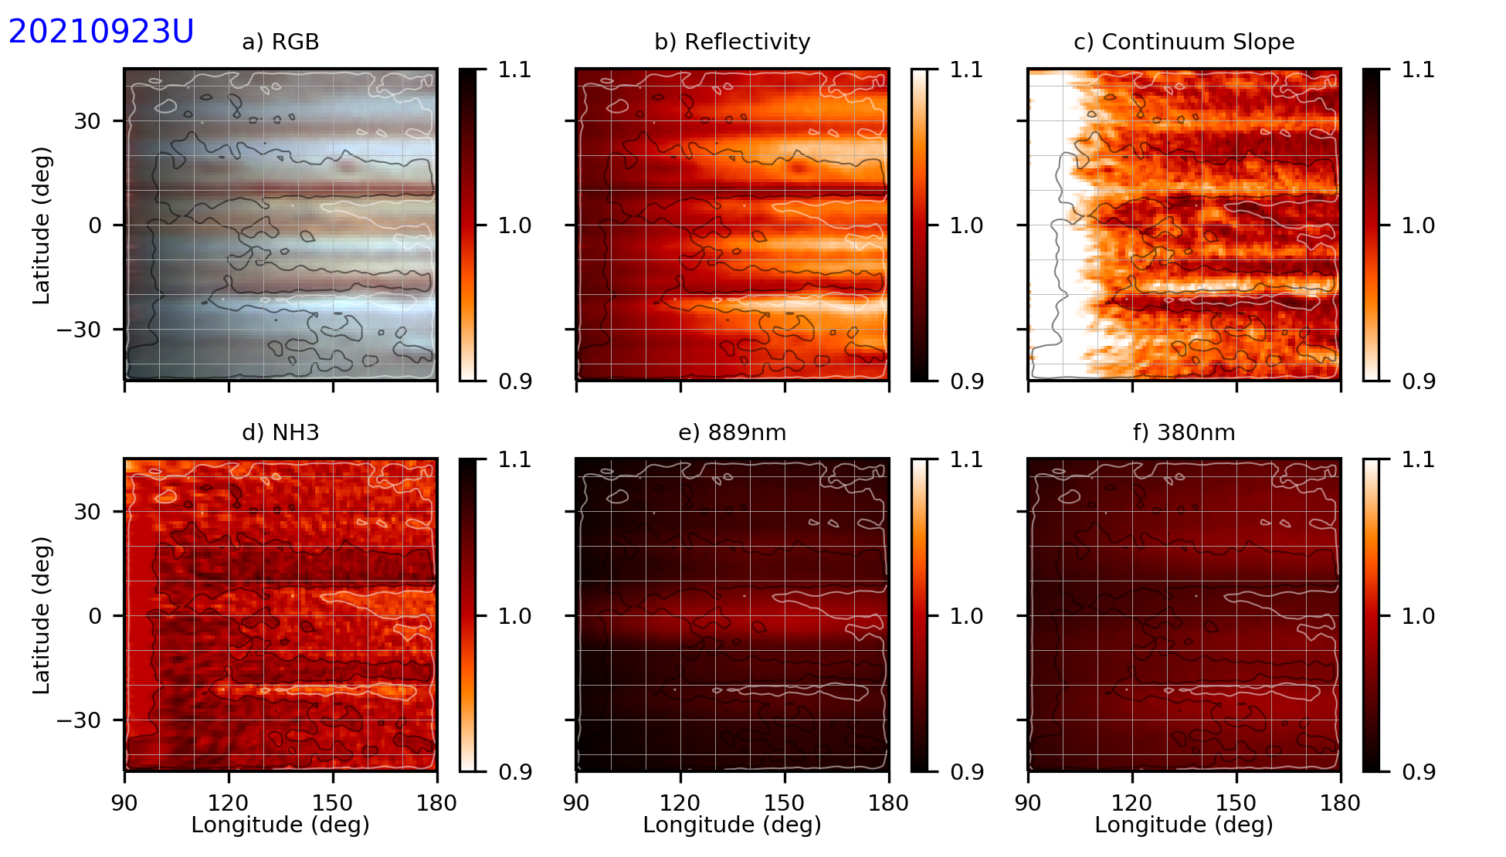

20210923UTbJupiter-NH3.png

### 2021-Sep-25 (Sep-26 UT): Jupiter and Neptune Video and NGC7009 spectra

Last Updated 9/27/2021

Transparency was very good (4.0/5). Seeing was good (3.0/5). (Is this true? It’s identical text to the 9/23 entry.) I’m not sure why I didn’t take CH4 data!

|  |  |  |  |  |  |
| --- | --- | --- | --- | --- | --- |
| **Video File** | **Exposure** | **Gain** | **Gamma** | **Binning** | **Capture Area** |
| 2021-09-26-0427_1-Jupiter_632OI.avi | 0.05 | 60 | 50 | 2 | 640x480 |
| 2021-09-26-0429_3-Jupiter_632OI.avi | 0.05 | 60 | 50 | 2 | 640x480 |
| 2021-09-26-0431_7-Jupiter_647CNT.avi | 0.05 | 60 | 50 | 2 | 640x480 |
| 2021-09-26-0433_8-Jupiter_647CNT.avi | 0.05 | 60 | 50 | 2 | 640x480 |
| 2021-09-26-0436_3-Jupiter_656HIA.avi | 0.05 | 60 | 50 | 2 | 640x480 |
| 2021-09-26-0438_5-Jupiter_656HIA.avi | 0.05 | 60 | 50 | 2 | 640x480 |
| 2021-09-26-0440_6-Jupiter_656HIA.avi | 0.05 | 60 | 50 | 2 | 640x480 |
| 2021-09-26-0444_3-Jupiter_550GRN.avi | 0.005 | 60 | 50 | 2 | 640x480 |
| 2021-09-26-0445_5-Jupiter_550GRN.avi | 0.005 | 60 | 50 | 2 | 640x480 |
| 2021-09-26-0447_0-Jupiter_450BLU.avi | 0.01 | 60 | 50 | 2 | 640x480 |
| 2021-09-26-0448_4-Jupiter_450BLU.avi | 0.01 | 60 | 50 | 2 | 640x480 |
| 2021-09-26-0452_4-Jupiter_380NUV.avi | 0.25 | 100 | 50 | 2 | 640x480 |
| 2021-09-26-0454_5-Jupiter_380NUV.avi | 0.25 | 100 | 50 | 2 | 640x480 |
| 2021-09-26-0456_6-Jupiter_380NUV.avi | 0.25 | 100 | 50 | 2 | 640x480 |
| 2021-09-26-0458_8-Jupiter_380NUV.avi | 0.25 | 100 | 50 | 2 | 640x480 |
| 2021-09-26-0502_8-Jupiter_380NUV_Dark.avi | 0.25 | 100 | 50 | 2 | 640x480 |

**Navigated Image Products**

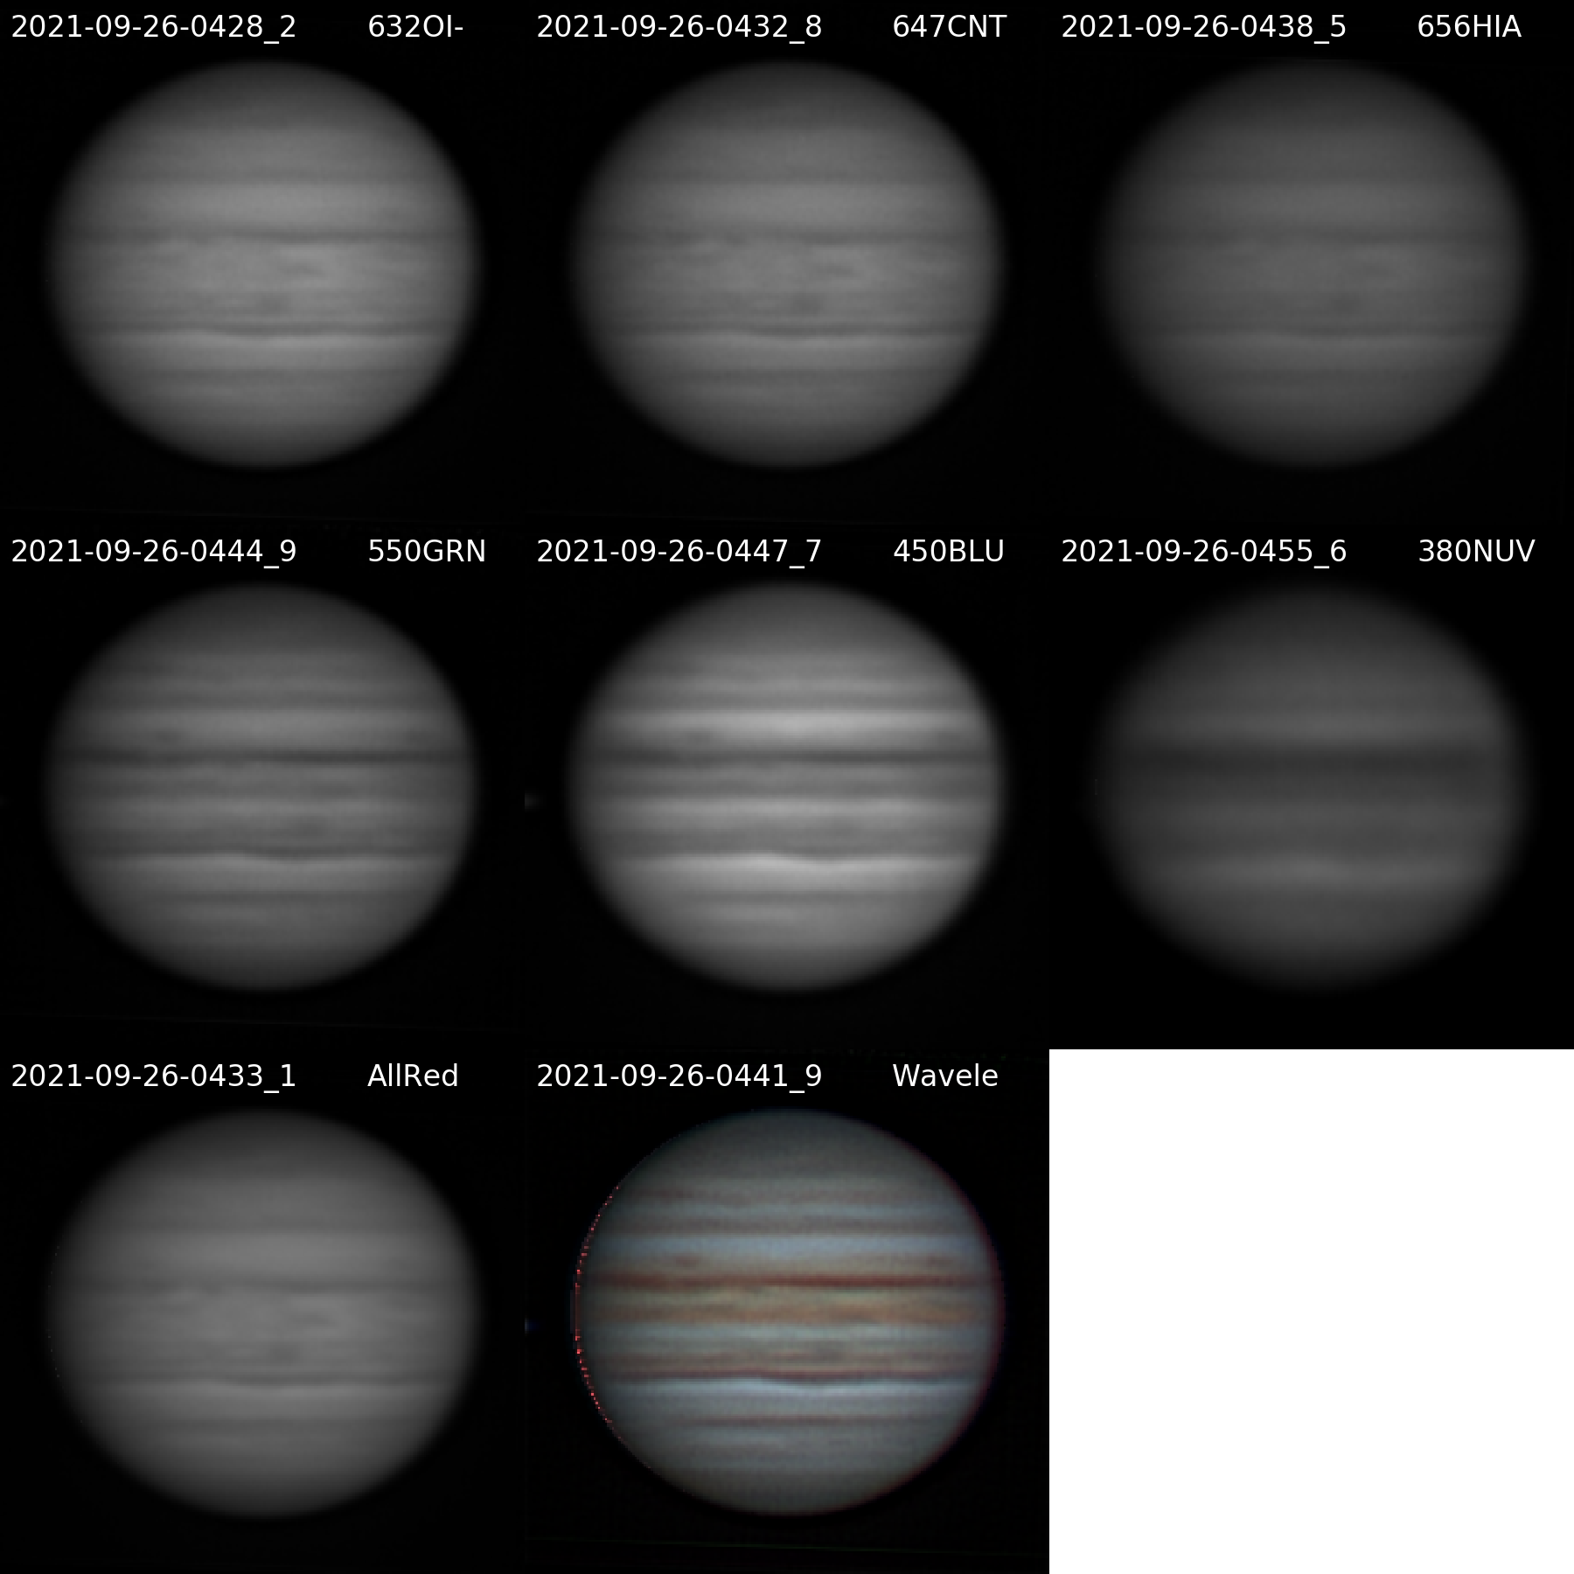

20210926UTJupiter-NavigatedArray.png

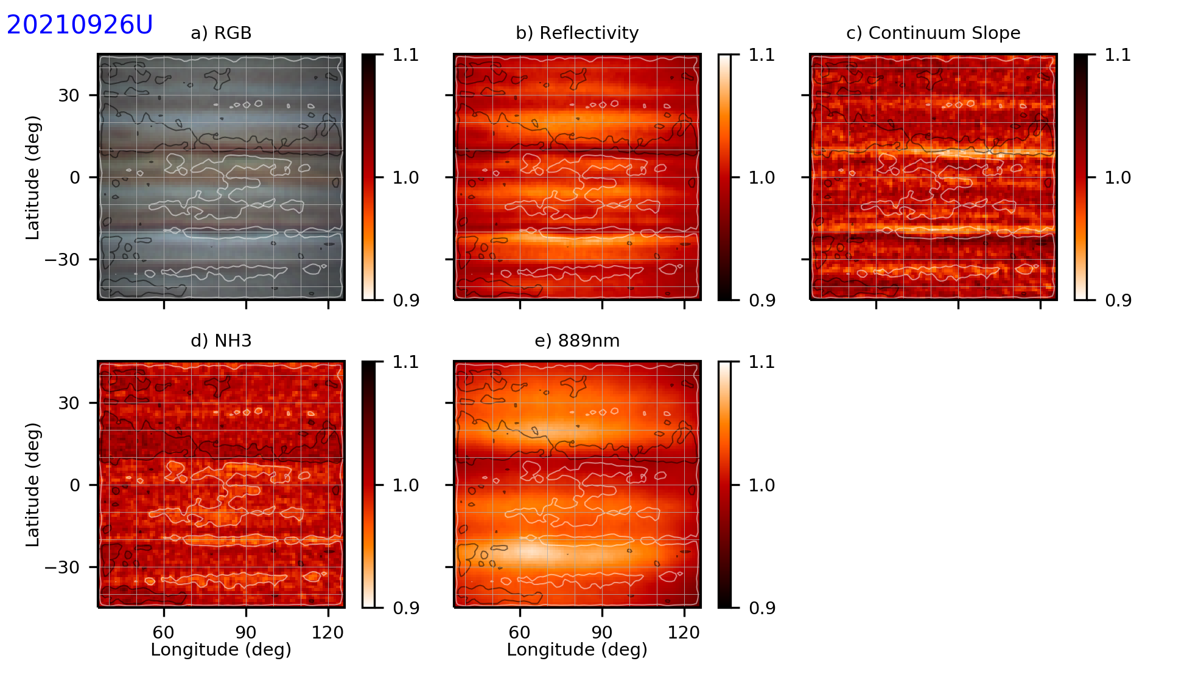

20210926UTwJupiter-NH3.png

**ANALYSIS:** It’s time to get the map longitude computations automated in Python. I’ve made mistakes with shifts in the longitude window because of misunderstanding positives and negatives.

|  |  |  |  |  |  |
| --- | --- | --- | --- | --- | --- |
| **Video File** | **Exposure** | **Gain** | **Gamma** | **Binning** | **Capture Area** |
| 2021-09-26-0515_4-Neptune_550GRN.avi | 0.5 | 100 | 50 | 1 | 640x480 |
| 2021-09-26-0520_6-Neptune_550GRN.avi | 0.5 | 100 | 50 | 1 | 640x480 |
| 2021-09-26-0529_9-Neptune_550GRN.avi | 5 | 100 | 100 | 1 | 640x480 |

### 2021-Sep-26 (Sep-27 UT): Jupiter Video

Last Updated 9/27/2021

Transparency was poor to fair (2-3/5) with some high small cumulous and possible cirrus. Seeing was good (3.0/5).

|  |  |  |  |  |  |
| --- | --- | --- | --- | --- | --- |
| **Video File** | **Exposure** | **Gain** | **Gamma** | **Binning** | **Capture Area** |
| 2021-09-27-0306_6-Jupiter_632OI.avi | 0.05 | 60 | 50 | 2 | 640x480 |
| 2021-09-27-0308_7-Jupiter_632OI.avi | 0.05 | 60 | 50 | 2 | 640x480 |
| 2021-09-27-0311_0-Jupiter_647CNT.avi | 0.05 | 60 | 50 | 2 | 640x480 |
| 2021-09-27-0313_2-Jupiter_647CNT.avi | 0.05 | 60 | 50 | 2 | 640x480 |
| 2021-09-27-0315_5-Jupiter_656HIA.avi | 0.05 | 60 | 50 | 2 | 640x480 |
| 2021-09-27-0317_6-Jupiter_656HIA.avi | 0.05 | 60 | 50 | 2 | 640x480 |
| 2021-09-27-0321_8-Jupiter_550GRN.avi | 0.005 | 60 | 50 | 2 | 640x480 |
| 2021-09-27-0322_9-Jupiter_550GRN.avi | 0.005 | 60 | 50 | 2 | 640x480 |
| 2021-09-27-0324_5-Jupiter_450BLU.avi | 0.01 | 60 | 50 | 2 | 640x480 |
| 2021-09-27-0325_6-Jupiter_450BLU.avi | 0.01 | 60 | 50 | 2 | 640x480 |
| 2021-09-27-0327_9-Jupiter_380NUV.avi | 0.25 | 100 | 50 | 2 | 640x480 |
| 2021-09-27-0330_1-Jupiter_380NUV.avi | 0.25 | 100 | 50 | 2 | 640x480 |
| 2021-09-27-0333_5-Jupiter_889CH4.avi | 1 | 100 | 50 | 2 | 1280x960 |
| 2021-09-27-0335_7-Jupiter_889CH4.avi | 1 | 100 | 50 | 2 | 1280x960 |
| 2021-09-27-0337_9-Jupiter_889CH4.avi | 1 | 100 | 50 | 2 | 1280x960 |
| 2021-09-27-0340_1-Jupiter_889CH4.avi | 1 | 100 | 50 | 2 | 1280x960 |
| 2021-09-27-0342_1-Jupiter_889CH4_Dark.avi | 1 | 100 | 50 | 2 | 1280x960 |
| 2021-09-27-0343_3-Jupiter_380NUV_Dark.avi | 0.25 | 100 | 50 | 2 | 640x480 |

**Navigated Image Products**

2021-09-27-0336_8-Jupiter_889CH4-WV-DR-ST.png

2021-09-27-0307_6-Jupiter_632OI-WV-DR-ST.png

2021-09-27-0312_1-Jupiter_647CNT-WV-DR-ST.png

2021-09-27-0316_5-Jupiter_656HIA-WV-DR-ST.png

2021-09-27-0322_4-Jupiter_550GRN-WV-DR-ST.png

2021-09-27-0325_1-Jupiter_450BLU-WV-DR-ST.png

2021-09-27-0329_0-Jupiter_380NUV-WV-DR-ST.png

2021-09-27-0312_1-Jupiter_ALLRED-WV-DR-ST.png

2021-09-27-0319_8-Jupiter-Wavelets-R(ALL)GB-WV-RGB-WhtBal-ClrSmth-Smth-Wavelets.png

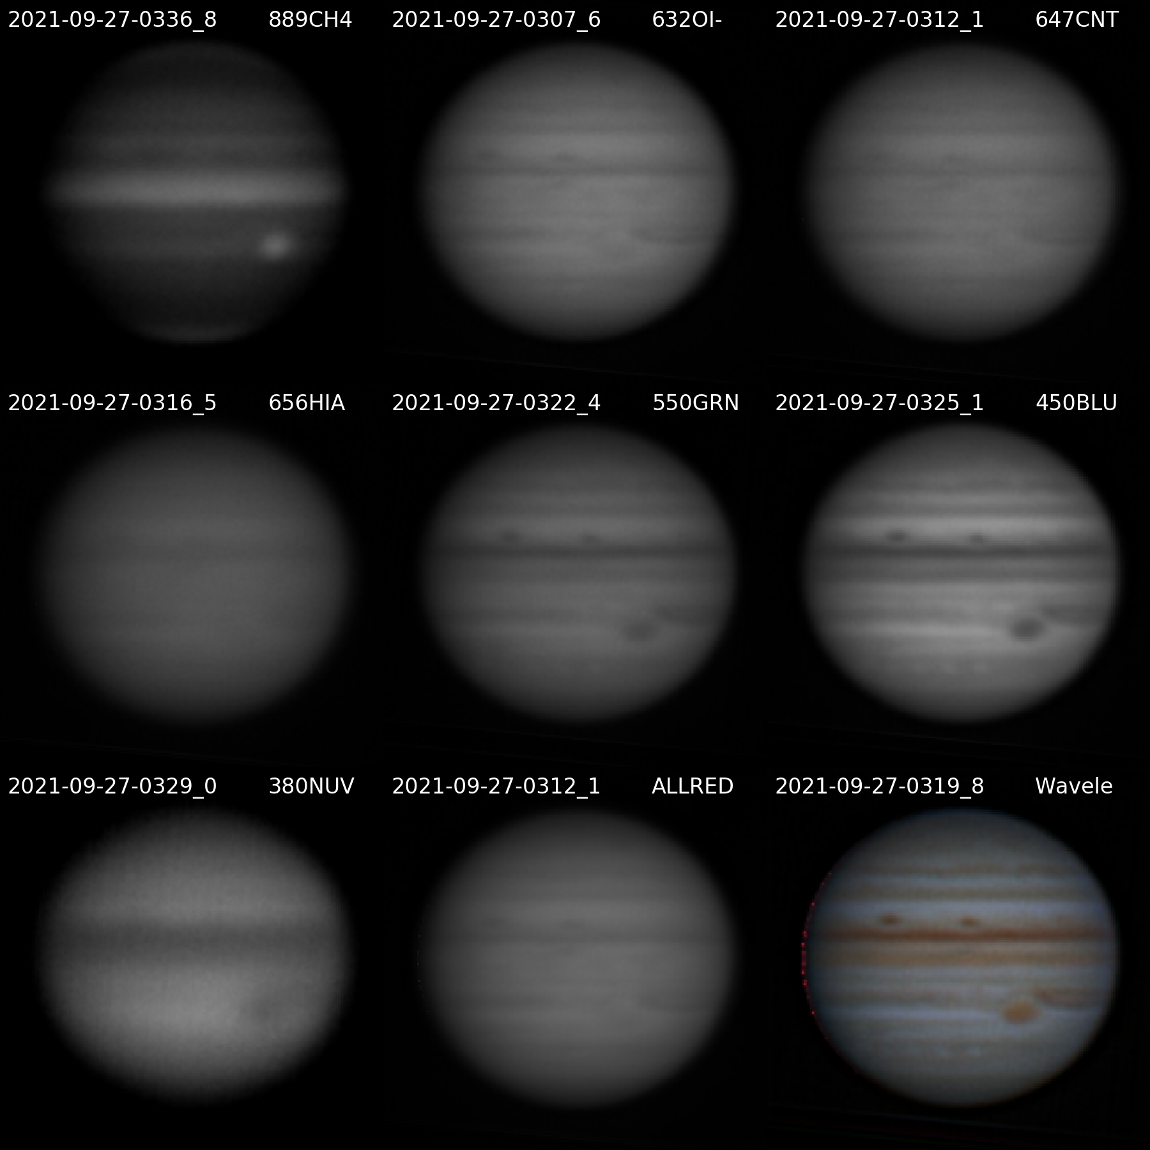

20210927UTJupiter-NavigatedArray.png

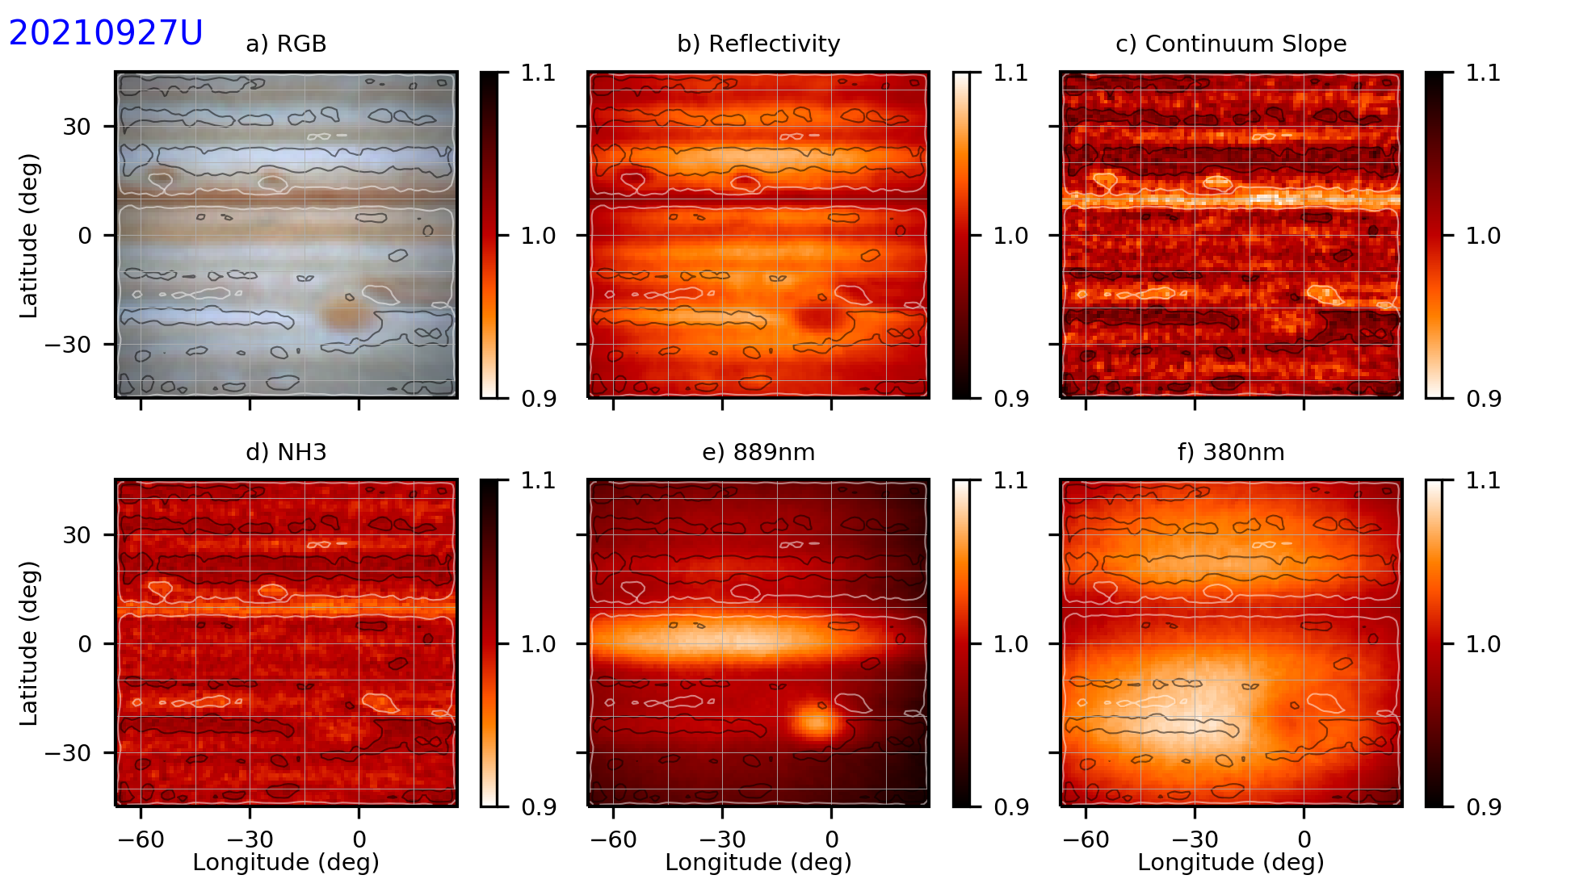

20210927UTwJupiter-NH3.png

**ANALYSIS:** It’s quite disturbing how closely the NH3 absorption follows the color slope in this observation. Looking at the image array above, it may be that the 656HIA image used in both the color slope and the absorption may have lower resolution than the 632OI and 647CNT images. So, there may be an effect due to differential sharpness.

## October

### 2021-Oct-03 (Oct-04 UT): PNe Imaging (M57, M27, NGC6826)

Last Updated 10/05/2021

Transparency was excellent (4.5/5). Seeing was good (3.5/5).

|  |  |  |  |  |  |  |  |  |  |  |
| --- | --- | --- | --- | --- | --- | --- | --- | --- | --- | --- |
| **Target** | **DateUT** | **Optics** | **Camera** | **Aperture** | **FL** | **Binning** | **Scale** | **Filter** | **Grating** | **Exposure** |
| M57 | 2021-10-04 | C11_Prime | ST2000XM | 0.280 | 2.800 | 2 | 1.090 | 501OIII | None | 300 |
| M57 | 2021-10-04 | C11_Prime | ST2000XM | 0.280 | 2.800 | 2 | 1.090 | 730OII | None | 270 |
| M57 | 2021-10-04 | C11_Prime | ST2000XM | 0.280 | 2.800 | 2 | 1.090 | 632OI | None | 280 |
| M27 | 2021-10-04 | C11_Prime | ST2000XM | 0.280 | 2.800 | 2 | 1.090 | 501OIII | None | 240 |
| M27 | 2021-10-04 | C11_Prime | ST2000XM | 0.280 | 2.800 | 2 | 1.090 | 730OII | None | 200 |
| M27 | 2021-10-04 | C11_Prime | ST2000XM | 0.280 | 2.800 | 2 | 1.090 | 632OI | None | 240 |
| NGC6826 | 2021-10-04 | C11_Prime | ST2000XM | 0.280 | 2.800 | 2 | 1.090 | 501OIII | None | 300 |
| NGC6826 | 2021-10-04 | C11_Prime | ST2000XM | 0.280 | 2.800 | 2 | 1.090 | 730OII | None | 240 |
| NGC6826 | 2021-10-04 | C11_Prime | ST2000XM | 0.280 | 2.800 | 2 | 1.090 | 632OI | None | 250 |

|  |  |  |
| --- | --- | --- |
|  |  |  |
| M57-20211004UT-501OIII-sum300s-RotCrop.jpg | M57-20211004UT-632OI-sum280s-RotCrop.jpg | M57-20211004UT-730OII-sum270s-RotCrop.jpg |
|  |  |  |
| M27-20211004UT-501OIII-sum240s-RotCrop.jpg | M27-20211004UT-632OI-sum240s-FlattenedRotCrop.jpg | M27-20211004UT-730OII-sum200s-FlattenedRotCrop.jpg |
|  |  |  |
| NGC6826-20211004UT-501OIII-sum300s-RotCrop.jpg | NGC6826-20211004UT-632OI-sum250s-RotCrop.jpg | NGC6826-20211004UT-730OII-sum240s-RotCrop.jpg |

**Data Disposition:**

* Raw data is zipped and archived on the 4TB drive.
* Processed data is in appropriate project directories on the Astronomy SD card.

### 2021-Oct-04 (Oct-05 UT): PNe Imaging (NGC6543, M27, NGC7009)

Last Updated 10/05/2021

Transparency was excellent (4.5/5). Seeing was good (3.5/5).

|  |  |  |  |  |  |  |  |  |  |  |
| --- | --- | --- | --- | --- | --- | --- | --- | --- | --- | --- |
| **Target** | **DateUT** | **Optics** | **Camera** | **Aperture** | **FL** | **Binning** | **Scale** | **Filter** | **Grating** | **Exposure** |
| NGC6543 | 2021-10-05 | C11_Prime | ST2000XM | 0.280 | 2.800 | 2 | 1.090 | 632OI | None | 540 |
| NGC6543 | 2021-10-05 | C11_Prime | ST2000XM | 0.280 | 2.800 | 2 | 1.090 | 730OII | None | 790 |
| NGC6543 | 2021-10-05 | C11_Prime | ST2000XM | 0.280 | 2.800 | 2 | 1.090 | 501OIII | None | 270 |
| M27 | 2021-10-05 | C11_Prime | ST2000XM | 0.280 | 2.800 | 2 | 1.090 | 632OI | None | 810 |
| NGC7009 | 2021-10-05 | C11_Prime | ST2000XM | 0.280 | 2.800 | 2 | 1.090 | 632OI | None | 530 |
| NGC7009 | 2021-10-05 | C11_Prime | ST2000XM | 0.280 | 2.800 | 2 | 1.090 | 730OI | None | 880 |

|  |  |  |
| --- | --- | --- |
|  |  |  |
| NGC6543-20211005UT-501OIII-sum270s-RotCrop.jpg | NGC6543-20211005UT-632OI-sum540s-RotCrop.jpg | NGC6543-20211005UT-730OII-sum790s-RotCrop.jpg |
|  |  |  |
| M27-20211005UT-632OI-sum810s-RotCrop.jpg | NGC7009-20211005UT-632OI-sum530s-RotCrop.jpg | NGC7009-20211005UT-730OII-sum880s-RotCrop.jpg |

**Data Disposition:**

* Raw data is zipped and archived on the 4TB drive.
* Processed data is in appropriate project directories on the Astronomy SD card.

### 2021-Oct-05 (Oct-06 UT): PNe Imaging (NGC6543, M57, M27, NGC7009)

Last Updated 10/06/2021

Transparency was excellent (4.5/5). Seeing was fair (2.5/5).

|  |  |  |  |  |  |  |  |  |  |  |
| --- | --- | --- | --- | --- | --- | --- | --- | --- | --- | --- |
| **Target** | **DateUT** | **Optics** | **Camera** | **Aperture** | **FL** | **Binning** | **Scale** | **Filter** | **Grating** | **Exposure** |
| NGC6543 | 2021-10-06 | C11_Prime | ST2000XM | 0.280 | 2.800 | 2 | 1.090 | 540CON | None | 280 |
| NGC6543 | 2021-10-06 | C11_Prime | ST2000XM | 0.280 | 2.800 | 2 | 1.090 | 647CNT | None | 270 |
| M57 | 2021-10-06 | C11_Prime | ST2000XM | 0.280 | 2.800 | 2 | 1.090 | 632OI | None | 1100 |
| M57 | 2021-10-06 | C11_Prime | ST2000XM | 0.280 | 2.800 | 2 | 1.090 | 730OII | None | 1560 |
| M57 | 2021-10-06 | C11_Prime | ST2000XM | 0.280 | 2.800 | 2 | 1.090 | 540CON | None | 290 |
| M57 | 2021-10-06 | C11_Prime | ST2000XM | 0.280 | 2.800 | 2 | 1.090 | 647CNT | None | 280 |
| M27 | 2021-10-06 | C11_Prime | ST2000XM | 0.280 | 2.800 | 2 | 1.090 | 632OI | None | 1660 |
| NGC7009 | 2021-10-05 | C11_Prime | ST2000XM | 0.280 | 2.800 | 2 | 1.090 | 730OI | None | 880 |

|  |  |  |
| --- | --- | --- |
|  |  |  |
| NGC6543-20211006UT-647CNTsum270sec-Flattened-RotCrop.jpg | NGC6543-20211006UT-540CNTsum280sec-Flattened-RotCrop.jpg | M57-20211006UT-730OII-sum1560sec-Flattened-RotCrop.jpg |
|  |  |  |
| M57-20211006UT-647CNT-sum280sec-Flattened-RotCrop.jpg | M57-20211006UT-632OI-sum1100sec-Flattened-RotCrop.jpg | M57-20211006UT-540CNT-sum290sec-Flattened-RotCrop.jpg |
|  |  |  |
| M27-20211006UT-632OI-sum1660s-Flattened-RotCrop.jpg | NGC7009-20211006UT-632OI-sum1690sec-Flattened-RotCrop.jpg |  |

**Data Disposition:**

* Raw data is zipped and archived on the 4TB drive.
* Processed data is in appropriate project directories on the Astronomy SD card.

### 2021-Oct-09 (Oct-10 UT): PNe (M27) and Galaxy (NGC6946) Imaging

Last Updated 10/10/2021

Transparency was good (3.5/5) – a few tiny patches of thin cumulous. Seeing was fair (2.5/5).

|  |  |  |  |  |  |  |  |  |  |  |
| --- | --- | --- | --- | --- | --- | --- | --- | --- | --- | --- |
| **Target** | **DateUT** | **Optics** | **Camera** | **Aperture** | **FL** | **Binning** | **Scale** | **Filter** | **Grating** | **Exposure** |
| M27 | 2021-10-10 | C11_Prime | ST2000XM | 0.280 | 2.800 | 2 | 1.090 | 656HIA | None | 500 |
| M27 | 2021-10-10 | C11_Prime | ST2000XM | 0.280 | 2.800 | 2 | 1.090 | 672SII | None | 1280 |
| NGC6946 | 2021-10-10 | C11_Prime | ST2000XM | 0.280 | 2.800 | 2 | 1.090 | 550CLR | None | 1213 |
| NGC6946 | 2021-10-10 | C11_Prime | ST2000XM | 0.280 | 2.800 | 2 | 1.090 | 656HIA | None | 290 |

|  |  |
| --- | --- |
|  |  |
| M27-20211010UT-656HIA-sum500s-RotCrop.jpg | M27-20211010UT-672SII-sum1280s-RotCrop.jpg |
|  |  |
| NGC6946-20211010UT-550OPNX-sum1213sec-RotCrop.jpg | NGC6946-20211010UT-656HIA-sum290sec-RotCrop.jpg |

NOTES:

* First, I was unable to unscrew the problematic filter cell for the 630OI filter from the CFW8 filter wheel carousel. I ended up taking out the filter itself, and using it as an OPN filter (OPNX since it wasn’t truly an open slot – it still had the cell slightly reducing the aperture).
* A quick test of the 1000NIR imaging on M27 showed no signal for 10 seconds so I gave up for the time being
* I spent a lot of time trying to get guiding working for NGC6946. It worked fair at best for the 550OPNX filter. I adjusted just about every parameter you can in MaximDL and in the hand controller. Better guiding was accomplished with training at 0.5 x sidereal and actual guiding at 0.2-0.3 x sidereal. There was a lot of jumping around in the telescope DEC axis (image x-axis). I now believe that this was due to inability in the SBIG physical relay box to send accurate, short signals for guiding at this focal length. (This may also have been a problem with the Losmandy GM-8! Supporting evidence is the long running fact that commanding moves manually from MaximDL has been problematic, sometimes getting no move at all.) I need to try controlling the guiding from the ST-4 port *without* the relay box next time.

**Plans for 20211011UT follow-up:**

* M57 – 672SII (a bit, 300s?), 647CNT (300s), and1000NIR (1200s)
* M27 – 672SII (1200s) and 1000NIR (test, maybe 600s)
* NGC7009 – 672SII (600s) and 1000NIR (test, maybe 600s)
* NGC6826 – 672SII (600s) and 1000NIR (test, maybe 600s)
* Try guiding on NGC6946 again, but without the relay box. Try also with H-alpha, but better focused than last night.

**Data Disposition:**

* Raw data is zipped and archived on the 4TB drive.
* Processed data is in appropriate project directories on the Astronomy SD card.

### 2021-Oct-10 (Oct-11 UT): PNe (M57, NGC6543) and Galaxy (NGC6946) Imaging

Last Updated 10/10/2021

Transparency was poor (1.0/5) initially with lots of scattered small cumulous and higher cirrus. Later (for NGC6946) it cleared and transparency became good (3/5). Seeing was fair (2.5/5).

|  |  |  |  |  |  |  |  |  |  |  |
| --- | --- | --- | --- | --- | --- | --- | --- | --- | --- | --- |
| **Target** | **DateUT** | **Optics** | **Camera** | **Aperture** | **FL** | **Binning** | **Scale** | **Filter** | **Grating** | **Exposure** |
| M57 | 2021-10-11 | C11_Prime | ST2000XM | 0.280 | 2.800 | 2 | 1.090 | 672SII | None | 1020 |
| M57 | 2021-10-11 | C11_Prime | ST2000XM | 0.280 | 2.800 | 2 | 1.090 | 1000NIR | None | 990 |
| NGC6543 | 2021-10-11 | C11_Prime | ST2000XM | 0.280 | 2.800 | 2 | 1.090 | 672SII | None | 910 |
| NGC6543 | 2021-10-11 | C11_Prime | ST2000XM | 0.280 | 2.800 | 2 | 1.090 | 1000NIR | None | 820 |
| NGC6946 | 2021-10-11 | C11_Prime | ST2000XM | 0.280 | 2.800 | 2 | 1.090 | 550CLR | None | 600 |
| NGC6946 | 2021-10-11 | C11_Prime | ST2000XM | 0.280 | 2.800 | 2 | 1.090 | 656HIA | None | 3000 |

|  |  |  |
| --- | --- | --- |
|  |  |  |
| M57-20211011UT-672SII-sum1020sec-Flattened-RotCrop.jpg | M57-20211011UT-1000NIR-sum990sec-Flattened-RotCrop.jpg | NGC6946-20211011UT-550OPNX-sum600sec-RotCrop.jpg |
|  |  |  |
| NGC6543-20211011UT-672SII-sum910sec-RotCrop.jpg | NGC6543-20211011UT-1000NIR-sum820sec-RotCrop.jpg | NGC6946-20211011UT-656HIA-sum3000sec-RotCrop.jpg |

**Data Disposition:**

* Raw data is zipped and archived on the 4TB drive.
* Processed data is in appropriate project directories on the Astronomy SD card.

### 2021-Oct-11 (Oct-12 UT): PNe (M57, M27) and Galaxy (NGC6946) Imaging

Last Updated 10/10/2021

Transparency was fair (3.0/5) – a bit of high cirrus to the east drifting eastward. Seeing was fair (3.0/5).

|  |  |  |  |  |  |  |  |  |  |  |
| --- | --- | --- | --- | --- | --- | --- | --- | --- | --- | --- |
| **Target** | **DateUT** | **Optics** | **Camera** | **Aperture** | **FL** | **Binning** | **Scale** | **Filter** | **Grating** | **Exposure** |
| M57 | 2021-10-12 | C11_Prime | ST2000XM | 0.280 | 2.800 | 2 | 1.090 | 672SII | None | 1260 |
| M57 | 2021-10-12 | C11_Prime | ST2000XM | 0.280 | 2.800 | 2 | 1.090 | 647CNT | None | 1140 |
| M57 | 2021-10-12 | C11_Prime | ST2000XM | 0.280 | 2.800 | 2 | 1.090 | 1000NIR | None | 780 |
| M27 | 2021-10-12 | C11_Prime | ST2000XM | 0.280 | 2.800 | 2 | 1.090 | 672SII | None | 1440 |
| NGC6946 | 2021-10-12 | C11_Prime | ST2000XM | 0.280 | 2.800 | 2 | 1.090 | 647CNT | None | 3000 |

|  |  |  |
| --- | --- | --- |
|  |  |  |
| M57-20211012UT-672SII-sum1260sec-RotCrop.jpg | M57-20211012UT-647CNT-sum1140sec-RotCrop.jpg | M57-20211012UT-1000NIR-sum780sec.jpg |
|  |  |  |
| M27-20211012UT-672SII-sum1440sec-RotCrop.jpg | NGC6946-20211012UT-647CNT-sum3000sec.jpg |  |

**Data Disposition:**

* Raw data is zipped and archived on the 4TB drive.
* Processed data is in appropriate project directories on the Astronomy SD card.

### 2021-Oct-13 (Oct-14 UT): PNe (M57) and Galaxy (NGC6946) Imaging

Last Updated 10/14/2021

Transparency was fair (3.0/5) – a bit of high cirrus to the west and then scattered impacting some of the NGC6946 647CNT images. Seeing was fair (3.0/5).

|  |  |  |  |  |  |  |  |  |  |  |
| --- | --- | --- | --- | --- | --- | --- | --- | --- | --- | --- |
| **Target** | **DateUT** | **Optics** | **Camera** | **Aperture** | **FL** | **Binning** | **Scale** | **Filter** | **Grating** | **Exposure** |
| M57 | 2021-10-14 | C11_Prime | ST2000XM | 0.280 | 2.800 | 2 | 1.090 | 647CNT | None | 2400 |
| NGC6946 | 2021-10-14 | C11_Prime | ST2000XM | 0.280 | 2.800 | 2 | 1.090 | 656HIA | None | 3360 |
| NGC6946 | 2021-10-14 | C11_Prime | ST2000XM | 0.280 | 2.800 | 2 | 1.090 | 647CNT | None | 3000 |
| IC5146 | 2021-10-14 | C11_Prime | ST2000XM | 0.280 | 2.800 | 2 | 1.090 | 550CLR | None | 540 |

|  |  |
| --- | --- |
|  |  |
| M57-20211014UT-647CNT-sum2400sec-RotCrop.jpg | NGC6946-20211014UT-656HIA-sum3360sec-RotCrop.jpg |
|  |  |
| IC5146-20211014UT-550OPNXsum540sec-RotCrop.jpg | NGC6946-20211012UT-647CNT-sum3000sec.jpg |

**Data Disposition:**

* Raw data is zipped and archived on the 4TB drive.
* Processed data is in appropriate project directories on the Astronomy SD card.

### 2021-Oct-16 (Oct-17 UT): Saturn, Jupiter, Neptune, and 96 Aqr Video

Last Updated 10/14/2021

Transparency was good (4.0/5). Seeing was fair (3.0/5).

**SATURN**

|  |  |  |  |  |  |
| --- | --- | --- | --- | --- | --- |
| **Video File** | **Exposure** | **Gain** | **Gamma** | **Binning** | **Capture Area** |
| 2021-10-17-0325_6-Saturn_685NIR.avi | 0.04 | 60 | 50 | 2 | 640x480 |
| 2021-10-17-0327_7-Saturn_685NIR.avi | 0.04 | 60 | 50 | 2 | 640x480 |
| 2021-10-17-0330_0-Saturn_550GRN.avi | 0.04 | 60 | 50 | 2 | 640x480 |
| 2021-10-17-0332_1-Saturn_550GRN.avi | 0.04 | 60 | 50 | 2 | 640x480 |
| 2021-10-17-0334_7-Saturn_450BLU.avi | 0.05 | 60 | 50 | 2 | 640x480 |
| 2021-10-17-0336_8-Saturn_450BLU.avi | 0.05 | 60 | 50 | 2 | 640x480 |

**JUPITER**

|  |  |  |  |  |  |
| --- | --- | --- | --- | --- | --- |
| **Video File** | **Exposure** | **Gain** | **Gamma** | **Binning** | **Capture Area** |
| 2021-10-17-0345_5-Jupiter_450BLU.avi | 0.01 | 60 | 50 | 2 | 640x480 |
| 2021-10-17-0346_6-Jupiter_450BLU.avi | 0.01 | 60 | 50 | 2 | 640x480 |
| 2021-10-17-0353_3-Jupiter_550GRN.avi | 0.005 | 60 | 50 | 2 | 640x480 |
| 2021-10-17-0354_4-Jupiter_550GRN.avi | 0.005 | 60 | 50 | 2 | 640x480 |
| 2021-10-17-0355_9-Jupiter_685NIR.avi | 0.01 | 60 | 50 | 2 | 640x480 |
| 2021-10-17-0357_0-Jupiter_685NIR.avi | 0.01 | 60 | 50 | 2 | 640x480 |
| 2021-10-17-0359_1-Jupiter_632OI.avi | 0.05 | 60 | 50 | 2 | 640x480 |
| 2021-10-17-0401_2-Jupiter_632OI.avi | 0.05 | 60 | 50 | 2 | 640x480 |
| 2021-10-17-0403_9-Jupiter_647CNT.avi | 0.05 | 60 | 50 | 2 | 640x480 |
| 2021-10-17-0406_0-Jupiter_647CNT.avi | 0.05 | 60 | 50 | 2 | 640x480 |
| 2021-10-17-0408_7-Jupiter_656HIA.avi | 0.05 | 60 | 50 | 2 | 640x480 |
| 2021-10-17-0411_0-Jupiter_656HIA.avi | 0.05 | 60 | 50 | 2 | 640x480 |
| 2021-10-17-0415_6-Jupiter_889CH4+Moons.avi | 0.999 | 100 | 50 | 2 | 1280x960 |
| 2021-10-17-0418_2-Jupiter_889CH4.avi | 1 | 100 | 50 | 2 | 1280x960 |
| 2021-10-17-0420_3-Jupiter_889CH4.avi | 1 | 100 | 50 | 2 | 1280x960 |
| 2021-10-17-0422_4-Jupiter_889CH4.avi | 1 | 100 | 50 | 2 | 1280x960 |
| 2021-10-17-0424_5-Jupiter_889CH4.avi | 1 | 100 | 50 | 2 | 1280x960 |
| 2021-10-17-0427_7-Jupiter_889CH4_Dark.avi | 1 | 100 | 50 | 2 | 1280x960 |
| 2021-10-17-0431_0-Jupiter_889CH4_Flat.avi | 0.2 | 60 | 50 | 2 | 1280x960 |
| 2021-10-17-0432_4-Jupiter_656HIA_Flat.avi | 0.04 | 60 | 50 | 2 | 640x480 |
| 2021-10-17-0433_3-Jupiter_647CNT_Flat.avi | 0.04 | 60 | 50 | 2 | 640x480 |
| 2021-10-17-0434_2-Jupiter_632OI_Flat.avi | 0.04 | 60 | 50 | 2 | 640x480 |
| 2021-10-17-0435_2-Jupiter_450BLU_Flat.avi | 0.005 | 60 | 50 | 2 | 640x480 |
| 2021-10-17-0436_1-Jupiter_550GRN_Flat.avi | 0.004 | 60 | 50 | 2 | 640x480 |
| 2021-10-17-0436_9-Jupiter_685NIR_Flat.avi | 0.004 | 60 | 50 | 2 | 640x480 |
| 2021-10-17-0439_6-Jupiter_685NIR_Flat.avi | 0.004 | 60 | 50 | 2 | 1280x960 |

**Navigated Image Products**

2021-10-17-0421_4-Jupiter_889CH4-WV-DR-ST.png

2021-10-17-0346_1-Jupiter_450BLU-WV-DR-ST.png

2021-10-17-0353_8-Jupiter_550GRN-WV-ST-DR.png

2021-10-17-0356_5-Jupiter_685NIR-WV-ST-DR.png

2021-10-17-0400_2-Jupiter_632OI-WV-DR-ST.png

2021-10-17-0404_9-Jupiter_647CNT-WV-DR-ST.png

2021-10-17-0409_8-Jupiter_656HIA-WV-DR-ST.png

2021-10-17-0405_0-Jupiter_AllRED-WV-DR-ST.png

2021-10-17-0352_1-Jupiter-Wavelets-R685GB-WV-RGB-WhtBal-ClrSmth-Smth-Wavelets.png

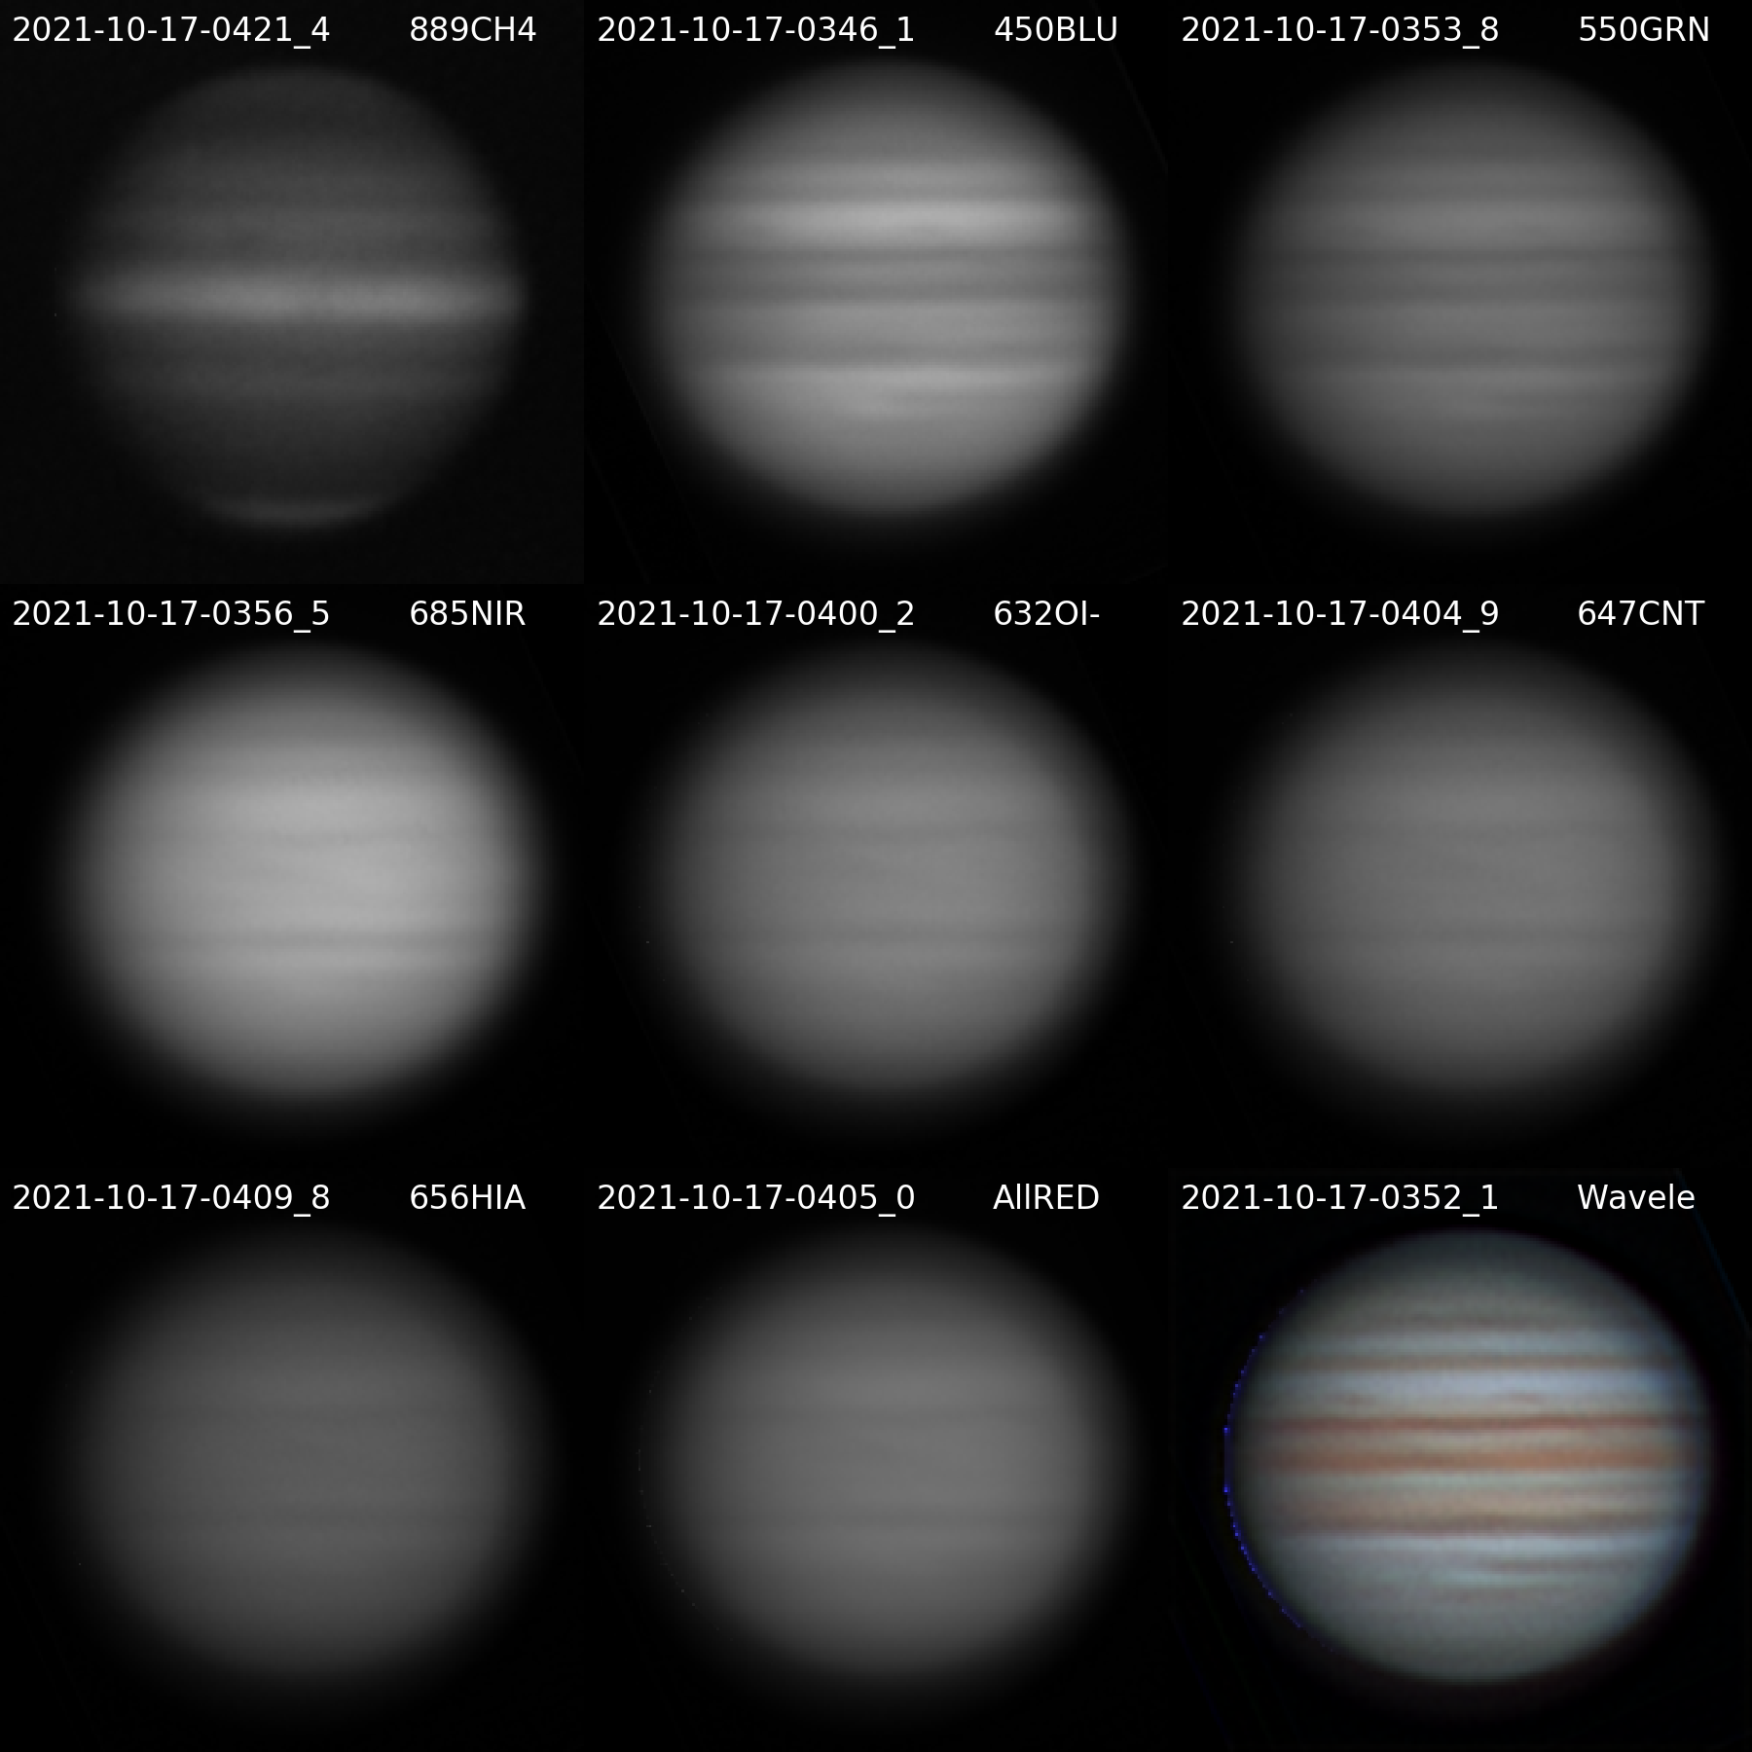

20211017UTJupiter-NavigatedArray.png

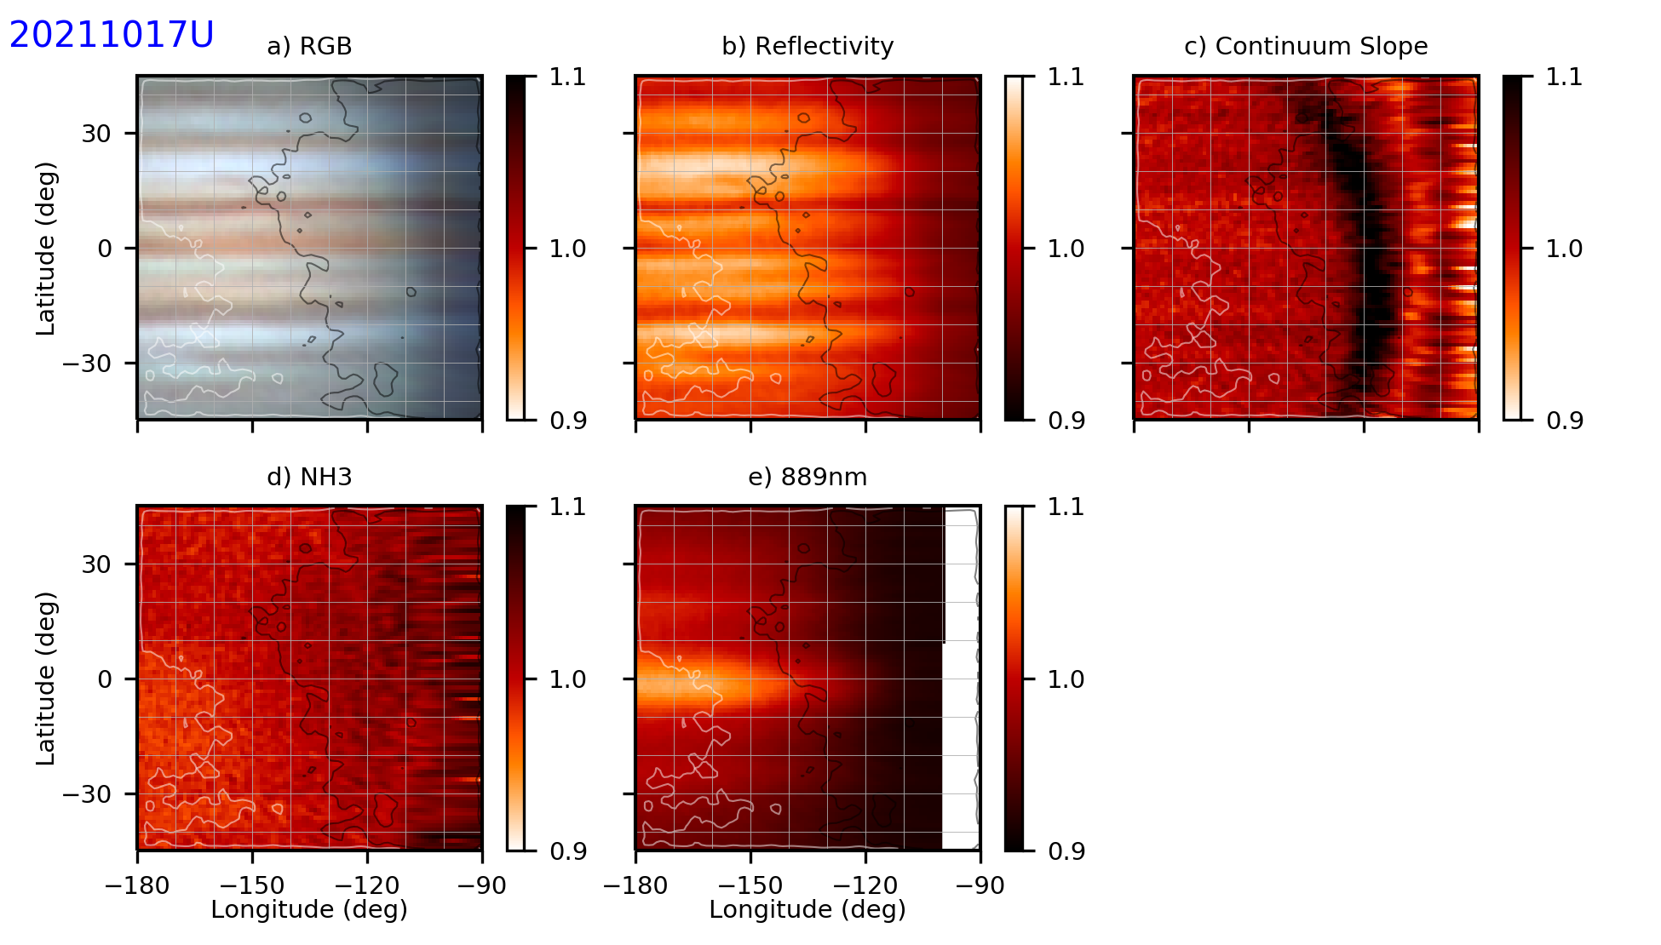

20211017UTaJupiter-NH3.png

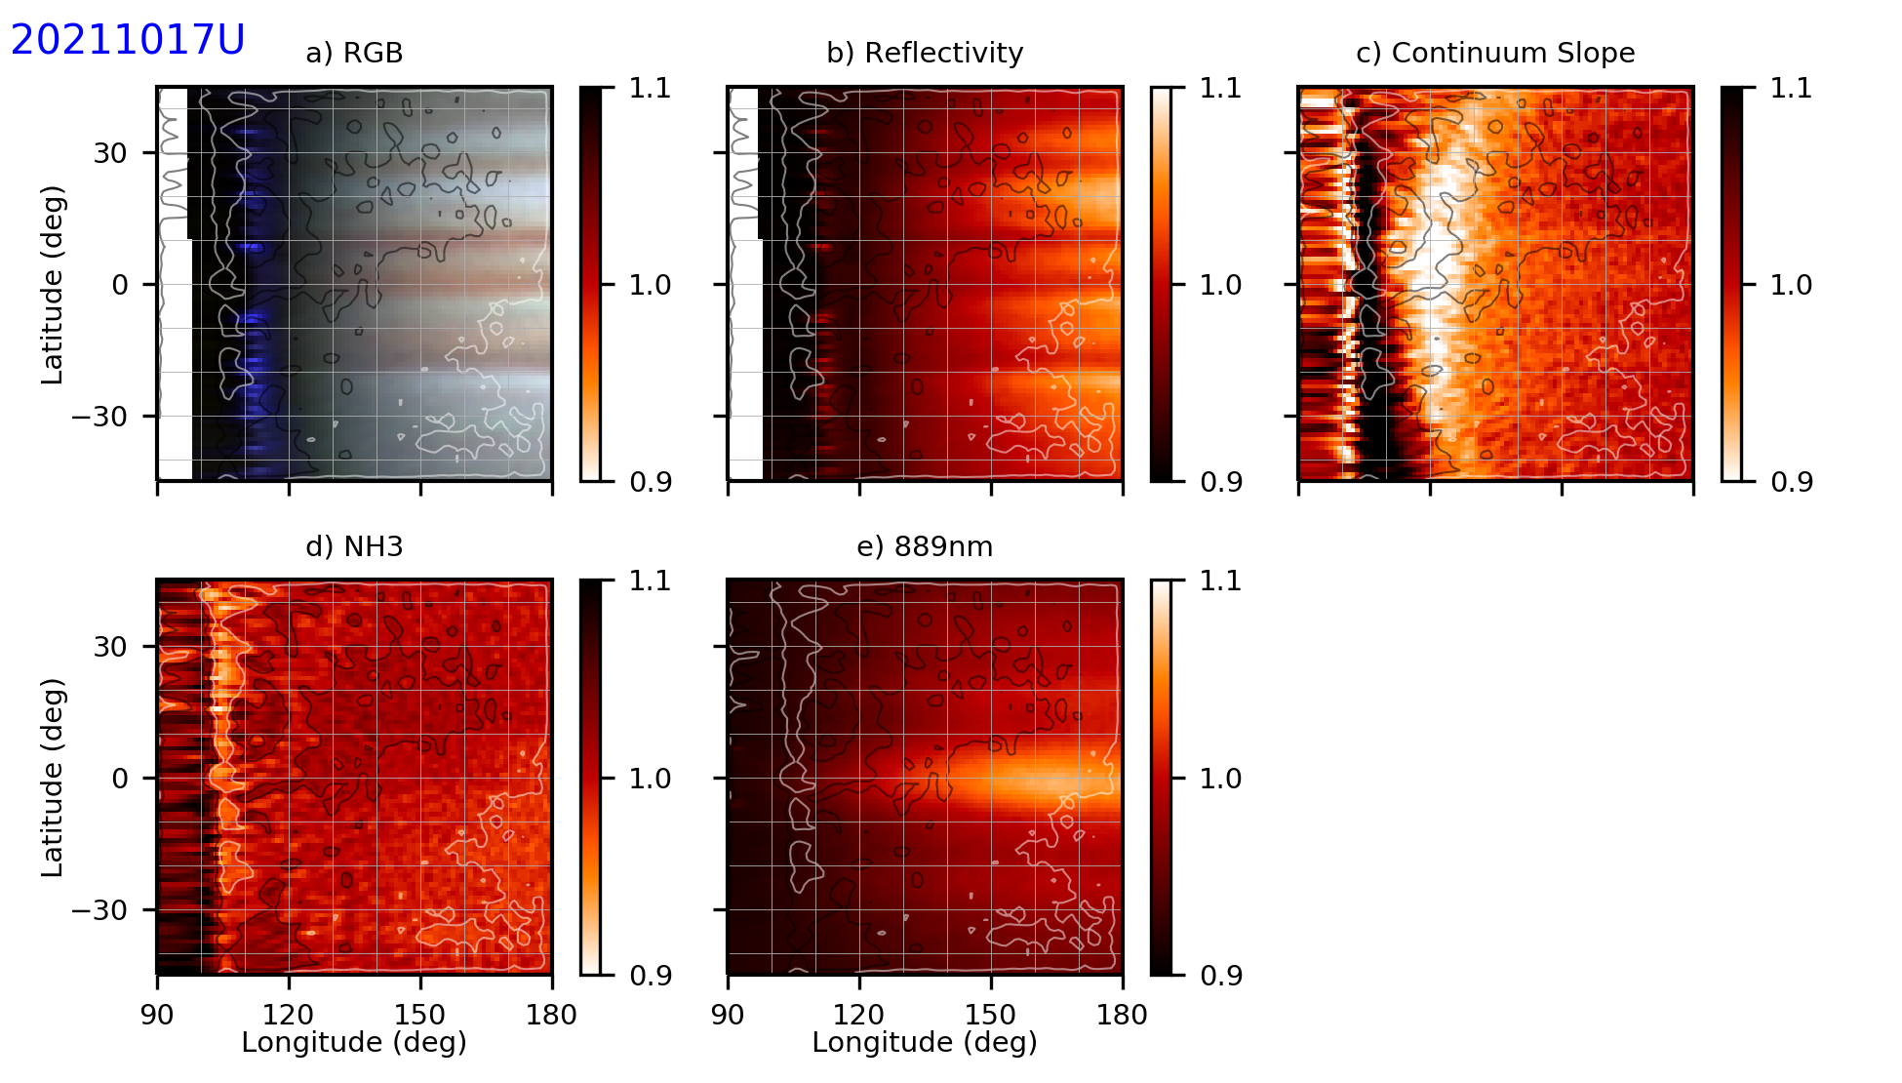

20211017UTbJupiter-NH3.png

**96 AQR**

|  |  |  |  |  |  |
| --- | --- | --- | --- | --- | --- |
| **Video File** | **Exposure** | **Gain** | **Gamma** | **Binning** | **Capture Area** |
| 2021-10-17-0503_1-96Aqr_685NIR.avi | 0.2 | 100 | 50 | 2 | 640x480 |
| 2021-10-17-0505_1-96Aqr_685NIR_Drift.avi | 0.2 | 100 | 50 | 2 | 1280x960 |

**NEPTUNE**

|  |  |  |  |  |  |
| --- | --- | --- | --- | --- | --- |
| **Video File** | **Exposure** | **Gain** | **Gamma** | **Binning** | **Capture Area** |
| 2021-10-17-0511_9-Neptune_685NIR.avi | 1 | 100 | 50 | 2 | 640x480 |
| 2021-10-17-0516_9-Neptune_685NIR.avi | 1 | 100 | 50 | 2 | 640x480 |
| 2021-10-17-0522_1-Neptune_685NIR.avi | 1 | 100 | 50 | 2 | 640x480 |
| 2021-10-17-0527_2-Neptune_685NIR.avi | 1 | 100 | 50 | 2 | 640x480 |
| 2021-10-17-0532_3-Neptune_685NIR.avi | 1 | 100 | 50 | 2 | 640x480 |
| 2021-10-17-0538_0-Neptune+Triton_685NIR.avi | 5 | 100 | 50 | 2 | 640x480 |
| 2021-10-17-0541_8-Neptune+Triton_685NIR_Dark.avi | 5 | 100 | 50 | 2 | 640x480 |
| 2021-10-17-0545_0-Neptune_685NIR_Dark.avi | 1 | 100 | 50 | 2 | 640x480 |

### 2021-Oct-18 (Oct-19 UT): Jupiter, Neptune, and 96 Aqr Video

Last Updated 10/14/2021

Transparency was good (4.0/5). Seeing was fair (3.0/5).

|  |  |  |  |  |  |
| --- | --- | --- | --- | --- | --- |
| **Video File** | **Exposure** | **Gain** | **Gamma** | **Binning** | **Capture Area** |
| 2021-10-19-0351_2-Jupiter_685NIR.avi | 0.01 | 50 | 50 | 2 | 640x480 |
| 2021-10-19-0352_2-Jupiter_685NIR.avi | 0.01 | 50 | 50 | 2 | 640x480 |
| 2021-10-19-0355_1-Jupiter_632OI.avi | 0.05 | 50 | 50 | 2 | 640x480 |
| 2021-10-19-0358_6-Jupiter_632OI.avi | 0.05 | 50 | 50 | 2 | 640x480 |
| 2021-10-19-0400_8-Jupiter_632OI.avi | 0.05 | 60 | 50 | 2 | 640x480 |
| 2021-10-19-0403_0-Jupiter_632OI.avi | 0.05 | 60 | 50 | 2 | 640x480 |
| 2021-10-19-0405_3-Jupiter_647CNT.avi | 0.05 | 60 | 50 | 2 | 640x480 |
| 2021-10-19-0407_4-Jupiter_647CNT.avi | 0.05 | 60 | 50 | 2 | 640x480 |
| 2021-10-19-0409_9-Jupiter_656HIA.avi | 0.05 | 60 | 50 | 2 | 640x480 |
| 2021-10-19-0412_0-Jupiter_656HIA.avi | 0.05 | 60 | 50 | 2 | 640x480 |
| 2021-10-19-0416_1-Jupiter_450BLU.avi | 0.01 | 60 | 50 | 2 | 640x480 |
| 2021-10-19-0417_2-Jupiter_450BLU.avi | 0.01 | 60 | 50 | 2 | 640x480 |
| 2021-10-19-0419_0-Jupiter_550GRN.avi | 0.008 | 60 | 50 | 2 | 640x480 |
| 2021-10-19-0420_1-Jupiter_550GRN.avi | 0.008 | 60 | 50 | 2 | 640x480 |
| 2021-10-19-0423_8-Jupiter_685NIR.avi | 0.01 | 60 | 50 | 2 | 640x480 |
| 2021-10-19-0424_9-Jupiter_685NIR.avi | 0.01 | 60 | 50 | 2 | 640x480 |
| 2021-10-19-0433_5-Jupiter_889CH4.avi | 1 | 100 | 50 | 2 | 1280x960 |
| 2021-10-19-0435_6-Jupiter_889CH4.avi | 1 | 100 | 50 | 2 | 1280x960 |
| 2021-10-19-0437_7-Jupiter_889CH4.avi | 1 | 100 | 50 | 2 | 1280x960 |
| 2021-10-19-0439_9-Jupiter_889CH4.avi | 1 | 100 | 50 | 2 | 1280x960 |
| 2021-10-19-0442_3-Jupiter_889CH4_DARK.avi | 1 | 100 | 50 | 2 | 1280x960 |

**Navigated Image Products**

2021-10-19-0436_7-Jupiter_889CH4-WV-DR-ST.png

2021-10-19-0408_0-Jupiter_685NIR-WV-DR-ST.png

2021-10-19-0359_4-Jupiter_632OI-WV-DR-ST.png

2021-10-19-0406_4-Jupiter_647CNT-WV-DR-ST.png

2021-10-19-0410_9-Jupiter_656HIA-WV-DR-ST.png

2021-10-19-0416_6-Jupiter_450BLU-WV-DR-ST.png

2021-10-19-0419_5-Jupiter_550GRN-WV-ST-DR.png

2021-10-19-0414_7-Jupiter-Wavelets-R685GB-WV-RGB-WhtBal-ClrSmth-Smth-Wavelets.png

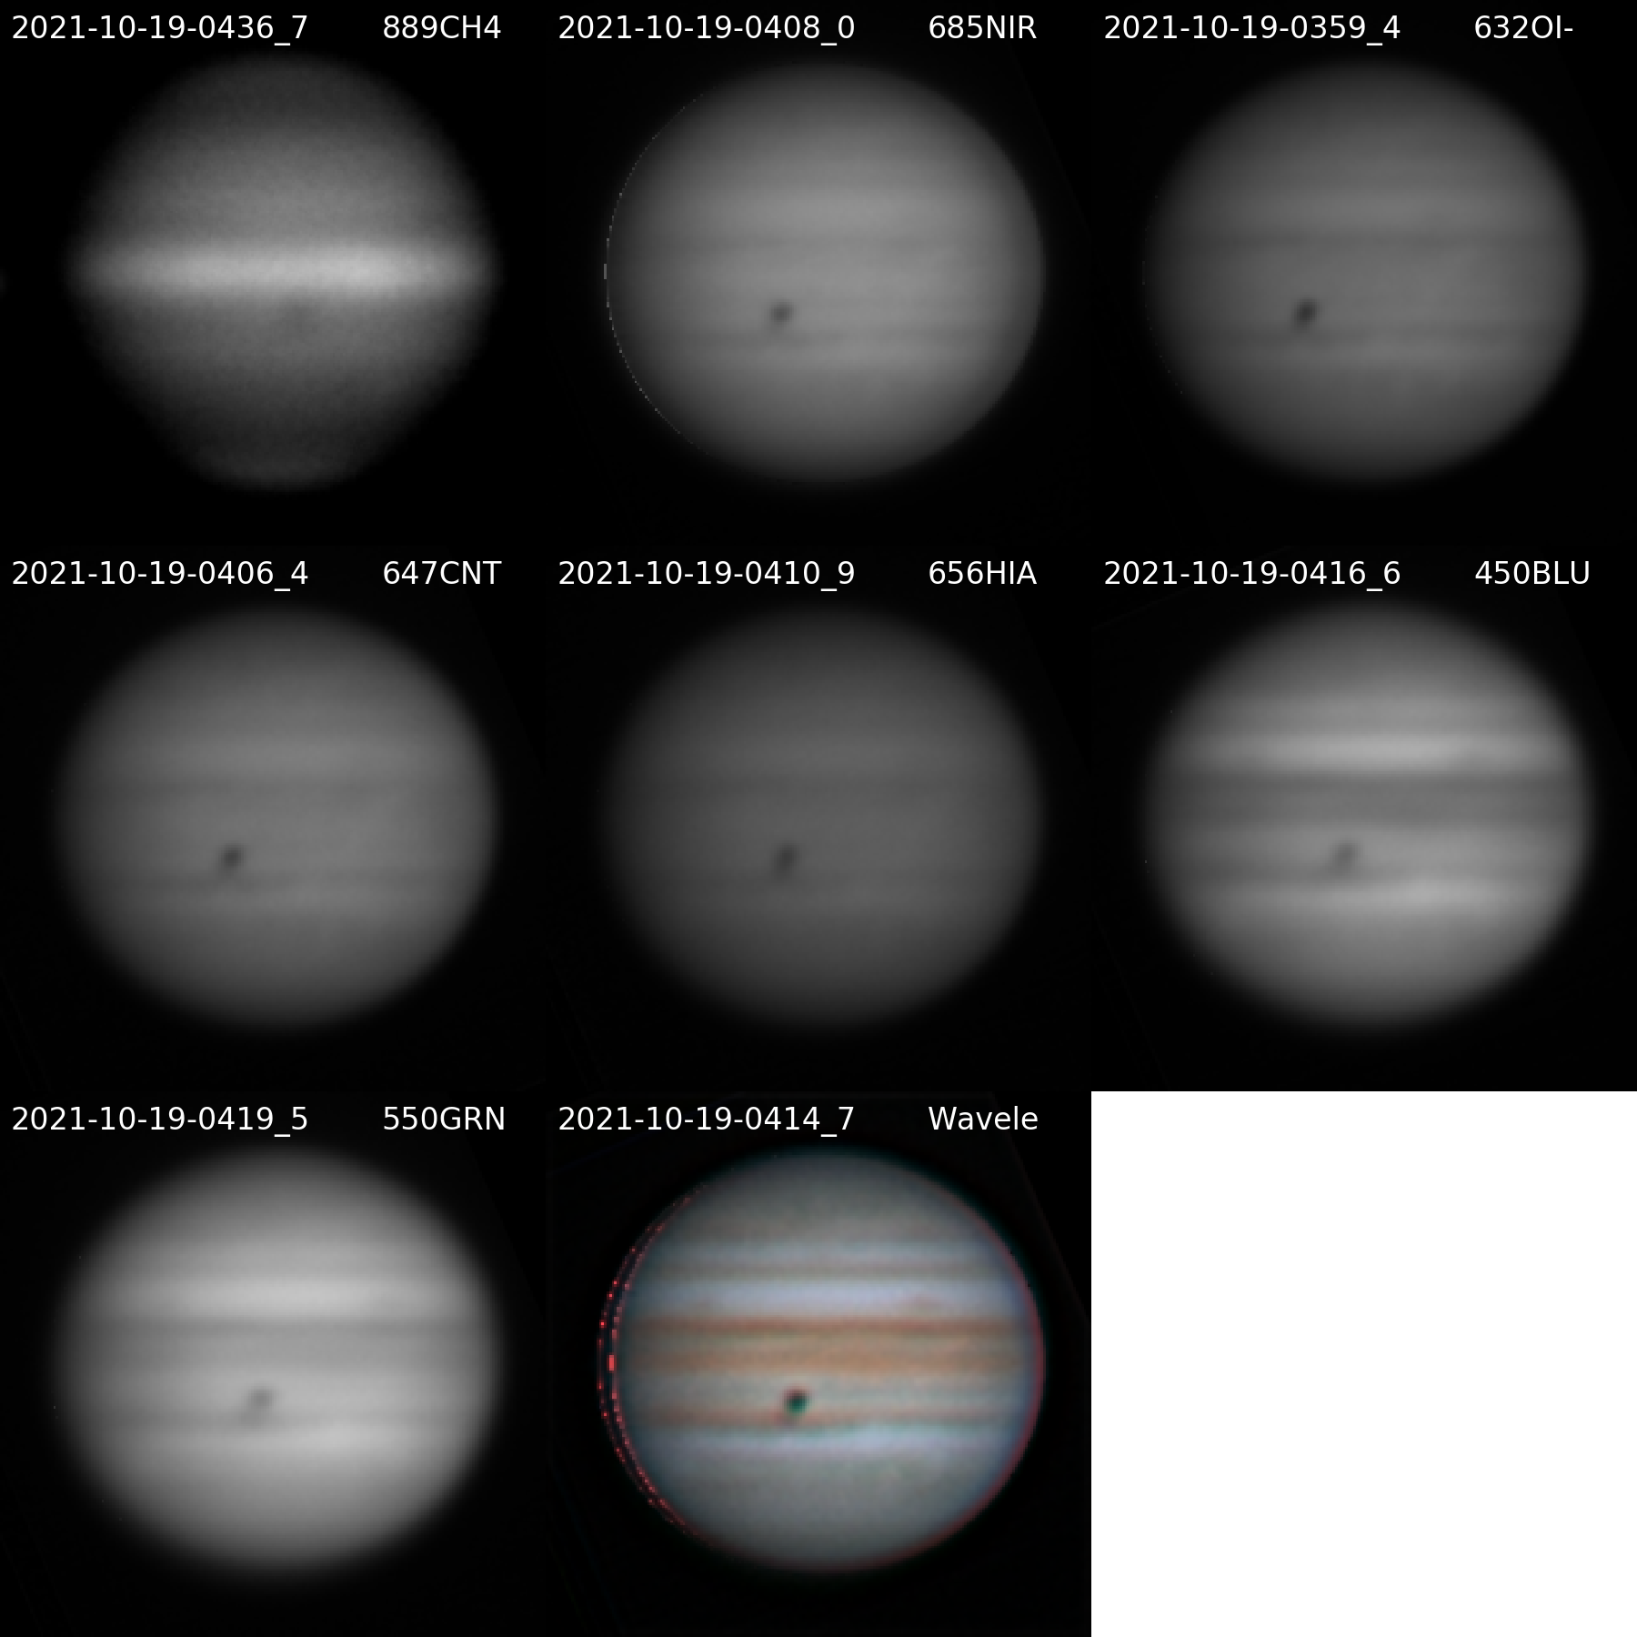

20211019UTJupiter-NavigatedArray.png

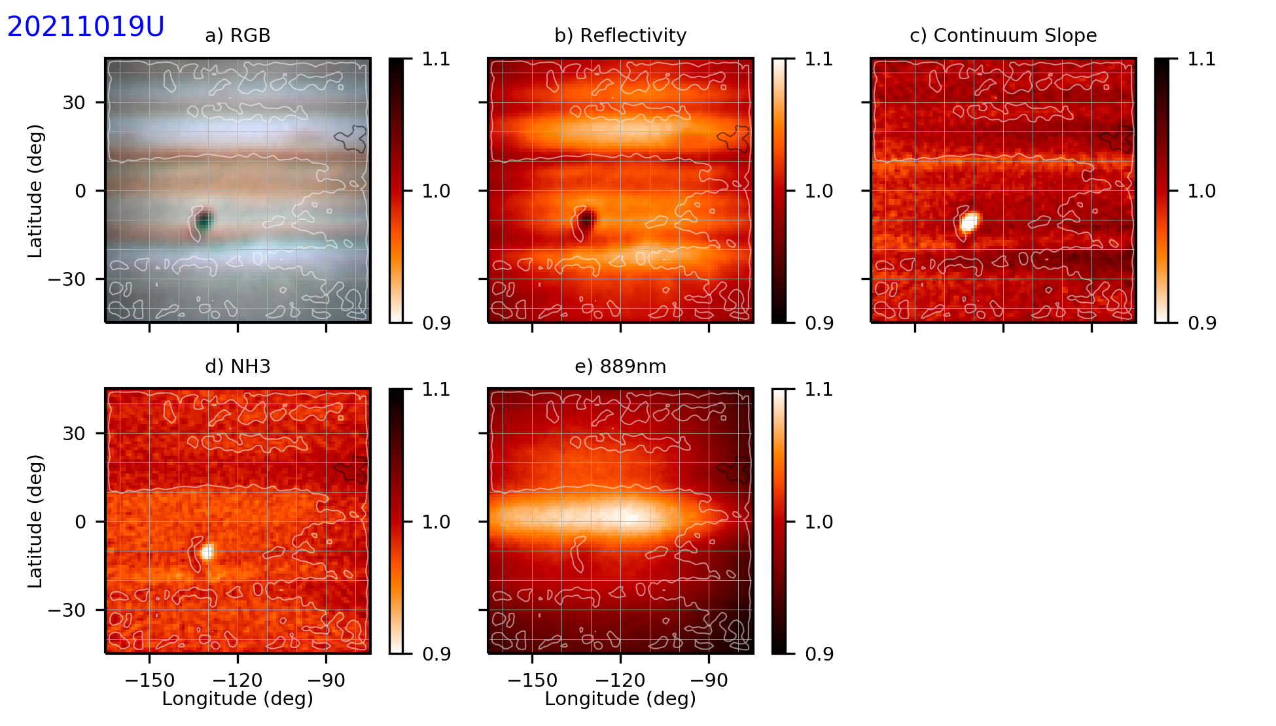

20211019UTwJupiter-NH3.png – **Note – stretched the NH3Abs map, which I shouldn’t have done.**

### 2021-Oct-21 (Oct-22 UT): Jupiter Video

Last Updated 10/14/2021

Transparency was good (4.0/5). Seeing was fair (3.0/5).

|  |  |  |  |  |  |
| --- | --- | --- | --- | --- | --- |
| **Video File** | **Exposure** | **Gain** | **Gamma** | **Binning** | **Capture Area** |
| 2021-10-22-0254_4-Jupiter_550GRN.avi | 0.005 | 60 | 50 | 2 | 640x480 |
| 2021-10-22-0255_4-Jupiter_550GRN.avi | 0.005 | 60 | 50 | 2 | 640x480 |
| 2021-10-22-0257_1-Jupiter_450BLU.avi | 0.01 | 60 | 50 | 2 | 640x480 |
| 2021-10-22-0258_4-Jupiter_450BLU.avi | 0.01 | 60 | 50 | 2 | 640x480 |
| 2021-10-22-0300_2-Jupiter_450BLU.avi | 0.01 | 60 | 50 | 2 | 640x480 |
| 2021-10-22-0302_0-Jupiter_685NIR.avi | 0.01 | 60 | 50 | 2 | 640x480 |
| 2021-10-22-0303_2-Jupiter_685NIR.avi | 0.01 | 60 | 50 | 2 | 640x480 |
| 2021-10-22-0305_4-Jupiter_632OI.avi | 0.05 | 60 | 50 | 2 | 640x480 |
| 2021-10-22-0307_5-Jupiter_632OI.avi | 0.05 | 60 | 50 | 2 | 640x480 |
| 2021-10-22-0312_1-Jupiter_647CNT.avi | 0.05 | 60 | 50 | 2 | 640x480 |
| 2021-10-22-0314_5-Jupiter_647CNT.avi | 0.05 | 60 | 50 | 2 | 640x480 |
| 2021-10-22-0316_9-Jupiter_656HIA.avi | 0.05 | 60 | 50 | 2 | 640x480 |
| 2021-10-22-0319_0-Jupiter_656HIA.avi | 0.05 | 60 | 50 | 2 | 640x480 |
| 2021-10-22-0321_4-Jupiter_632OI.avi | 0.05 | 60 | 50 | 2 | 640x480 |
| 2021-10-22-0324_0-Jupiter_647CNT.avi | 0.05 | 60 | 50 | 2 | 640x480 |
| 2021-10-22-0326_3-Jupiter_656HIA.avi | 0.05 | 60 | 50 | 2 | 640x480 |
| 2021-10-22-0328_5-Jupiter_685NIR.avi | 0.01 | 60 | 50 | 2 | 640x480 |
| 2021-10-22-0329_7-Jupiter_685NIR.avi | 0.01 | 60 | 50 | 2 | 640x480 |
| 2021-10-22-0331_0-Jupiter_450BLU.avi | 0.01 | 60 | 50 | 2 | 640x480 |
| 2021-10-22-0333_9-Jupiter_550GRN.avi | 0.01 | 60 | 50 | 2 | 640x480 |
| 2021-10-22-0334_6-Jupiter_550GRN.avi | 0.005 | 60 | 50 | 2 | 640x480 |
| 2021-10-22-0335_7-Jupiter_550GRN.avi | 0.005 | 60 | 50 | 2 | 640x480 |
| 2021-10-22-0337_2-Jupiter_550GRN.avi | 0.01 | 60 | 50 | 2 | 640x480 |
| 2021-10-22-0338_3-Jupiter_450BLU.avi | 0.01 | 60 | 50 | 2 | 640x480 |
| 2021-10-22-0340_6-Jupiter_889CH4.avi | 1 | 100 | 50 | 2 | 1280x960 |
| 2021-10-22-0342_8-Jupiter_889CH4.avi | 1 | 100 | 50 | 2 | 1280x960 |
| 2021-10-22-0347_7-Jupiter_889CH4.avi | 1 | 100 | 50 | 2 | 1280x960 |
| 2021-10-22-0349_9-Jupiter_889CH4.avi | 1 | 100 | 50 | 2 | 1280x960 |
| 2021-10-22-0352_6-Jupiter_889CH4_DARK.avi | 1 | 100 | 50 | 2 | 1280x960 |

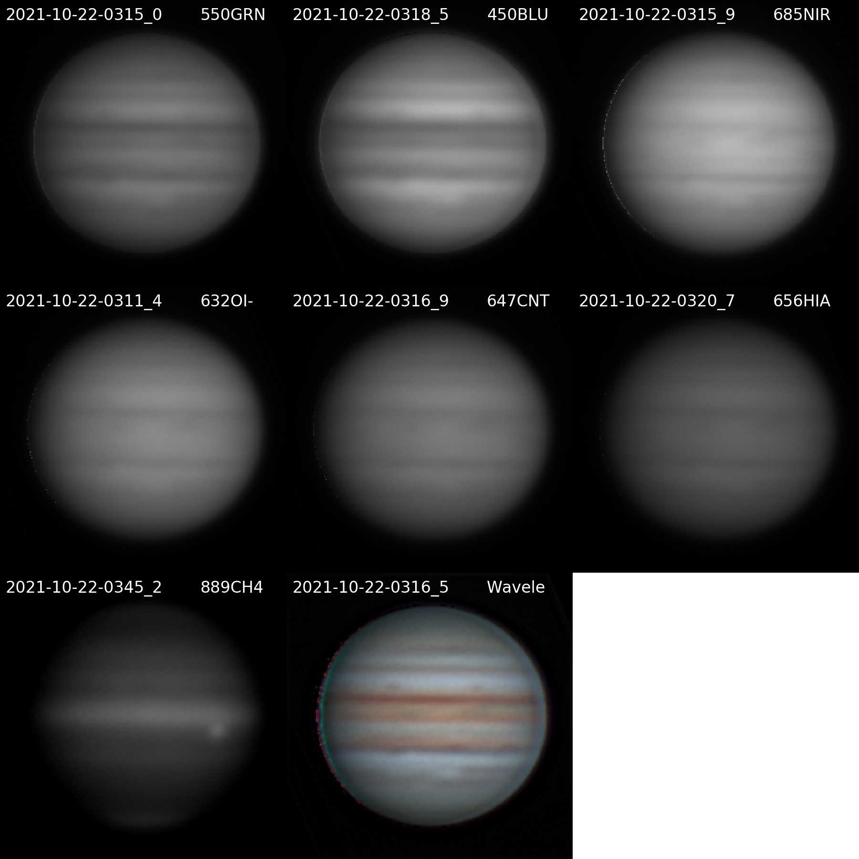

20211022UTJupiter-NavigatedArray.png

**Navigated Image Products**

2021-10-22-0315_0-Jupiter_550GRN-WV-DR-ST.png

2021-10-22-0318_5-Jupiter_450BLU-WV-DR-ST.png

2021-10-22-0315_9-Jupiter_685NIR-WV-DR-ST.png

2021-10-22-0311_4-Jupiter_632OI-WV-DR-ST.png

2021-10-22-0316_9-Jupiter_647CNT-WV-DR-ST.png

2021-10-22-0320_7-Jupiter_656HIA-WV-DR-ST.png

2021-10-22-0345_2-Jupiter_889CH4-WV-DR-ST.png

2021-10-22-0316_5-Jupiter-Wavelets-R685GB-WV-RGB-WhtBal-ClrSmth-Smth-Wavelets.png

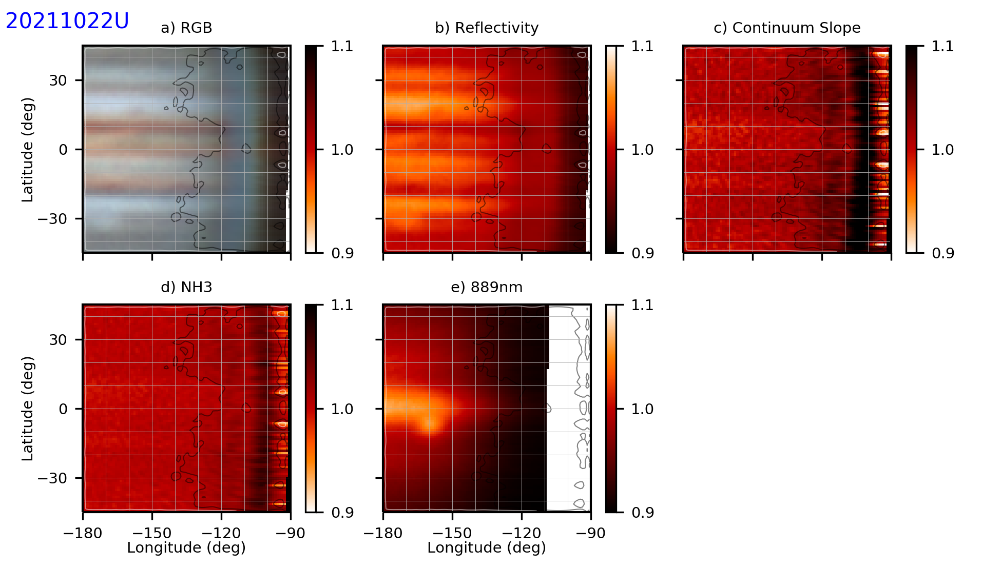

20211022UTaJupiter-NH3.png

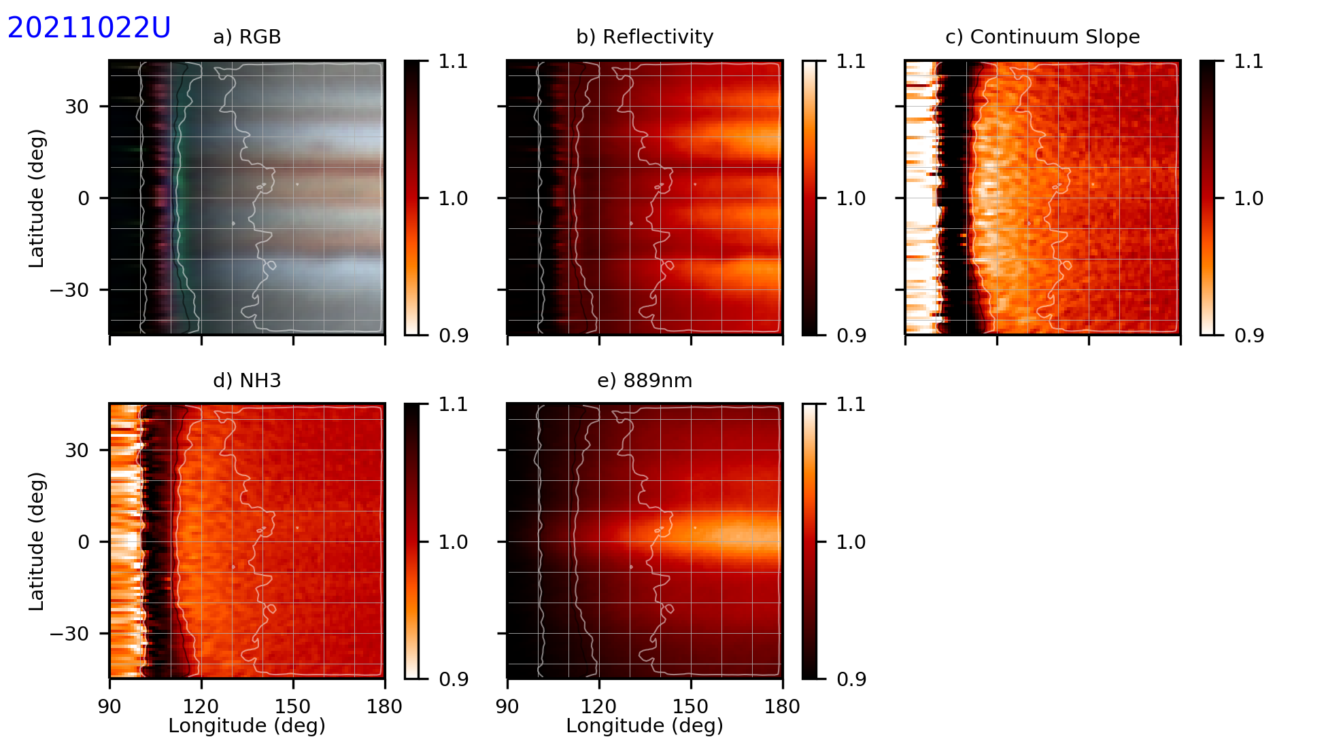

20211022UTbJupiter-NH3.png

Candidate double stars to video

* Mu Cyg
* Lam Cyg
* Del Cyg
* 61 Cyg
* Del Ser

### 2021-Oct-25 (Oct-26 UT): PNe and other Nebulae Narrow Band Imaging

Last Updated 10/27/2021

IC5146, NGC6543, NGC7635, and NGC 7662

Transparency was fair (3.0/5) with thin cirrus moving in later during the NGC7662 imaging. Seeing was fair (3.0/5).

|  |  |  |
| --- | --- | --- |
|  |  |  |
| NGC6543-20211026UT-656HIA-sum580sec-RotCrop.jpg | NGC6543-20211026UT-540CNT-sum560sec-RotCrop.jpg | NGC6543-20211026UT-501OIII-sum500sec-RotCrop.jpg |
|  |  |  |
| NGC6543-20211026UT-486HIB-sum514sec-RotCrop.jpg | NGC6543-20211026UT-467HeII-sum530sec-RotCrop.jpg |  |

|  |
| --- |
|  |
| IC5146-20211026UT-656HIA-sum270sec-RotCrop.jpg |

|  |  |
| --- | --- |
|  |  |
| NGC7635-20211026UT-656HIA-sum250sec-RotCrop-Log.jpg | NGC7635-20211026UT-501OIII-sum270sec-RotCrop-Log.jpg |
|  |  |
| NGC7635-20211026UT-467HeII-sum240sec-RotCrop-Log.jpg | NGC7635-20211026UT-XXX-R656G467B501.jpg |

|  |  |  |
| --- | --- | --- |
|  |  |  |
| NGC7662-20211026UT-656HIA-sum260sec-RotCrop-Log.jpg | NGC7662-20211026UT-540CNT-sum240sec-RotCrop-Log.jpg | NGC7662-20211026UT-501OIII-sum260sec-RotCrop-Log.jpg |
|  |  |  |
| NGC7662-20211026UT-486HIB-sum270sec-RotCrop-Log.jpg | NGC7662-20211026UT-467HeII-sum300sec-RotCrop-Log.jpg |  |

**M27 all blues guide star avail HIP 98440**

**7009 all blues**

6826 all blues, but need good focus on HIB and HeII

7662 more blues

IC5146 more HIA

7635 more OIII & HIA

**Data Disposition:**

* Raw data is zipped and archived on the 4TB drive.
* Processed data is in appropriate project directories on the Astronomy SD card.

### 2021-Oct-27 (Oct-28 UT): PNe and other Nebulae Narrow Band Imaging

Last Updated 10/30/2021

Transparency was good (4.0/5). Seeing was fair (3.0/5).

|  |  |  |
| --- | --- | --- |
|  |  |  |
| M27-20211028UT-656HIA-sum720sec-RotCrop.jpg | M27-20211028UT-540CNT-sum600sec-RotCrop.jpg | M27-20211028UT-501OIII-sum180sec-RotCrop.jpg |
|  |  |  |
| M27-20211028UT-486HIB-sum630sec-RotCrop.jpg | M27-20211028UT-467HeII-sum1700sec-RotCrop.jpg |  |

|  |  |  |
| --- | --- | --- |
|  |  |  |
| NGC7662-20211028UT-656HIA-sum600sec-RotCrop-Log.jpg | NGC7662-20211028UT-540CNT-sum1140sec-RotCrop-Log.jpg | NGC7662-20211028UT-501OIII-sum600sec-RotCrop-Log.jpg |
|  |  |  |
| NGC7662-20211028UT-486HIB-sum660sec-RotCrop-Log.jpg | NGC7662-20211028UT-467HeII-sum900sec-RotCrop-Log.jpg | NGC7662-20211028UT-XXX-R656G501B467-USMask.jpg |

|  |  |
| --- | --- |
|  |  |
| Ced214-20211028UT-656HIA-sum1200sec-Rot.jpg | Ced214-20211028UT-540CNT-sum1800sec-Rot.jpg |
|  |  |
| Ced214-20211028UT-501OIII-sum2400sec-Rot.jpg | Ced214-20211028UT-XXX-R656G540B501.jpg |

Next:

* M27: 467HeII 1800s, 486HIB 1200s, 501OIII 600s, 540CNT 1200s
* NGC7009: 467HeII 1200s, 486HIB 1200s, 540CNT 1200s, 656HIA 600s
* Ced214: 656HIA 2400s, 501OIII 2400s, 540CNT 2400s

**Data Disposition:**

* Raw data is zipped and archived on the 4TB drive.
* Processed data is in appropriate project directories on the Astronomy SD card.

### 2021-Oct-28 (Oct-29 UT): M27, NGC7331, and M33 (NGC604 region) Imaging

Last Updated 10/30/2021

Transparency again was good (4.0/5). Seeing was fair (3.0/5).

|  |  |
| --- | --- |
|  |  |
| M27-20211029UT-540CNT-sum600sec-RotCrop.jpg | M27-20211029UT-501OIII-sum480sec-RotCrop.jpg |
|  |  |
| M27-20211029UT-486HIB-sum1800sec-RotCrop.jpg | M27-20211029UT-467HeII-sum2100sec-RotCrop.jpg |

|  |  |
| --- | --- |
|  |  |
| NGC7331-20211029UT-656HIA-sum2760sec-Crop-Log.jpg | NGC7331-20211029UT-540CNT-sum1620sec-  Crop-Log.jpg |

|  |  |  |
| --- | --- | --- |
|  |  |  |
| M33-NGC604-20211029UT-656HIA-sum1800s-Rot-Log.jpg | M33-NGC604-20211029UT-501OIII-sum1800s-Rot-Log.jpg | M33-NGC604-20211029UT-486HIB-sum1800s-Rot-Log.jpg |
|  |  |  |
| M33-NGC604-20211029UT-467HeII-sum300s-Rot-Log.jpg | M33-NGC604-20211029UT-RGB-NB-467-486-501-656-Rot-Log.jpg |  |

Next:

* NGC7009: 467HeII 1200s, 486HIB 1200s, 540CNT 1200s, 656HIA 600s
* NGC6286 (refresh all – some were poorly focused in 2019): 467HeII 1200s, 486HIB 1200s, 540CNT 1200s, 656HIA 600s
* M33: 467HeII 1500s, 540CNT 1800s, 486HIB 1800s, 501OIII 1800s, 656HIA 1800s
* Ced214: 656HIA 2400s, 501OIII 2400s, 540CNT 2400s

**Data Disposition:**

* Raw data is zipped and archived on the 4TB drive.
* Processed data is in appropriate project directories on the Astronomy SD card.

## November

### 2021-Nov-03 (Nov-04 UT): NGC7009, NGC7293, and Ced214 Imaging

Last Updated 10/30/2021

Transparency was good (4.0/5). Seeing was fair (3.0/5).

|  |  |  |
| --- | --- | --- |
|  |  |  |
| NGC7009-20211104UT-656HIA-sum300sec-Flattened-RotCrop.jpg | NGC7009-20211104UT-540CNT-sum840sec-Flattened-RotCrop.jpg | NGC7009-20211104UT-501OIII-sum300sec-Flattened-RotCrop.jpg |
|  |  |  |
| NGC7009-20211104UT-486HIB-sum900sec-Flattened-RotCrop.jpg | NGC7009-20211104UT-467HeII-sum900sec-Flattened-RotCrop.jpg |  |

|  |  |  |
| --- | --- | --- |
|  |  |  |
| NGC7293-20211104UT-656HIA-sum540sec-Rot.jpg | NGC7293-20211104UT-501OIII-sum180sec-Rot.jpg | NGC7293-20211104UT-656HIA+501OIII-NB-Blend-Rot.jpg |

|  |  |  |
| --- | --- | --- |
|  |  |  |
| Ced214-20211104UT-656HIA-sum2220sec-Rot.jpg | Ced214-20211104UT-501OIII-sum2400sec-Rot.jpg | Ced214-20211104UT-540CNT-sum2460sec-Rot.jpg |

**Data Disposition:**

* Raw data is zipped and archived on the 4TB drive.
* Processed data is in appropriate project directories on the Astronomy SD card.

### 2021-Nov-04 (Nov-05 UT): M27 Imaging

Last Updated 10/30/2021

Transparency was poor (2.0/5) with patches of very thin, high cirrus. Pretty clear for the initial 672SII imaging but had to drop about 5 images for higher background due to clouds. 730OII was probably contaminated throughout, but it was not so evident on visual inspection so I stacked all images. Seeing was good (4.0/5).

|  |  |
| --- | --- |
|  |  |
| M27-20211105UT-658NII-sum960sec-RotCrop.jpg | M27-20211105UT-730OII-sum1200sec-RotCrop.jpg |

New filters: 658NII, 647CNT, 730OII, 672SII, 550OPN

* M27: 658NII 1800s, 647CNT 1800s, 730OII 3600s
* NGC7331 550OPN 1200s
* NGC 7662: 658NII 600s, 647CNT 900s, 730OII 900s, 672SII 900s
* Ced214: 658NII 1800s, 672SII 2400s, 550OPN 900s
* M33: 658NII 1800s, 647CNT 1800s, 672SII 1800s, 550OPN 900s

Types of images

* RGB broad band
* SHO Hubble palette
* Oxygen I, II, III – really kind of ionization
* Recombination: HIA, HIB, HeII?

**Data Disposition:**

* Raw data is zipped and archived on the 4TB drive.
* Processed data is in appropriate project directories on the Astronomy SD card.

### 2021-Nov-06 (Nov-07 UT): M27 Imaging

Last Updated 10/30/2021

Transparency was very poor (1/5) with lots of high clouds. Seeing was poor (2/5), but uncertain because of the poor transparency. I used dithering in MaximDL for the first time on the idea that the arcs of correlated background noise were due to uncorrected dark signal as the frame rotated due to polar misalignment. Maximum dithering was set to three pixels. In this case, the background looked horrible and had a variance of ~120DN for a 4400s exposure compared to about ~40DN for a 1200s exposure from 11/5UT. Not sure if this was due to significant signal from the cloud background, or something else I don’t understand.

It turned out that I was using the single auto-dark setting which probably contributed to the poor quality of this imaging session.

|  |
| --- |
|  |
| M27-20211107UT-730OII-sum4440sec-RotCrop.jpg |

**Data Disposition:**

* Raw data is zipped and archived on the 4TB drive.
* Processed data is in appropriate project directories on the Astronomy SD card.

### 2021-Nov-07 (Nov-08 UT): M27, NGC7331, NGC7662, and M33 Imaging

Last Updated 10/30/2021

Transparency was very good (4/5). Seeing was good (3/5).

|  |  |
| --- | --- |
|  |  |
| M27-20211108UT-730OII-sum3540sec-RotCrop.jpg | M27-20211108UT-647CNT-sum1560sec-RotCrop.jpg |

|  |  |  |  |
| --- | --- | --- | --- |
|  |  |  |  |
| NGC7662-20211108UT-730OII-sum900sec-RotCrop.jpg | NGC7662-20211108UT-672SII-sum900sec-RotCrop.jpg | NGC7662-20211108UT-658NII-sum600sec-RotCrop.jpg | NGC7662-20211108UT-647CNT-sum900sec-RotCrop.jpg |

|  |
| --- |
|  |
| NGC7331-20211108UT-550OPN-sum1800sec-Flattened-LogLog-UnSharp-Crop.jpg |

|  |  |
| --- | --- |
|  |  |
| M33-20211108UT-550OPN-sum900sec-Log-Rot.jpg | M33-20211108UT-647CNT-sum1800sec-Log-Rot.jpg |
|  |  |
| M33-20211108UT-658NII-sum1800sec-Log-Rot.jpg | M33-20211108UT-672SII-sum1740sec-Log-Rot.jpg |

**Data Disposition:**

* Raw data is zipped and archived on the 4TB drive.
* Processed data is in appropriate project directories on the Astronomy SD card.

### 2021-Nov-09 (Nov-10 UT): BASS Meeting

Last Updated 10/30/2021

Dr. Kevin McGouldrick

Worked with David Grinspoon and Mark Bullock

* My questions
  + Discuss wavelengths that amateurs can use and what they reveal [*J. Peralta et al.*, 2017]
* Two presentations
* What’s New with Venus
  + Three national missions to Venus
  + India and Russia talking about going also
  + Some private groups thinking about going
* Turbet et al 2021 – Venus may always have been hellish
* Giant dark clouds in the IR in the night on Venus
* I spent some of my time looking at my Venus references [*Mousis et al.*, 2014; *J. Peralta et al.*, 2017; *Javier Peralta et al.*, 2019]. Especially [*Javier Peralta et al.*, 2019] shows how amateurs can extract cloud images at ~900nm and 1000nm.
* From their Figure 1:
* 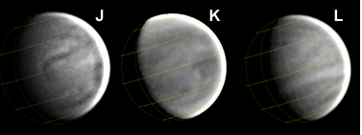
* These are amateur images at 900nm and have been Minnaert corrected and sharpened.
* Supposedly, the contrast ratios are about 4%.
* Why can’t I detect these contrast levels on Venus when I can do it for ratio images for NH3 on Jupiter?
* Amateur images were by , A. Wesley, E. Kardasis and S. Takagi
* I also discovered a new papers of interest
  + THE NEED FOR GROUND-BASED OBSERVATIONS OF VENUS [*Gray et al.*, 2021]
* On its own, I wasn’t super interested in McGouldrick’s work on the giant dark IR cloud.

### 2021-Nov-10 (Nov-11 UT): M57, NGC7635, and M33 Imaging

Last Updated 10/30/2021

Transparency started off very good (4/5) but degraded between 6 and 7pm with high stratocumulous. Cloudy until about 9pm then, just a few very small, widely scattered cumulous. Seeing was good (3/5) early on but degraded around 10:30 when the wind picked up. Gusts to maybe 20mph – and that disturbed the guiding. I was using a 32x32 pixel guiding box and the wind actually cause enough of a perturbation to push the star out of the box during the NGC7635 730OII exposure. About half of those frames were lost along with all of the subsequent 647CNT and 672SII frames.

New filters: 658NII, 647CNT, 730OII, 672SII, 550OPN

* M57: 730OII 1800s
* M27: 658NII 900s
* NGC7331: 550OPN 1800s (Transit 7:15)
* NGC7635: 658NII 900s, 672SII 900s, 730OII 900s, 647CNT 900s (Transit 7:59)
* Ced214: 658NII 1800s, 672SII 2400s, 550OPN 900s (Transit 8:43)
* M33: 658NII 1800s, 647CNT 1800s, 672SII 1800s, 550OPN 900s (Transit 10:12)
* M76: 658NII 600s, 672SII 600s, 730OII 1200s, 647CNT 1200s (Transit 10:21)
* NGC891: 550OPN 1800s (Transit 11:01)

|  |
| --- |
|  |
| M57-20211111UT-730OII-sum3120sec-RotCrop.jpg |

|  |  |
| --- | --- |
|  |  |
| NGC7635-20211111UT-730OII-sum420sec-Log-Rot.jpg | NGC7635-20211111UT-658NII-sum900sec-Log-Rot.jpg |

|  |  |  |
| --- | --- | --- |
|  |  |  |
| M33-20211111UT-550OPN-sum600sec-Log-Rot.jpg | M33-20211111UT-730OII-sum1380sec-Log-Rot.jpg | M33-20211111UT-672SII-sum1620sec-Log-Rot.jpg |
|  |  |  |
| M33-20211111UT-658NII-sum1080sec-Log-Rot.jpg | M33-20211111UT-647CNT-sum1680sec-Log-Rot.jpg |  |

**Data Disposition:**

* Raw data is zipped and archived on the 4TB drive.
* Processed data is in appropriate project directories on the Astronomy SD card.

### 2021-Nov-13 (Nov-14 UT): NGC7331 and NGC891 Imaging

Last Updated 10/30/2021

Transparency started off fair (3/5) but degraded to very poor (1/5) with high clouds and haze. Seeing was fair (3/5) degrading to poor (2/5).

|  |  |
| --- | --- |
|  |  |
| NGC7331-20211114UT-550OPN-sum3000sec-Flattened-Log-RotCrop.jpg | NGC7331-202111XXUT-550OPN-sum4800sec-Flattened-Log-RotCrop.jpg |
|  |  |
| M57-20211111UT-730OII-sum3120sec-RotCrop.jpg – was the luminance merged with the correct historical color image? | NGC891-20211114UT-550OPN-sum1620sec-Flattened-Unsharp-RotCrop.jpg |

**Data Disposition:**

* Raw data is zipped and archived on the 4TB drive.
* Processed data is in appropriate project directories on the Astronomy SD card.

### 2021-Nov-14 (Nov-15 UT): NGC7635 Imaging

Last Updated 10/30/2021

Transparency started off fair (3/5) but degraded to very poor (1/5) with high clouds and haze again. Seeing was fair (3/5) degrading to poor (2/5).

|  |  |
| --- | --- |
|  |  |
| NGC7635-20211115UT-730OII-sum900sec-Log-Rot.jpg | NGC7635-20211115UT-672SII-sum1740sec-Log-Rot.jpg |

**Data Disposition:**

* Raw data is zipped and archived on the 4TB drive.
* Processed data is in appropriate project directories on the Astronomy SD card.

Next Imaging Goals (full Moon):

* NGC7635: 658NII 1800s, 672SII 3600s, 730OII 3600s
* M76: 658NII 900s, 672SII 1800s, 730OII 3600s

### 2021-Nov-17 (Nov-18 UT): NGC7635 and M76 Imaging

Last Updated 10/30/2021

Transparency was very good (4/5). Seeing was fair (3/5).

I had trouble tracking NGC7635 with 10 second exposures of the 9.95mV star used for guiding (TYC 4279-1821-1). For some reason 5 second exposures had trouble with noise or with applying the autodark. Very late in the session I cleared the autodarks and retook a 5 sec on an it seemed to work better. Selecting only about half of the images from the session gives better guiding and stars only slightly out of round.

|  |  |  |
| --- | --- | --- |
|  |  |  |
| NGC7635-20211118UT-672SII-sum1380sec-BetterGuiding-Log-Rot.jpg | M76-20211118UT-730OII-sum1800sec-Flattened-Log-RotCrop.jpg | M76-20211118UT-672SII-sum1800sec-Flattened-Log-RotCrop.jpg |
|  |  |  |
| M76-20211118UT-658NII-sum1800sec-Log-RotCrop.jpg | M76-20211118UT-647CNT-sum1800sec-Flattened-Log-RotCrop.jpg | M76-20211118UT-550OPN-sum1740sec-Log-RotCrop.jpg |

For guiding, given the inaccuracy of current polar alignment (even though the iPolar says I’m right on, the 2-star alignment indicates something like a degree off), exposures should be 5 sec or less. For some objects 10 sec has been acceptable. For signal strength of the guiding star, total intensity of 10,000DN seems like a reliable minimum, 20,000DN is quite good, and sometimes, 5,000DN can work.

Given the 9.95mV star, for 672SII, a 10sec exposure gave about 17,000DN. The 6.66mV star HD10498 used for guiding on M76 produced 29,000DN with 1 second exposures. RMS errors in X and Y were between 0.5 and 0.7 pixels. So, that is extremely good.

**Data Disposition:**

* Raw data is zipped and archived on the 4TB drive.
* Processed data is in appropriate project directories on the Astronomy SD card.

### 2021-Nov-21 (Nov-22 UT): Jupiter, NGC7635, and M76 Imaging

Last Updated 10/30/2021

Transparency was fair to good (2-3/5) with some high haze and occasionally a contrail. Seeing was good (3/5).

|  |  |
| --- | --- |
|  |  |
| NGC7635-20211122UT-656HIA-sum3660sec-Log-Rot.jpg | NGC7635-20211122UT-632OI-sum1860sec-Log-Rot.jpg |
|  |  |
| M76-20211122UT-656HIA-sum3600sec-Log-RotCrop.jpg | M76-20211122UT-632OI-sum5160sec-Log-RotCrop.jpg |

**Next Potential Candidates:**

* NGC7731: 656HIA 3600s
* NGC7635: 647CNT 1800s; 632OI 1800s; 730OII 1800s
* M33: 630OI 3600s; 730OII 2700s; 647CNT 1800s, 656HIA 1800s
* M76: **730OII 3600s**; **647CNT 1800s**; **632OI 3600s**
* NGC891: 550OPN 3600s
* NGC925: 550OPN 3600s
* NGC974: 550OPN 3600s
* NGC1169: 550OPN 3600s

### 2021-Nov-22 (Nov-23 UT): Jupiter, NGC7635, and M33 Imaging

Last Updated 10/30/2021

Transparency was very good (4/5). Seeing was good (3/5).

### 2021-Nov-24 (Nov-25 UT): NGC7331 and NGC891 Imaging

Last Updated 10/30/2021

Transparency was good (3/5), but there were some early patchy clouds. Seeing was very good (4/5).

### 2021-Nov-28 (Nov-29 UT): NGC7635 and NGC925 Imaging

Last Updated 10/30/2021

Transparency was good (3/5), but there was some early very thin haze. Seeing was very good (4/5).

|  |  |
| --- | --- |
|  |  |
| NGC7635-20211129UT-730OII-sum1800sec-Rot-Log.jpg | NGC7635-20211129UT-647CNT-sum1680sec-Rot-Log.jpg |
|  |  |
| NGC7635-20211129UT-632OI-sum1740sec-Rot-Log.jpg | NGC925-20211129UT-550OPN-sum8520sec-Flattened-Log-RotCrop.jpg |

### 2021-Nov-29 (Nov-30 UT): Jupiter, Neptune, Uranus, 16Ari, 96Aqr, and NGC7662 Video

Last Updated 10/30/2021

Transparency was very good (4/5) early, but there were patchy clouds during the Uranus imaging. Seeing was good (3/5).

## December

### 2021-Dec-01 (Dec-02 UT): Jupiter Video

Last Updated 10/30/2021

Transparency was fair (3.0/5) with some contrails and high, thin cirrus. Seeing was poor to fair (2-3/5) despite a good forecast for 300mb winds from [NAM](https://www.emc.ncep.noaa.gov/mmb/mmbpll/opsnam/nam.conus.300_animate.html).

## References

Gray, C., et al. (2021), The Need for Ground-Based Observations of Venus, edited, p. 235.

Mousis, O., et al. (2014), Instrumental methods for professional and amateur collaborations in planetary astronomy, *Experimental Astronomy*, *38*, 91-191.

Peralta, J., Y. J. Lee, K. McGouldrick, H. Sagawa, A. Sánchez-Lavega, T. Imamura, T. Widemann, and M. Nakamura (2017), Overview of useful spectral regions for Venus: An update to encourage observations complementary to the Akatsuki mission, *Icarus*, *288*, 235-239.

Peralta, J., et al. (2019), Venus's middle & low clouds during the Akatsuki mission, in *EPSC-DPS Joint Meeting 2019*, edited.